NPO No.:002-114
PBO No.: 18/11/13/4722
Dierebeskermings-
vereniging

IngelyfdeVerenigingsonderwinsoogmerk
Society for the Prevention
of Cruelty to Animals

Incorporated Association not for gain
Lower South Coast SPCA

P O Box 530, Uvongo, 4270
Tel: 039 312 0962
inspectorate@spcalsc.org.za

REPORT ON APPLEDORE COMPLAINT

Date complaint received: 02 January 2024
Type of Complaint: Dogs and cat are not fed and are starving

FINDINGS
A complaint was received via NSPCA from Zelda Odendaal regarding dogs and a cat on a property in Ramsgate who were doing really bad and did not have food.
Due to Inspector Jacob Maduna not being available, I attended the complaint on Thursday 4th January 2024 at approximately 13h51. On arrival at the property, I found the main sliding gate closed and after hooting and numerous tries to call out, there was no sign of any person/s on the property.
I filled in and taped a Notice to Comply (#1016) to the gate at approximately 14h02.
1
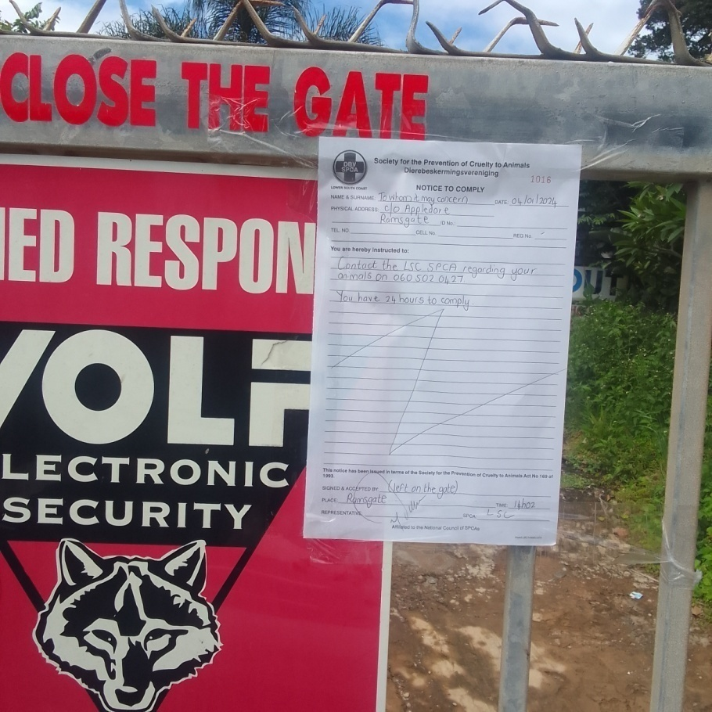
Photograph 1: I left a Notice to Comply on the main gate requesting that the owner contact me regarding the animals on the property.
At approximately 18h30 on the same day, 4th January 2024, Maggie Viljoen contacted me and it was arranged that she will be home the following day at 10h00 to meet at the property to discuss her animals.

FOLLOW UP AND FINDINGS
Date Attended: 05 January 2024
By Whom: Mike Davis

FINDINGS
At approximately 10h00am on Friday 5th January 2024 I arrived at the property and was met by Mr. Darryl and Maggie Viljoen. I advised that there was a complaint concern received that the animals were not being fed and that there was no food available for the animals. Maggie seemed surprised by this and advised that all the animals had food and were doing well. I was given permission to enter the property and the below list of animals was seen:
- 1 Pitbull unsterilised male black in colour (Diablo) approximately 13 years old
- 1 Yorki sterilised female golden in colour (Jasmin) approximately 3 years old
- 1 Pekingese Type sterilised female brown/cream in colour (Daisy) approximately 3 years old
- Yorki/Maltese Type sterilised female cream/beige in colour (Petunia) approximately 4 years old
I found all the above animals to be in fair condition, comfortable with their owners and all were found to be in acceptable weight and body score.
I requested to see around the property and where the animals were housed. I was taken in to the house and was told by Maggie that the small dogs all slept indoors and also had bedding on the sheltered verandah. There was also sufficient water available for all the animals. The Pitbull, Diablo slept in the garage at night. Whilst walking around the house, a Domestic Short Haired cat grey in colour came running past me from the bedroom. The cat also appeared to be in acceptable body condition. I was shown by Mr. Vijoen where the dog’s food was stored in a large black jim bin airtight container. Mr. Viljoen advised that the dogs were fed twice per day with pellets and soup with mielie meal mixed in with the afternoon meal. The cat had dry pellets ad lib. Maggie also advised that the small dogs were booked in at La Pooch grooming parlour in Uvongo in the following week. She also showed that she had the Dazzle NF bottle purchased from the SPCA to help with tick and flea control.
There was no odour in the house, and I did not find any old faeces on my look around the house and front section of the property where they resided.

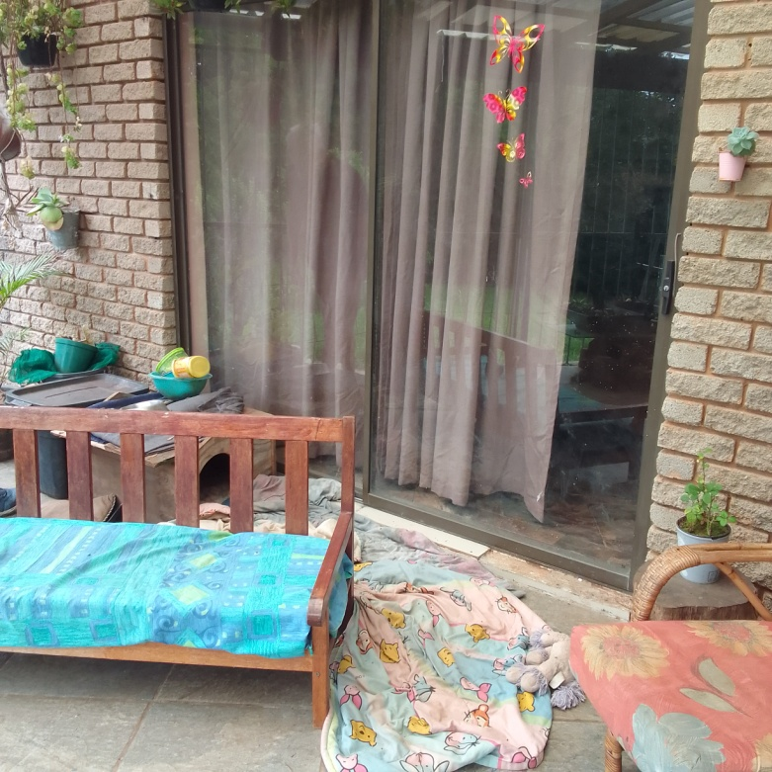
2
3
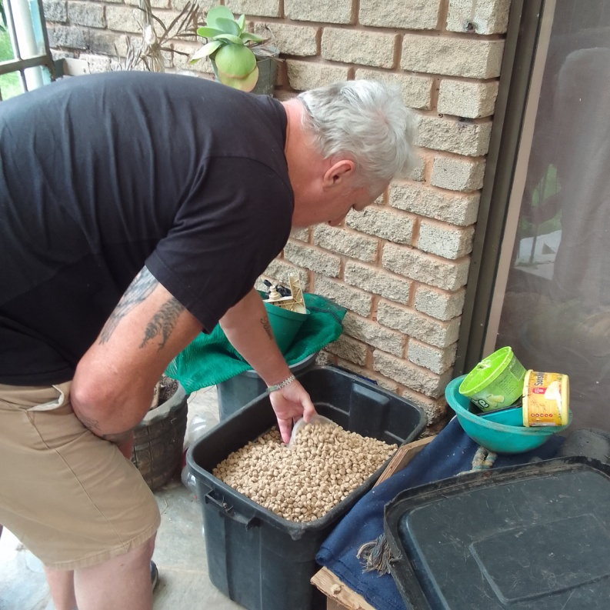
Photograph 2: The sheltered verandah area where the small dogs could also go in the day.
Photograph 3: Mr. Darryl Viljoen showed me the large airtight container where the dog’s food was stored.

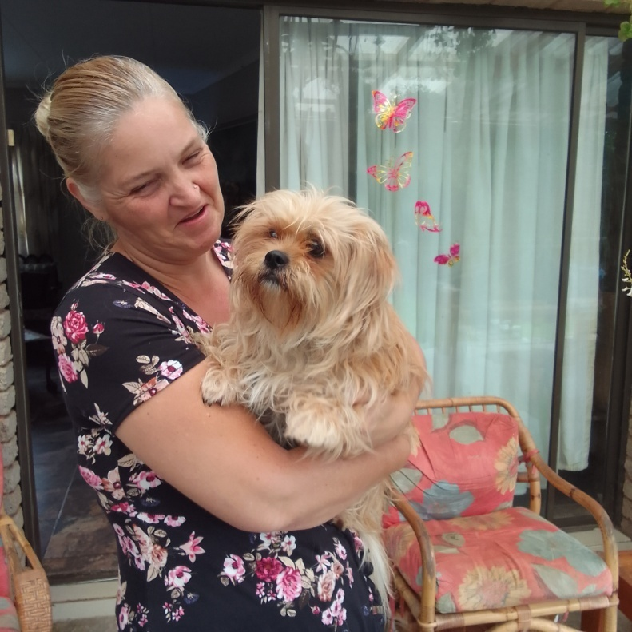
4
5

Photograph 4: Maggie Vijoen with Pertunia, the Yorki/Maltese Type sterilised female.
Photograph 5: I was greeted by Daisy, the Pekingese/Yorki Type sterilised female on entering the property.
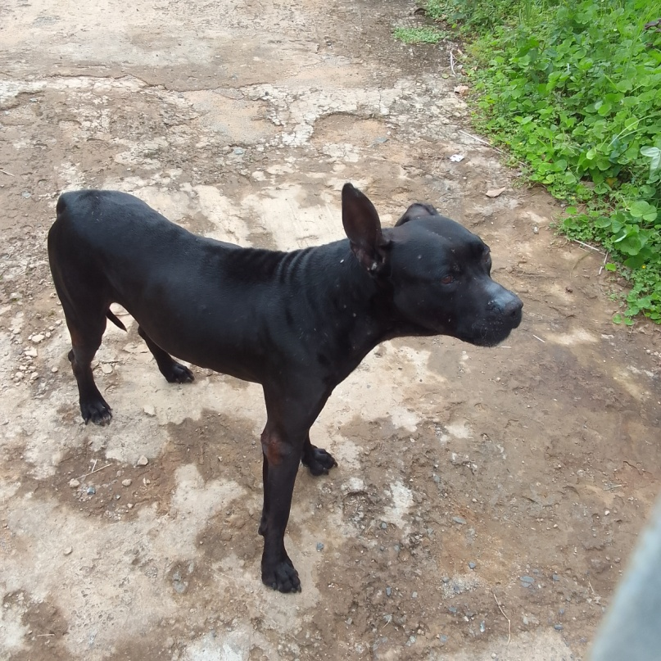
6
Photograph 6: Diablo, the Pitbull unsterilised male was the first at the gate. He is very protective of his owners.

ACTION AND CONCLUSION
No action was necessary on the follow up investigation.
I could not find any reason to conclude that there were welfare concerns for the animals that were on the property. As stated, all animals appeared in acceptable condition and did not appear to be underfed or starving. There was sufficient food available and the animals all appeared to be well looked after by their owners.
I did advise Mr. Vijoen and Maggie to contact myself or the SPCA if she ever needed assistance with anything.

This concludes the report.

MIKE DAVIS
TRAINEE INSPECTOR
LSC SPCA

