Hunting Dog packs – update – June 2026
Index:
The Issue Page 1
Objective of dog packs Page 1
History of our learning curve Page 2
Use of Drones Page 2
Early mistakes - where to position observers Page 3
Farm Watch (FW) Page 3
South African Police Service (SAPS) inclusivity Page 3
Other hill assets Page 4
Dog pack Modus Operandi Page 4
Action Plan Page 4
Cooperation with CapeNature Page 4
Threats of violence Page 5
A diary of incursions Page 5
Map of SLP side logistics Page 18
Conclusion Page 19
Contact Page 20
Appendix 1 - Legal / Acts Page 21

The Issue:
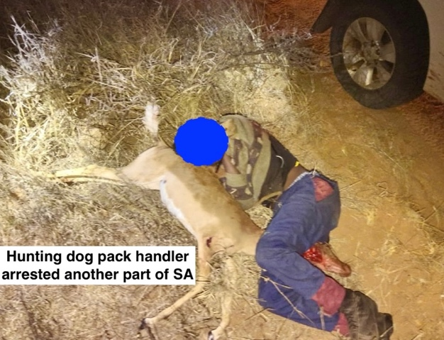
Hunting dog packs are a nationwide problem. There is support from some of the local settlements, but the organisational drive appears to be by those who have migrated from the Eastern Cape and KwaZulu Natal.
Illegal hunting is gaining momentum in the Western Cape. Dog packs are released out onto the mountainside, accompanied by handlers armed with rifles. Large amounts of money are bet on the outcome of a hunt. Weapons are sometimes cached in a hidden place on the hillside, such that the handler does not need to be seen carrying a firearm in a public place.
Apart from denuding our scarce wildlife, from dassies, gennets, to bokkies and leopards, dogs and handler weapons are a threat to recreational hill users, hikers, Reserve Rangers and to tourism in general.
In defence of their actions, dog pack organisers have used intimidation, threats of violence and even death threats against those who would curtail their activities.

For several years now the use of dog packs for hunting has taken place on the Grabouw side of the Hottentots Holland Mountains, in a range from the N2 to the lower flanks of Hans se Kop, within the ring of the Buys se Pad hill jeep track and on lower slopes down towards the Eikenhof dam. During the last two years, dog pack activities have spread to the SLP hillside, and also to ‘Highlands’ and Elgin side.

Objective of dog pack handlers:
- To hunt for bush meat. It is postulated by participants that in former times there is a history of hunting for bush meat. The cultural argument within the hunting community is quite simple. What they do is a traditional past time, and as such it is not restricted by what they see as arbitrary boundaries, which the handlers do not recognise.
- As a competitive sport / competition between the handlers to find which dog is first to run down the prey. Sometimes calls ‘taxi hunts’.
- To use animal parts in black magic rituals. Herbivore species are believed to have more black magic power than carnivores. Therefore, the porcupine (Hystrix africaeauastralis), and the dassie (Procavia capensis) are more highly prized for ritual animal parts, than carnivores such as caracal (Caracal caracal) or the Cape fox (Vulpes chama).

Breeding of Hunting dogs:
It is understood from sources we cannot divulge; dogs are bred for hunting. A mix of greyhound, whippet, coon hounds. It has been reported that dogs that do not perform, have been hung as a lesson to the other dogs

The dogs, which may number up to 40, are let loose on the hill to run down any ‘game’ they might scent, which is then chased until caught. Small game is often torn to pieces before the armed handlers can reach the melee.
The hunt is completely indiscriminate in that the dogs will chase down the first animal they find; a rabbit, a gennet, a dassie, a bokkie, Cape Fox and even a leopard.
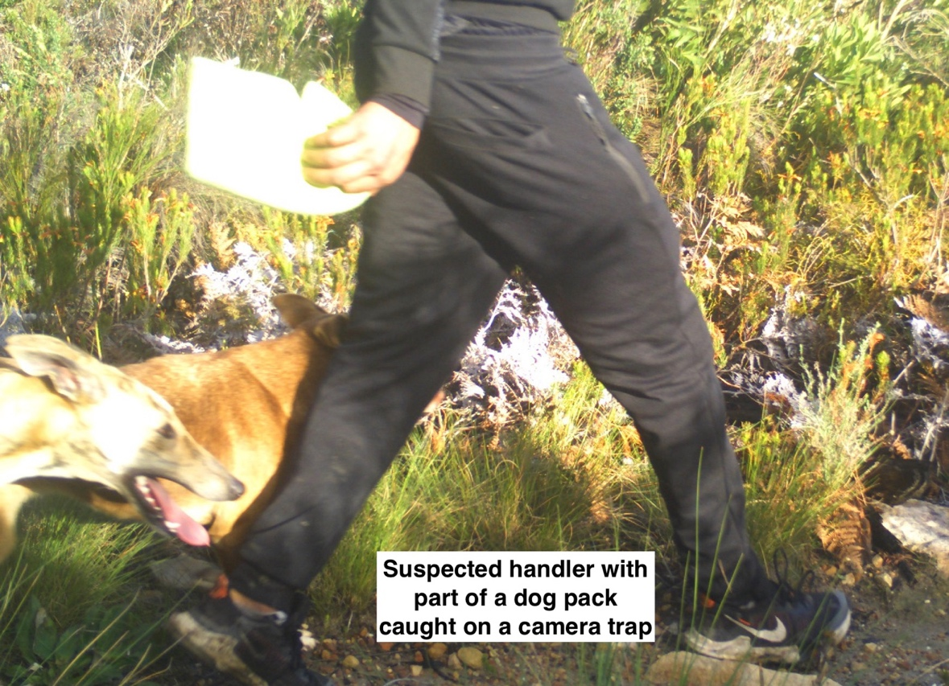

Our learning curve:
Hillside cooperation – Meetings have been held, and full support has been gained, with all SLP and Steenbras mountainside estates and Reserves.

Use of Drones:
All estates and Reserve authorities have authorised the use of drones specifically for seeking / interdicting dog packs and their handlers.

Drone upside:
- The ability to cover a large area of ground in a short space of time.
- When using infrared camera, there is an enhanced ability to find and see humans, dogs and game.
Drone downside:
- Inoperable in high winds.
- Infrared drone cameras – spotting heat sources, humans, dogs and game; cannot be differentiated from sunshine-warmed rock, unless there is movement.
- Drone support relies on drone operators being available at any one time. Currently our SLP team has two operators in Stellenbosch – 45 minutes mobilisation time. One operator flying the latest M30T drone is based in Somerset West – mobilisation time 20 minutes.

Early mistakes - where to position observers:
- Initially we chased our tails trying to track the packs and handlers across the hillside – to go where they were headed. We have learnt to go high on jeep tracks to vantage points that can be utilised by drone operators, that are situated on or near to their exit route.
- The use of drones is a ‘nice to have’ but must be discounted unless they are on site.
- The dogs will range extensively across the hillside. The handlers will invariably stick to trails and will only go off trail when game is cornered.
- We have also chosen several sites from which we have excellent visibility to view the entire SLP hillside.

Farm Watch (FW):
Farm Watch has built up an excellent knowledge of hill jeep track and trails. Individual FW members also know the high hill trails and passes intimately.
From a pool of active Farm Watch members, we can always mobilise at least three assets, who can be positioned at key vantage points.

South African Police Service (SAPS) inclusivity.
Monday 10:00 8th April 2024 at Im Eimer, SLP. A meeting was held between SAPS – Capt Riffel, WO Cloete, WO Visser, and Ryan Norris (security manager) and Steve Chadwick (FW Hill activities coordinator).
At the meeting it was agreed that:
- SAPS would give their full support to the hunting dog pack issue.
- SAPS would look at introducing talks at schools, to dissuade children at an early age from moving into dog pack hunting.
- SAPS will be prepared to assist in the interdiction of handlers and their dogs as they leave the hillside.
- SAPS asked that our group give themselves a group name that will assist SAPS to ‘sell’ the group to the higher echelons of SAPS management.
From a poll held with FW members ‘Helderberg Rural Environmental Protection Unit’ – HREPU was chosen for the group.

Other hill assets:
A good comms network has been established between hikers and mountain bikers regarding hill issues - dogs and flora harvesting. These assets send alerts out on the WhatsApp HREPU group.

Dog pack Modus Operandi:
Hunting groups change their routine, to escape our interdictions.
Currently, after their near arrest of Thursday 19th Feb 2026 – Grabouw side. See diary of events for that date.

Action Plan:
- A warning is given of dog pack activity. First Responder (FR).
Contacts withheld for security
- FR will put an alert out of the HREPU WhatsApp group.
- Contacts withheld for security

- Farm Watch assets will move to arranged vantage points, and report direction / numbers information. Assisted by drones if available.
- If good data available, FR will alert SAPS as to the likely exit.
- SAPS will be at exit point and interdict dog pack and handlers.
Note, Farm Watch will not remove caught dogs. This will be handled by animal welfare.

Cooperation with CapeNature
On 2nd November 2023 we received data from CapeNature regarding their modus operandi.
Documents:
- Action Plan to Address the Illegal Hunting with dogs and Fire Arms on CapeNature and DFFE Properties in Grabouw.
- Standard Operating Procedure for dealing with illegal activities on DFFE properties and HH Reserve Grabouw

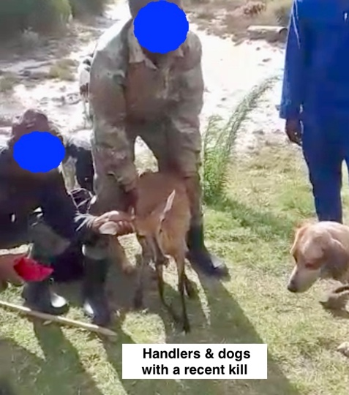

Threats of violence:
On the few times the gangs have been met on the hillside, they have used threats of violence against the would-be challengers of their activities. The handlers are armed.
Interception of the handlers is to be avoided as this may lead to physical harm.

Actual confrontation is strongly discouraged.
Observe - Report

Since June 2023 a diary of incursions has been kept, such that we may gain an insight into trends and times:
Tuesday 20th June 2023 SLP side
Incursion. Dog pack and handlers seen on the high Hepic trail above Bizwani. Tracks seen on the mountainside the next day.
Thursday 22nd June 2023 Grabouw side
Hikers heard the distress barks of what sounded like two dogs who seemed to be ‘crag fast’ on the lower cliffs of Hans se Kop. It is assumed that the dogs were chasing down prey that they chased onto the cliff face. Then became stuck (crag fast) on the cliff; not being able to get down. Inquiries were made with the local high estates, but there were no missing dogs.
Monday 25th June 2023 SLP side
A high estate again heard distressed barking from the lower slopes of Hans se Kop Mountain face.
Early on Tuesday 26th June two experienced local hikers (Claudia Schuster and Steve Chadwick) who are very familiar with the area hiked up to the lower steep slopes of Hans se Kop to search for the dogs. Local WSAR were informed and an SLP canine search unit was put on standby for action if confirmation of location was made.
However, as the pair ascended the slopes the weather deteriorated badly, bring driving rain and low visibility. Binocular searches were made of the lower cliffs with no sighting. Soon the cloud covered even these cliffs. High winds made it impossible to hear the distress calls of the dogs.
Over the next few days nothing further was heard.
Monday 31st July 2023 SLP side
Around 20 dogs and 12 handlers passed by Idiom restaurant on their way up the hill. This incursion via Knorhoek estate is a new development. It is not known at this stage if this was a Gantouw side group who had made their way in along the railway line, or that this was an SLP who had made their way up from Sir Lowry’s Pass village.
High estates were put on alert, but no further sight or sound was heard.
Saturday 28th October 2023 - 09:30 SLP side
Incursion of dog pack heard baying in land above Bizwani / upper Casa Maris / CN land. No assets were immediately available for investigation. Steve Chadwick drove up to Snowtower above Bizwani at 11:30. All parties had left.
Saturday 4th November 2023 SLP side
First heard around 12:30. Baying pack heard above Lorna and Leon’s place. Left of Bizwani. Again no assets were available.
Sunday 19th November 2023 SLP side
Single source reported eight youths with 12 dogs setting off across the hillside from the paragliding site on upper right of N2 below view point. Heading off towards hillside above Sweetwater dam. Claims definite hunting dogs.
Saturday 25th November 2023 SLP side
Alarm raised by Lorna at 06:18. Dogs heard moving across to Idiom. 07:19 Behind Lorna’s still thought to be heading to above Idiom. 08:04. Reported left of Hans se Kop. 08:10 Vanessa, Steve and Francois (Idiom farm manager) in position on high jeep track below and right of Hans se Kop.
08:21 Gun shot heard. 09:13 Joined by drone team from Stellenbosch. Flew drone, but it was thought that perps had set off back above Bizwani.
09:20 Flew drone from small quarry at end of jeep track towards bottom of Gantouw pass. Perps long gone.
Lessons. At first sound, go to comms tower above Bizwani. Try to be there as the perps head back. Not to chase our tails by going to above Idiom first. Be there at the exit, to see which way they go.
Saturday 2nd December 2023 Grabouw side
Dogs heard on Overberg side, below old Boland trail. Tracked down to jeep track below the Boland. Two youths with three dogs on an opportunistic hunt.
Thursday 21st March 2024 SLP side
Dogs heard from Lorna’s, left of Idiom, up towards Hans se Kop.
Coincidentally this was the morning we were testing the use of a new infra-red heat sensing camera drone.
Voices also heard by crew testing drone. Though the drone team had stood down prior to confirmation of the hunting dogs.
Ryan was the ‘runner’, to test using infra-red drone camera. Rocks also gave off heat signatures, which made Ryan hard to spot.
Sunday 24th March 2024 Grabouw side
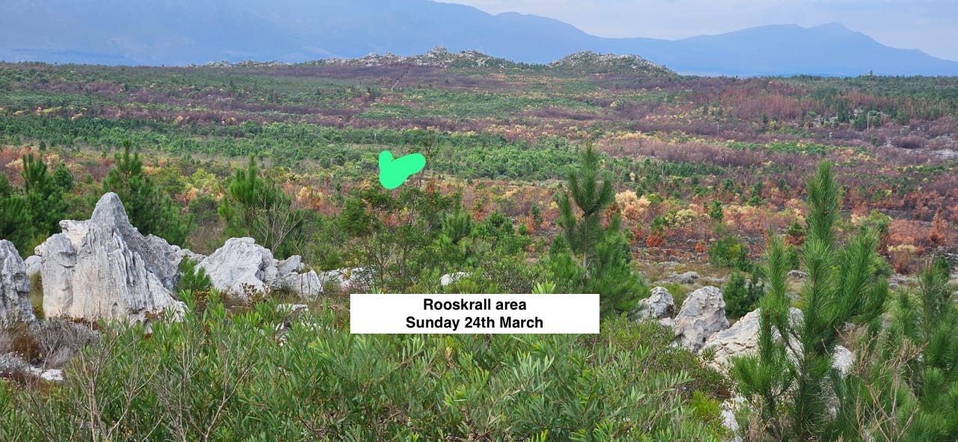
Report from biker in the area. Two men with large number of dogs – reckoned between 10 to 20. Heading north towards Hans se Kop.
Four shots heard.

Tuesday 26th March 2024 SLP side
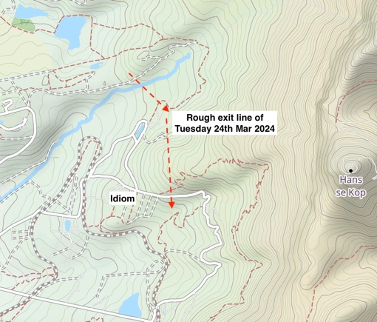
This was a serious change in the Modus Operandi of dog pack hunting, in so much as this incursion reached as far a Weddervill game reserve. Until it was realised that it was four youths with three dogs ‘having some excitement’ and not the hardened organised dog pack handlers that are our serious issue.
08:15 alarm raised by warden of game reserve, who gave chase and the youths plus dogs left, heading up rough ground above Idiom.
No drone operators available. Hunting dog pack group made up of Farm Watch members and high farm and estate people began to coordinate staking out key points of exit and visual lookout points.
Resulting in the interdiction of three youths and their three dogs.
A debriefing was held in Im Eimer that evening to discuss lessons learnt and moving forward – what we can improve. Meeting was attended by SAPS CPT Riffel who gave the group good feedback on protocols and SAPS cooperation.

Thursday 28th March 2024 Grabouw side
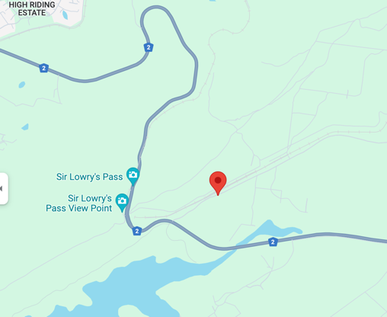
Hunting dogs heard below Hans se Kop. CN rangers on fire issues, unable to attend.

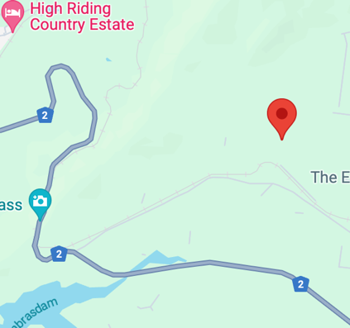
Friday 29th March 2024 Grabouw side
An incursion took place on the Grabouw side. Understood to be on CN land. CN just stood down from fire duty and are resting. Enquiries made for SAPS assistance.

Sunday 31st March 2024 Grabouw side
Hunters armed with rifles, with dogs seen heading towards N2

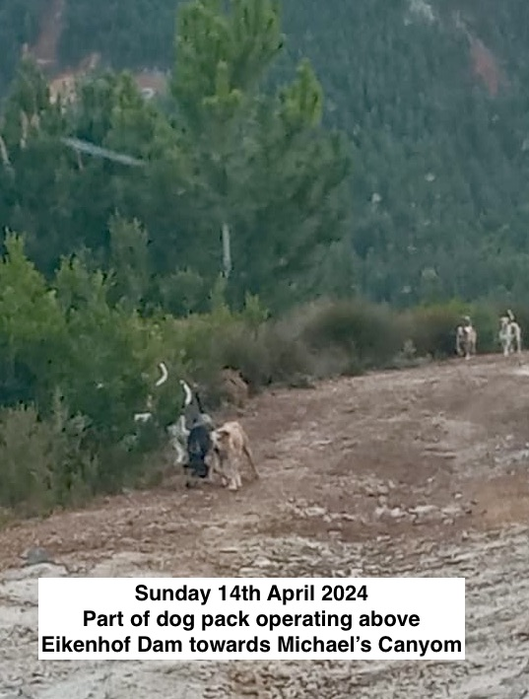
Sunday 15th April 2024 Grabouw side
Hunters armed with rifles, with dogs seen above Eikenhof dam.
SAPS arrived and taken to the suspected area of hunt. No dogs or handlers was seen.
Rangers were asked to leave the area due to concerns for their safety.
It was concluded that the hunters had left the area.
Learning points meeting planned for Monday 15th April 2024,

Tuesday 14th May 2024 Grabouw side
Four men with guns and dog pack. Law Enforcement attended but no sign of suspects
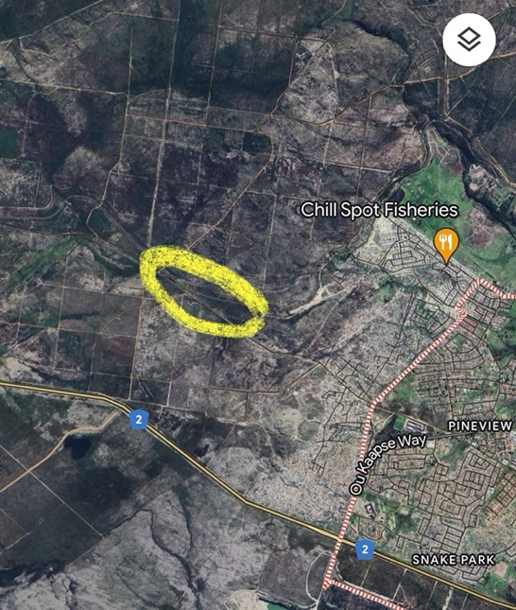
Saturday 18th May 2024 Grabouw side
One man and dog hunting GAWS responded. Man was very aggressive.

Wednesday 29^{h} May 2024 Grabouw side
Dog pack seen on jeep track heading for Rocky Garden side.

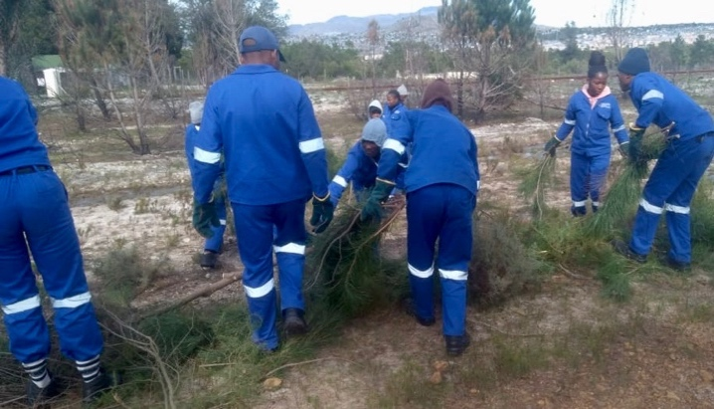
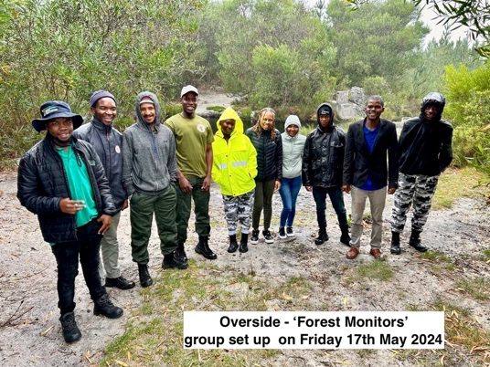
May 2024 Grabouw DFFE implement the Forest Monitors scheme. Employing local men and women to monitor forest and hillside activities.
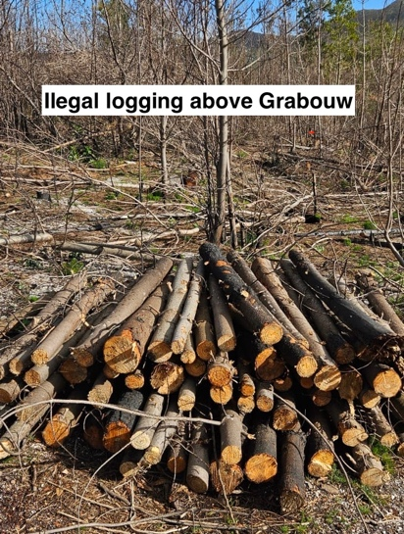
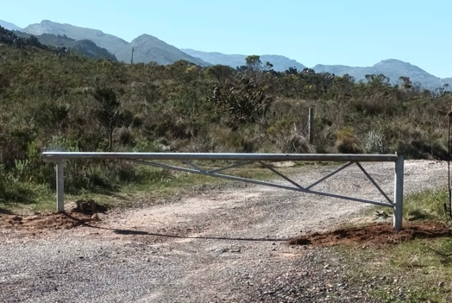
Mid July 2024 through to end August 2024 Grabouw side
Continued almost daily bakkies going in and returning with full loads of timber – cleaned log lengths.
In an attempt to halt this illegal activity a steel barrier has now been erected at the turn of from the N2 opposite the Steenbras dam road entrance.

9th July 2024 Grabouw side
Bakkie leaving DFFE area with full load of fynbos

Tuesday 30^{h} July 2024 SLP side
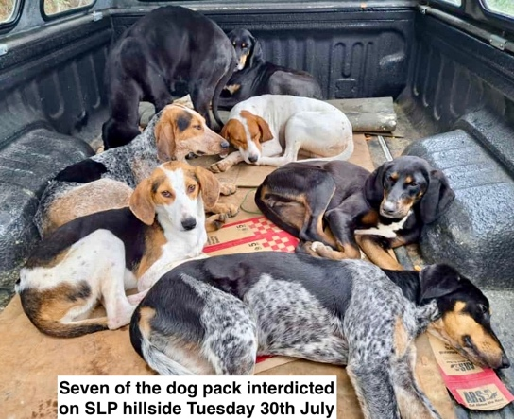
Dog pack was heard, then seen actively hunting on the hillside by Idiom and Casa Maris estates. Estates and FW assets were mobilised resulting in the interdiction of ten hound type dogs. On advice these animals were taken to the SPCA at Grassy Park.
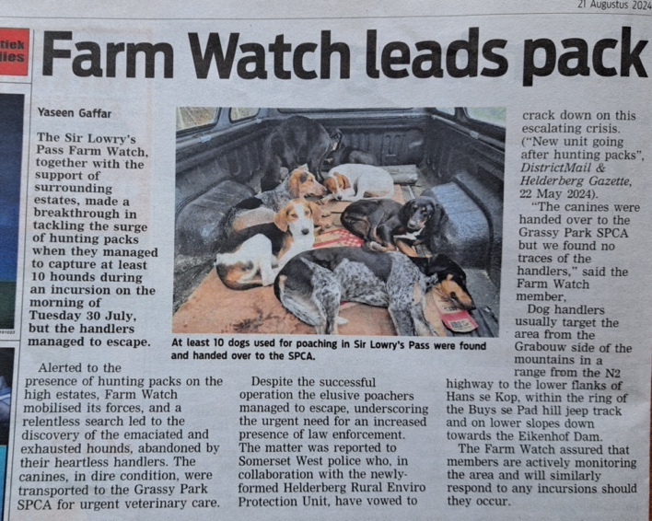

Wednesday 21st August 2024 Grabouw side
Dog pack heard above Eikenhof Dam

Monday 7th October 2024 Grabouw side
18:30 Hunting dogs heard and two shote fired

Wednesday 9th October 2024 Grabouw side
10:15 hunting dogs seen and heard above country club and farm 24 east

Tuesday 22nd October 2024 Grabouw side
21:00 Hunting dogs heard going from Rooidakke towards Country Club.
Residents also reported to Grabouw side Farm Watch dogs heard 22:00
Tuesday 29th October 2024 Grabouw side
Dogs heard at top of Magwitch. Handler seen with hunting rifle.

Sunday 17th November 2024 Grabouw side
Dogs heard & seen. DFFE plantation
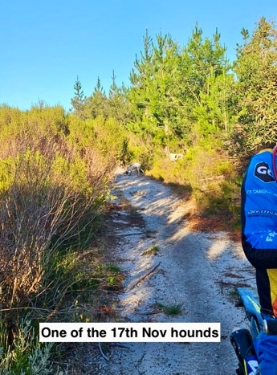
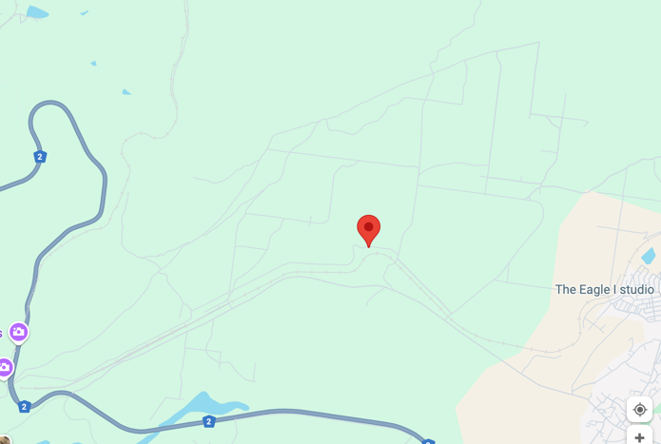

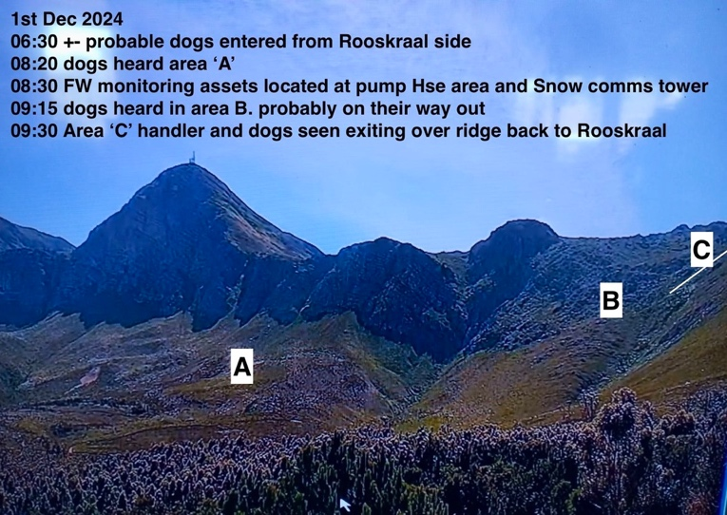
Sunday 1st December 2024 SLP side
08:20. Dog pack was heard between Bizwani and Grove. FW assets deployed to SnowPac tower area. Probably entered around 07:00 from Roskraal Overberg. Heard down to Hepic trail left of steep landslip. 09:30 dogs and handler seen cresting ridge left of SnowPac tower. Heading back Overberg side where maybe transport was waiting.

Sunday 8th December 2024 SLP side
06:45 FW & Helderberg Rural Environmental Unit alerted to hunting dog pack on the hill left of Klipspringer Kloof.
07:45 Overside DFFE group alerted.
07:50 SLP side assets mobilised to Parmalat Quarry Spring 1 and Snowball Comms tower. So good visual cover on the hill aspect.
08:45 Handlers and dogs visual confirmed on hillside left of Klipspringer kloof.
09:00 Multiple shots heard.
09:50 Handlers with dog pack exited up K’ kloof towards Rooskraal
SLP FW asset mobilised to Overberg side entered hillside from opposite dam entrance. Dogs spotted but no handlers.
10:00 SLP assets stood down.
12:00 SLP assets on Overberg side stood down.

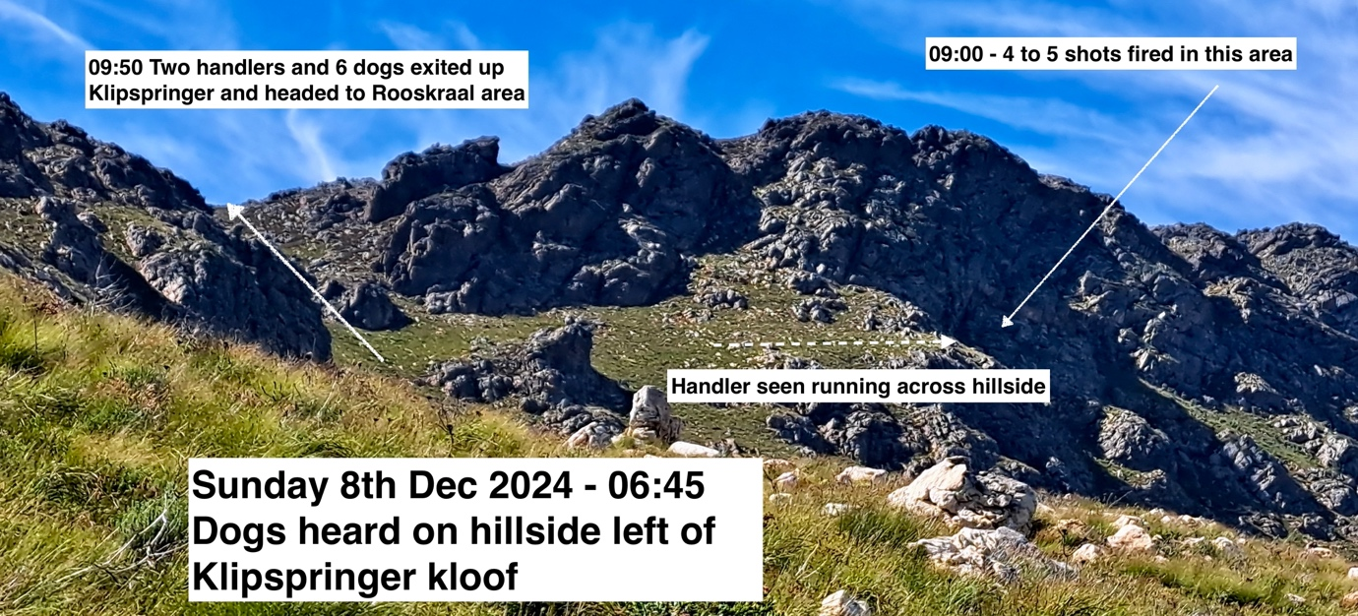

Thursday 2nd January 2025 Grabouw side
Six hunting dogs, one male handler in blue overall. Above Blue Rock studio

Friday 17th January 2025 Grabouw side
22:40 hrs. Hunting dogs on farm 25, heading towards Country . Unusual evening hunt.

Sunday 9th February 2025 SLP side
06:15 Dogs clearly heard above Bizwani. Steve and Ben investigated up to Hepic trail above snow Comms tower. Saw two handlers with two dog packs heading up kloof to look out flat area where one can drive to for Rooskraal.

Wednesday 12th Febuary 2025 Grabouw side
20:50 hrs. Hunting dogs heard above country club

Friday 14th Febuary 2025 Grabouw side
Handler with ten dogs above township heading up towards Hans si Kop

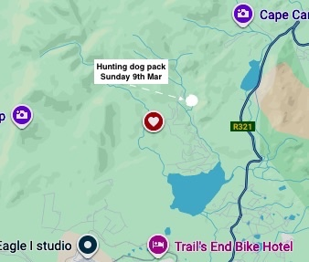
Sunday 9th March 2025 Grabouw side
Hunter in blue ‘overalls’ with around 20 dogs.
This in in the area much used by bikers and mountain bikers. And must be a danger to them.

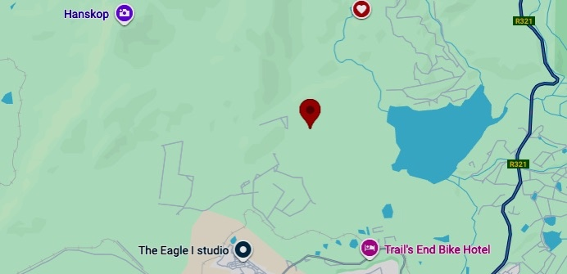

Friday 21stMarch 2025 Grabouw side 10:30
Three handlers with about 30 dogs reported in are Q above Country Club
Saturday 22nd March 2025 SLP side 04:20
Dogs heard above and behind Grove

Thursday 1st May 2025 Grabouw side 04:20
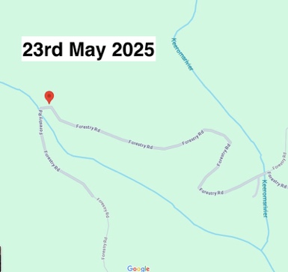
Dogs with handlers heard leaving Rooidakke heading upslope. Heavy rain began. It is thought that the group returned home.

Sunday 23rd May 2025 Grabouw side 12:07
Large dog pack heard at Keerom weir area. About four handlers. High excitement from dogs on scent.

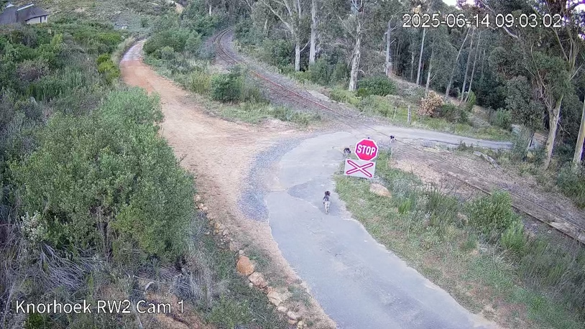
Saturday 14th Jun 2025 SLP side 09:03
Dogs heard above and behind Grove
Dogs seen on camera at Bizwani / rail line / Beoconsfield junction. Heading along rail service Rd No handlers seen

Sunday 15th Jun 2025 Highlands 11;19
One man with four hunting hounds.

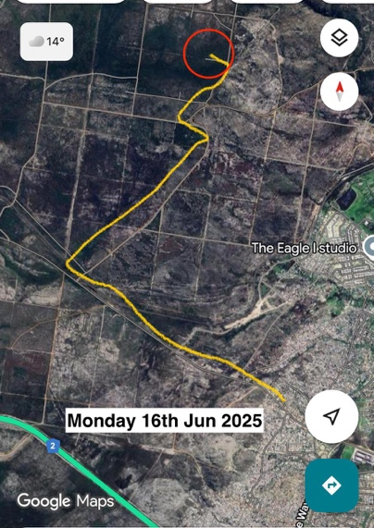
Monday 16th Jun 2025 Grabouw side 20:25
Handlers I blue overall, with hunting dog pack

Wednesday 18th Jun 2025 09:30 Grabouw side
Large dog pack heard above country club

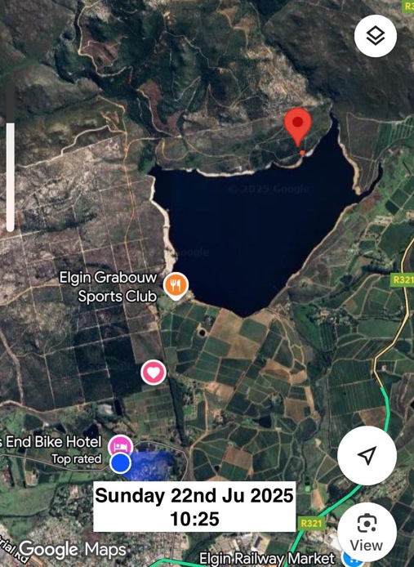
Sunday 22nd Jun 2025 Grabouw side 10:25
Man with pack of four dogs
Two dogs confiscated. DFFE group and CN searched or handler, but had gone tog round and hid

Saturday 28th Jun 2025 Grabouw side 13:30
One man with four dogs – again
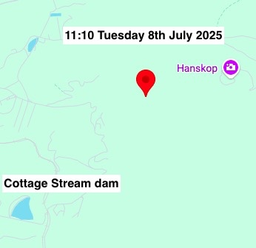

Tuesday 8th July 2025 SLP side. 11:10
Audio of dogs on the veld below Hans si Kop.
12:05 Dogs calling. Gunshot heard.
Team went to Snowpac tower. Nothing seen or heard further. 12:40. Everyone stood down.
Later that day dogs were heard Grabouw side, in the ‘ravine’ down from Han si Kop. Probably the same pack heading back to base on Grabouw side.

Satday 19th July 2025 SLP / Grabouw side.
Search exercise. Vergelegen estate, SLP Farm Watch, Grabouw Farm Watch, SAS, Hill bikes.
A coordinated search exercise from Vergelegn to Gantouw Pass, over the hill above Grabouw and round to Grabouw side of Han si Kop.

Sunday 20th July 2025 Grabouw side. 12:15
Dog pack and two handlers found by motor bike patrol.
One man arrested, taken to SAPS station and released after a warning. One other got away with dog pack. No firearms seen
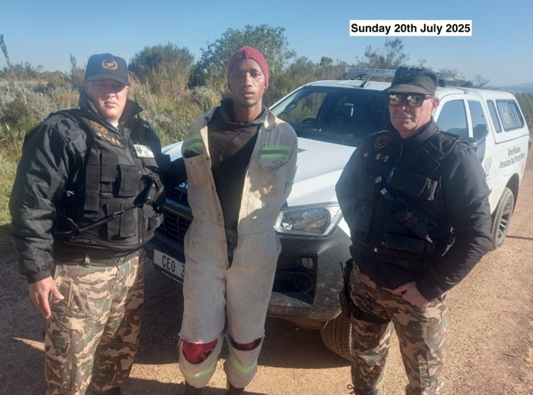
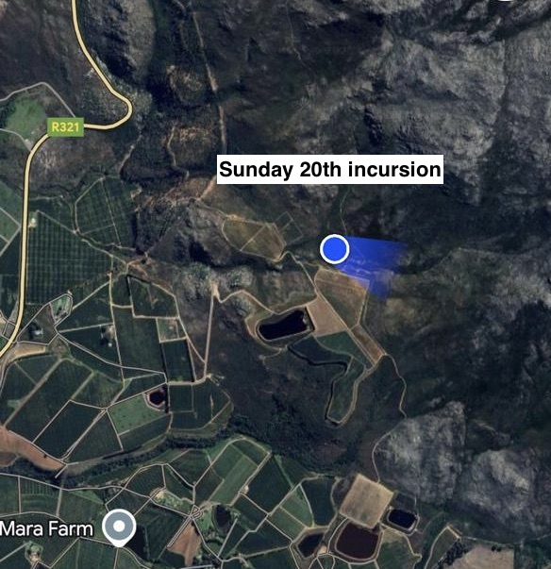
Thursday 31th July 2025 SLP side. 23:35
Dog pack heard and torches seen on mountain side between Grove and Bizwani estate.
Idiom manager went out but perps had gone.

Saturday 2nd August 2025 SLP side. 16:55
Dogs heard on mountainside, Idiom side.
Wedderwill game reserve warden and Cottage Stream estate responded.
Sound located to below and right of land slip on Hepic trail.
17:57 Shots heard. By 18:15 searches failed to find anything. 18:56. Personal stood down.
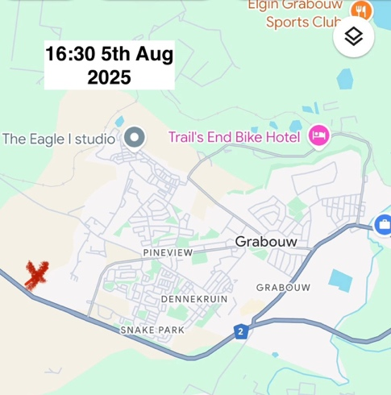
Tuesday 5^{h} Aug 2025 Grabouw side. 16:30
Dog pack and three handlers near N2 heading towards Siyayanzela.

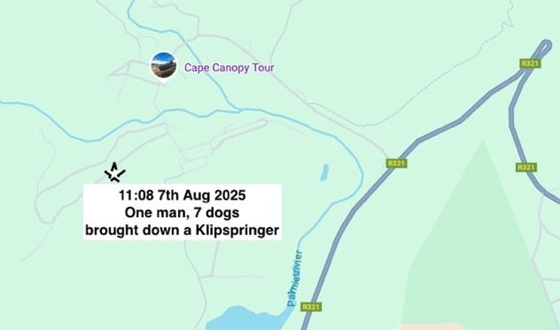
Tuesday 7^{h} Aug 2025 Grabouw side. 11:08
Seven dogs one armed handler. Brought down one Klipspringer. 30m from road near CapeNature HH Nuwerberg offices.
SAPS arrested one perp’ at his dwelling. Confiscated one home-made rifle.

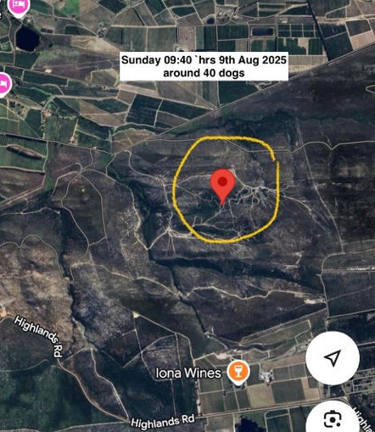
Saturday 8th August 2025 Highlands 09:40
“Hunting dogs (about 40) are active in the forestry land below Iona (north).”

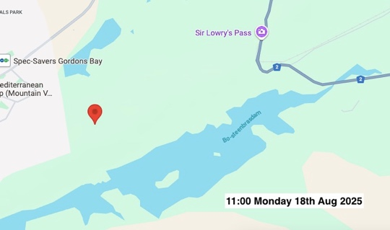
Monday 18th August 2025 Steenbras / Sweetwater 11:00
Two handlers, five dog, Gustrouw, above Sweetwater dam

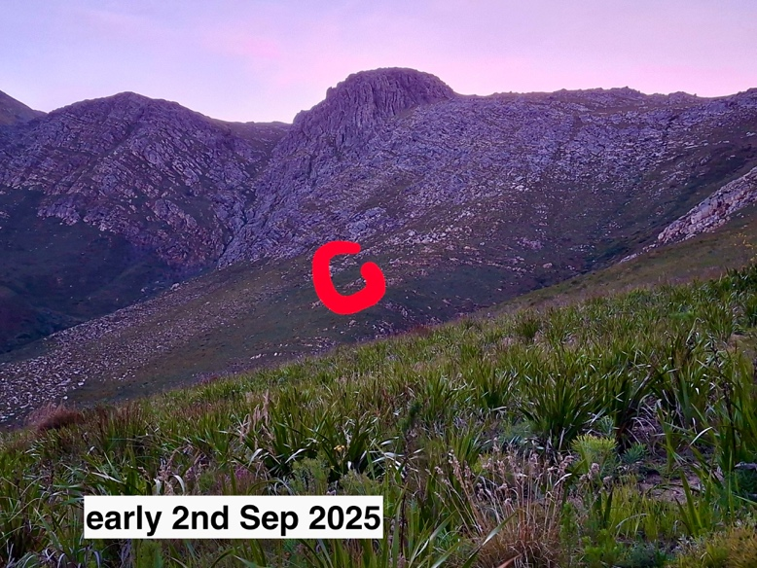
SLP side. 2nd Sep 04:30
04.30 Had a call from a high estate that a hunting dog pack was on the hill. Usually accompanied by armed handlers. The pack hunts indiscriminately. Anything from rabbits, bokkies, to leopards. At 04.45 I drove up as high as I could get. Snopac comms tower at 370m.
Sure enough, a number of dogs. As it grew light i could get a good audio location but neither the Estate or I could get a visual to then call for back up police. Frustrating. Eventually stood down around 08.15.

Thursday 4th Sep 2025 Grabouw side. 03:45
“Hunting dogs close to Proefplaas, Worcester Rd, above in the mountains. Dogs screaming and howling”
2nd day in a row. Very early start.

Sunday 7th Sep 2025 Grabouw side. 09:30
Hunting dogs heard near Veselsgat. Gun shot heard.

Sunday 7th Sep 2025 SLP side. 14:50
14:50 Dogs heard and shots fired about 100m above Grove Estate
15:00 Incident reported to SAPS
15:50 Poachers voices heard believed to be in hillside above Wedderwill winery
16:10 2 SAPS vans arrived.

1/ Two events. Could be the same group.
2/ SAPS took 1hr 10mins to arrive
2/ We must not underestimate the distance on rough ground that these perps can cover. They are fit and strong.
3/ In both instances today shots were heard. Unacceptable to general safety of anyone in the area.

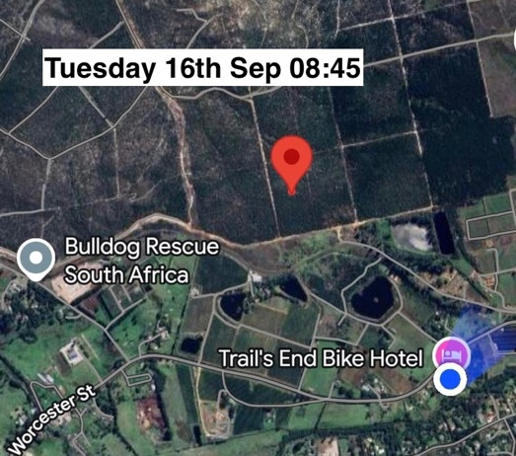
Tuesday 16th Sep 2025 Grabouw side. 08:45
Hunting pack of 6 dogs. One handler, black pants, red top.

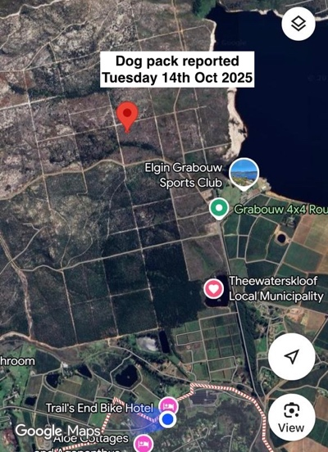
Wednesday 24th Sep 2025 Grabouw side. 08:55
Hunting pack on Proefplaas. Heading towards Country club

Tuesday 14th Oct 2025 Grabouw side. 15:17
Hikers reported large group of hunting dogs near Q above country club

Thursday 23rd Oct 2025 Grabouw side. 18:00
From manager HH CN reserve.
‘Just received word that the individual whom is out on bail is above farm 24 and fired shots with rifle. He is making his way down to Irak / Roiidak with his hunting dogs’
Hunting dogs also reported on Proefplaas. Maybe same group.
22:20 Doga baying, animal screaming heard.
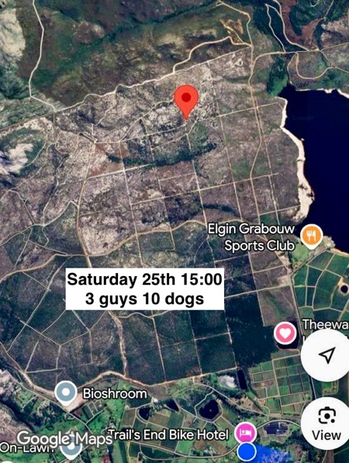
Friday 24th 2025 Grabouw side. 06:50
Hunting dogs reported on Proeplaas (again) heading above Country club.

Saturday 25th Oct 2025 Grabouw side. 13:07
Three guys with large pack of hunting dogs seen near N2
15:00 Three cyclist’s reported three guys with 10 dogs. Probably same group returning from hunt.

Saturday 28th October 2025 Grabouw side. 13:07
Large dog pack circa 25, seen above Eagle studios.

Monday 12th Nov 2025 SLP side. 06:30
Small dog pack heard in lower Beaconsfield.
08:45. Three handlers and five dogs seen leaving along the Knorhoek Rd.

Friday 9th Nov 2025 Grabouw side. 20:30
Three Handlers and dog pack reported behind Country Club

Tuesday 13th Nov 2025 Grabouw side. 07:00
Again…Excited dog pack heard in lower Beaconsfield.
Seems to be a new modus operandi. Dog pack operating from SLP village.

Monday 13th Nov 2025 Grabouw side. 09:40
Hunting dogs with four handlers, hunting on Proefplaas, next to Belvue

Sunday 18th January 2026 (1) SLP side. 05:50
Reported by Grove estate at 05:50. Large pack and several handlers. Lots of noise. Probably entered from Grabouw side via Klipspringer gully. Then came on down and round to behind Grove. Then went back up probably via Devils Craw. Heard Grabouw side and 09:00.

Tuesday 20th January 2026 (2) Grabouw side. 07:20
Hunting dogs with handler reporte3d from Grabouw side. Near ‘Rock Garden’ area.
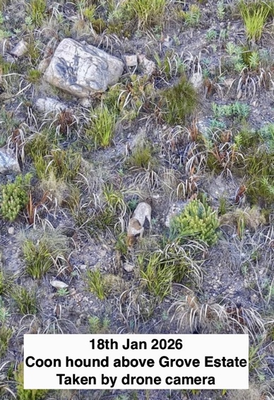
Tuesday 18th January 2026 (3) SLP side. 20:00
Pack with handlers reported above Grove estate at 05:50. Coon hounds identified.
Possible breeder known to HREPU.

Saturday 14th February 2026 (4) Grabouw side. 11:45
One man in red, with rifle and dogs. Seen above Iraq.

Sunday 15th Febuary 2026 (5) Grabouw side. 07:20
Hunting dogs with handler reported above Country club near Wesselsgat. Heading in Hans si Kop direction.
10:00 Cape Nature HH alerted. “team of rangers sent to investigate’.
11:55 sighting between Wesselsgat and Buys se Pad.
12:29 CN Rangers reported in at above location.
Somerset West NHW 4x4 on scene
13:00 one individual found hiding in veld.
Up to 15:31. Combined search by CN / DFFE / Grabouw FW
15:39. CN team followed perps into Iraq township. One man carrying black bag. Suspected dead animal.

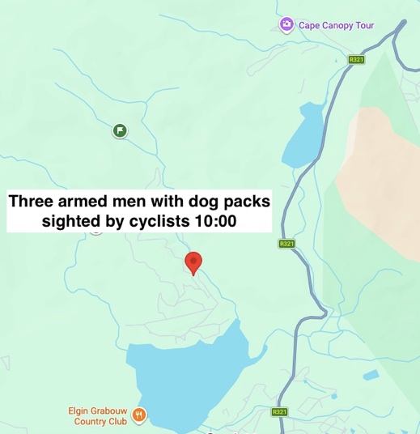
Thursday 19th February 2026 (6) Grabouw side. 10:00
Armed men with large dogpack. Seen above Eikenhof dam.
DFFE, Grabouw FW, Cape Nature Rangers, mobilised to interdict the handlers and pack.
11:30 SAPS called and sent one vehicle.
14:50 SAPS arrived at Country club gate.
15:13 CN Rangers have handlers and dogs in sight.
15:15 SAPS withdrawn due to other priorities.
15:40 Good ‘stake out’ of area, to hem in perps.
16:00 Confirmation received that men are armed. One rifle, one shotgun, one handgun.
!6:05 One handler threatened a Cape Nature Ranger with a handgun.
16:15 A further attempt to gain in field support from SAPS
16:26 SAPS cannot assist to workload.
17:03 handlers and dogs moving left across hillside. SLP side alerted in case of movement in SLP direction.
19:06 Four handlers seen entering Iraq. One entered with dogs, three others entered separately.
19:10 All units stood down.
Over the years that we have been monitoring hunting dog packs and their handlers, many shots heard before on hunts. This is the first time that someone has been directly threatened with firearm. A major escalation.

Sunday 22nd February 2026 (7) SLP side. 09:35 and again around 3:00
Dogs heard above Knorehoek farm 32 Grove

Friday 6th March 2026 (8)Grabouw side. 06:51
Hunter with four dogs on Q trail.

Saturday 7th March 2026 (9) Grabouw side. 13:15
Hunting dogs near Eikenhof cottages.

Monday 9th March 2026 (10) side. 14:30
Hunting dogs with three bravo males. Heading back to Irak

Tuesday 17th March 2026 (11) Grabouw side. 13:05
Two men spotted with hunting dogs. Left of Swemgat.

Monday 23rd March 2026 (12) Grabouw side. 11:05
Hunting dogs on Rustoord farm. Moving towards farms 23 & 24

Tuesday 31st March 2026 (13) Grabouw side. 07:08
Hunting dogs on railway line opposite farm 24

Saturday 11th April 2026 (14) Grabouw side. 21:22
Hunting dogs along river on farms 23 & 24

Friday 10^{gth} March 2026 !15) SLP side. 22:50
Hunting dogs seen high on Hans si kop tarred approach road. Suspected waiting for dawn for early activity. But it rained overnight. Hunters probably retreated back home.
SLP HREPU mobilised early Saturday morning to below Hans si kop, SLP side. No activity seen or heard.
Thanks to Grabouw side for ‘heads up’ info.
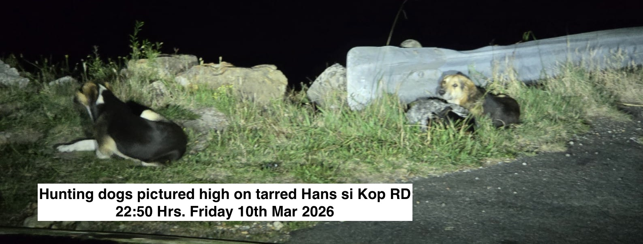
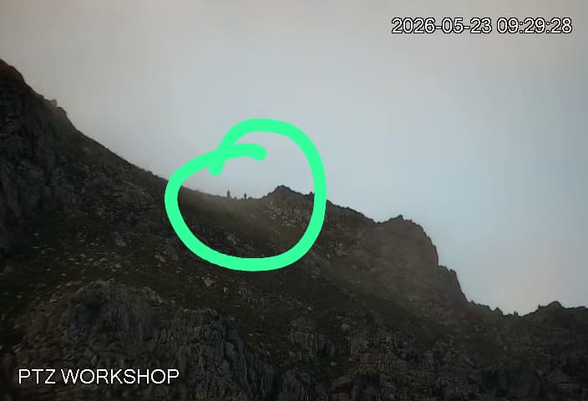
Saturday 23rd May 2026 (16) SLP side. 07:40
First heard by Bizwani security guards at 07:40
Confirmed by Overside that they had crossed over from Grabouw side around 6 that morning.
Circa 20 dogs with three handlers then seen high above Bizwani, at top of Klipspringer gully.
By 09:30 were seen heading back to Grabouw townships.

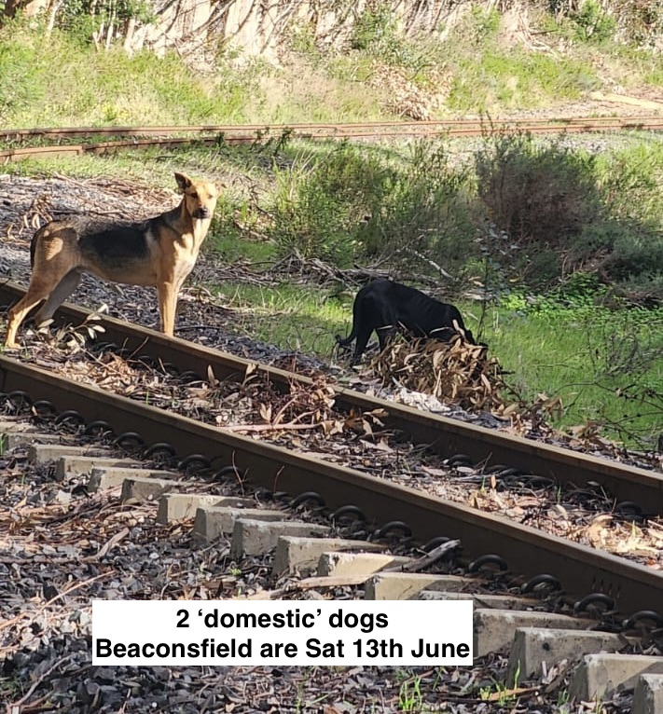
Saturday 13th Jun 2026 (17) SLP side.
Barking heard above Cottage Stream. 13:18
Two dogs seen in Beaconsfield. One Alsatian type and one russet dog similar size.
Separate incident 14:00 Handlers and several dogs seen on high jeep track from Bizwani to Grove, Registered with SAPS Ref 1003185507. Believed to be herders with dogs.
Local security mobilised and handlers and dogs escorted from area.
Cottage Stream reporting loss of over the past six weeks of five Bokkies, one baby Duikertjie.

2023 June to December 9
2024 Total 22
2025 Total 37
2026 to date – June 17

SLP Operations:
Overall map of SLP side logistics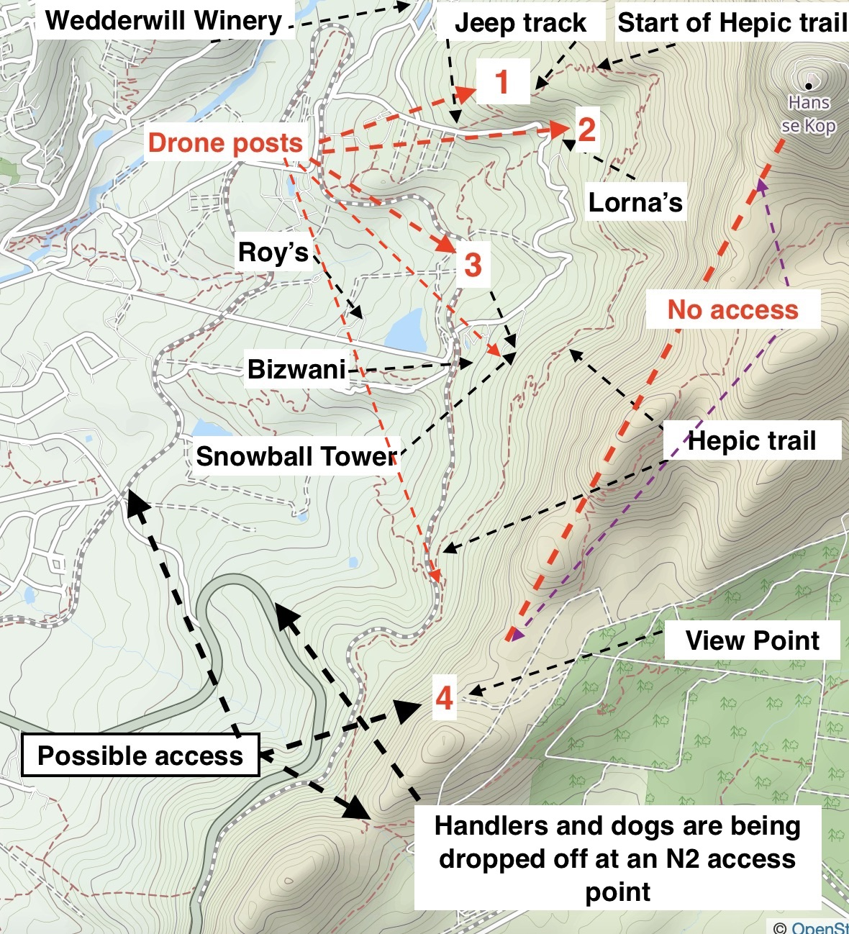

- Drone handlers have been taken onto the hillside and three vantage sites were agreed.
This surveillance system may also lend itself to Wilderness Search and Rescue scenarios in the same area.

Conclusion:
- It is hoped that these actions will reduce the fast decline of our already threatened wildlife.
- Interdiction of the handler gangs could result in the confiscation of illegal firearms, thus reducing the weapons available for robberies and inter gang violence.
- Note: Most previous incursions take place in the early morning, with the intention of the perpetrators to be out by 09:00.
- It is known that publicity regarding our efforts to stop dog pack hunting does have a positive effect, in that the dog pack handlers are dissuaded from hunting on the hillside when they know that modalities are in place to monitor their activities.

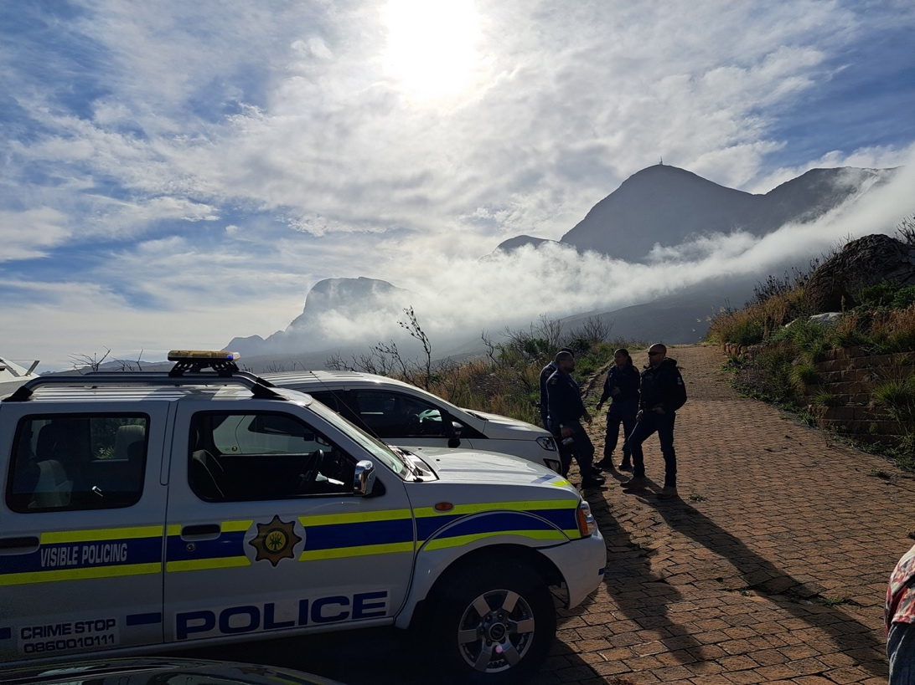

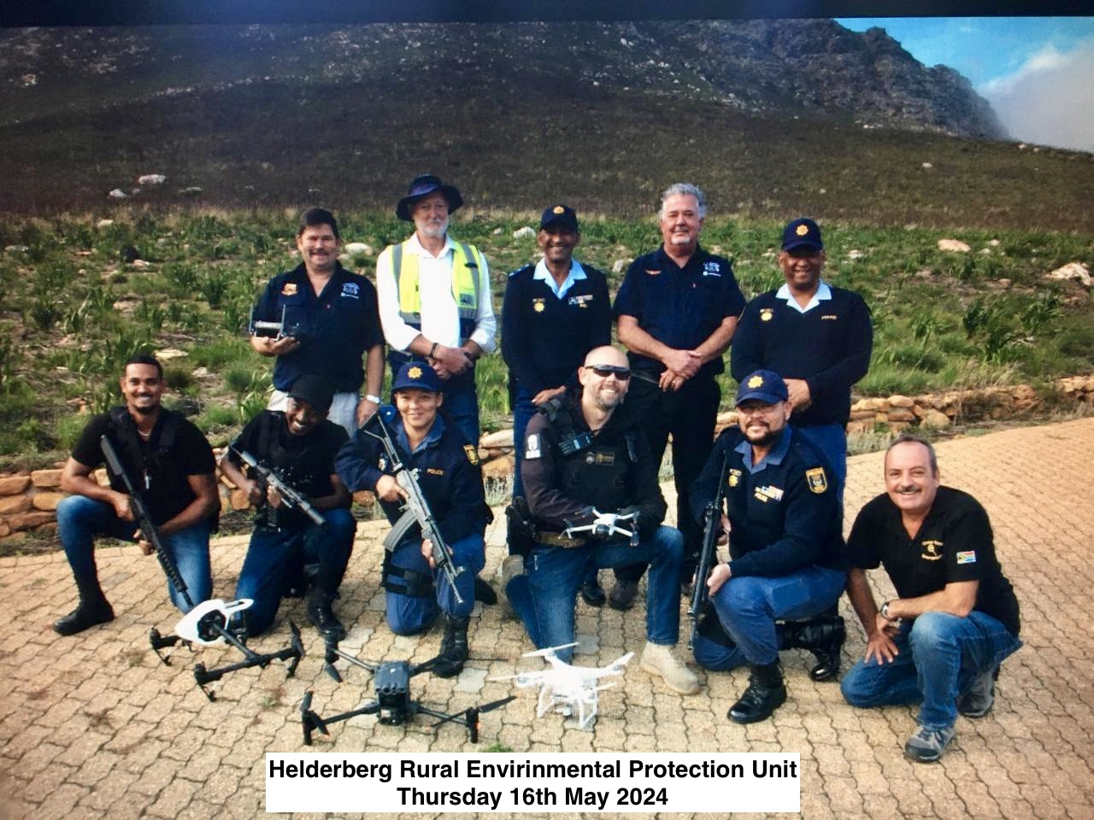

Steve Chadwick
Updated Aug 21st 2025.

