Record of weekend 28-2 till 1-3-26
My grandson was at my house on Sunday 28th February, 2026.
In the afternoon, I set up a safe target shooting area alongside my house – between the house and garden wall, which is over 10 feet tall.
Information from ChatGPT: Shooting a pellet gun on private property.
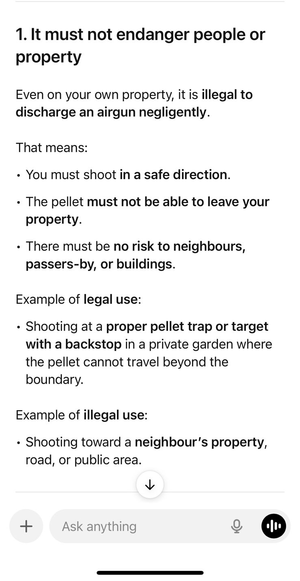
Target was an extra-thick, flattened cardboard box plus 4 rubber mats behind the cardboard, placed in front of my trolley bin, i.e. a fail-proof backstop, surrounded by high walls. My grandson shot a few pellets directly into the target area under my direct supervision. The distance was about 7 metres. All pellets entered the cardboard target. There were no cats on my property.
On Tuesday, 3rd March, Russell de Wet from Carnoustie Street came over in the afternoon to ask me if I had had “a young man” visiting me on Sunday. I replied in the affirmative. He then told me that a cat had been shot – an x-ray was posted on the social WA group with an x-ray, allegedly of the cat in question, with a pellet lodged inside it.
I stated quite clearly that I had been with my grandson every moment he had used the pellet gun and there were no cats anywhere in the vicinity. I invited Russell to view the area, which he declined to do.
On the complex WA chat group, I saw that he had “given all the information” he had to his friend, the cat’s owner – a man called Ady (Adriaan?). I called Ady and left a message. He came over that evening, and I again explained my grandson was under my direct supervision and no cats were shot by him or myself. I invited him to view the area and the safe target set-up. He asked about my garage side door. This door was some way behind the target and behind the trolley bin. It was not hit by any pellets. He left, saying over his shoulder, “So if your grandson shot my cat it was an accident”, or words to that effect. I again affirmed that my grandson could not have been and was not responsible for injuring his cat.
On Thursday, 5th March, Ady sent me a message that he was coming over at 6pm to “discuss the way forward”. I replied that there was nothing to discuss as my grandson was not responsible for the injury to his cat.
It is noteworthy to record that in his postings on the WA group, he said his vet was of the opinion that the cat had been shot about 2 weeks prior to the visit to that vet and thus at least 2 weeks before the only discharge of the pellet gun on my premises.
He also said that his cat had been scared to leave the house for about a month. He said that the cat had “collapsed” on Sunday.
I categorically state again that my grandson could not have been responsible for the injury to the cat. He was accompanied by me at all times and I can testify that no cats were in my yard on Sunday and that no pellets were shot at any living creature. Any pellets shot were shot safely into a safe target, with a quadruple rubber backstop.
I consider any further enquiries to be harassment and will take the necessary steps.

Diagram of the target shooting area:
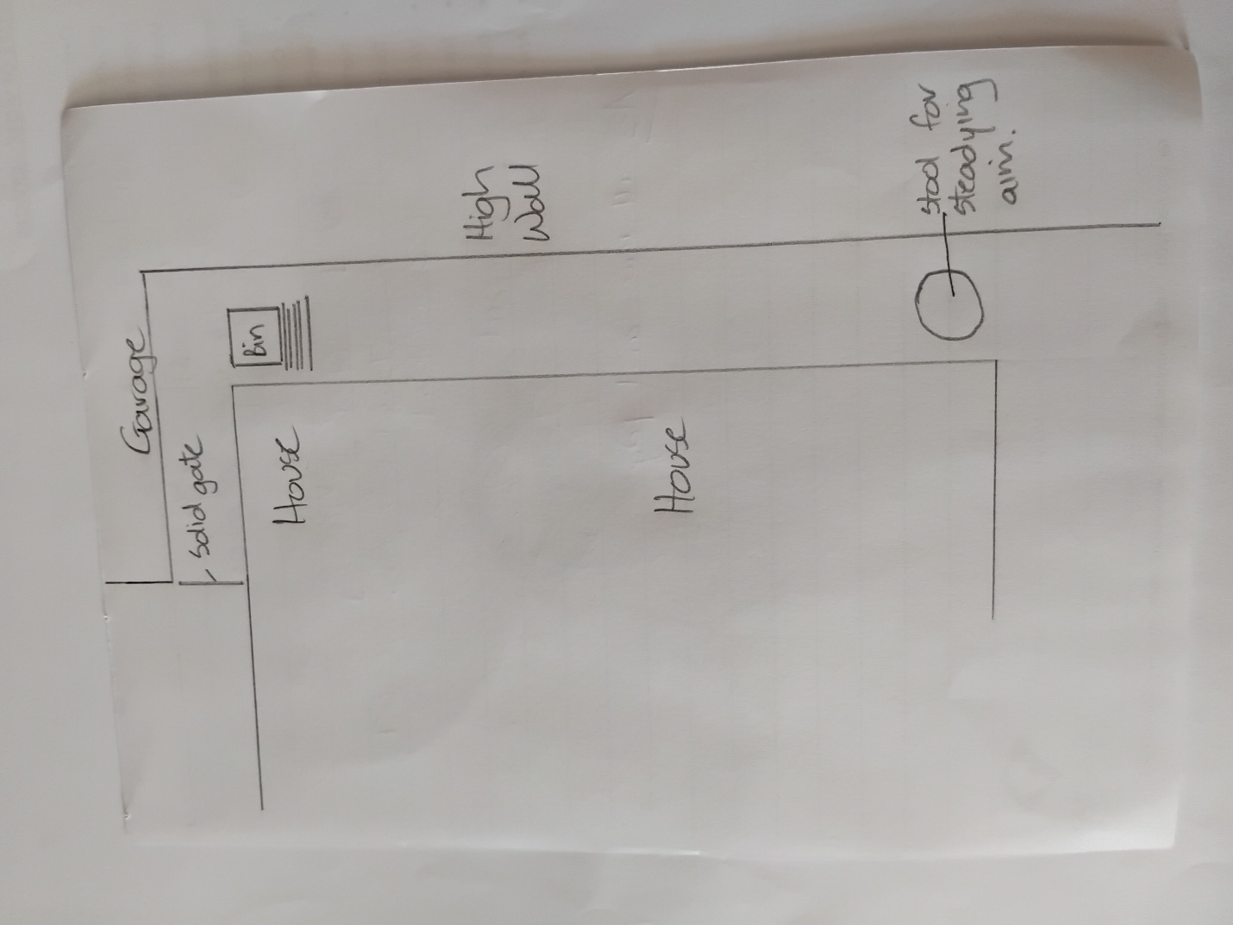

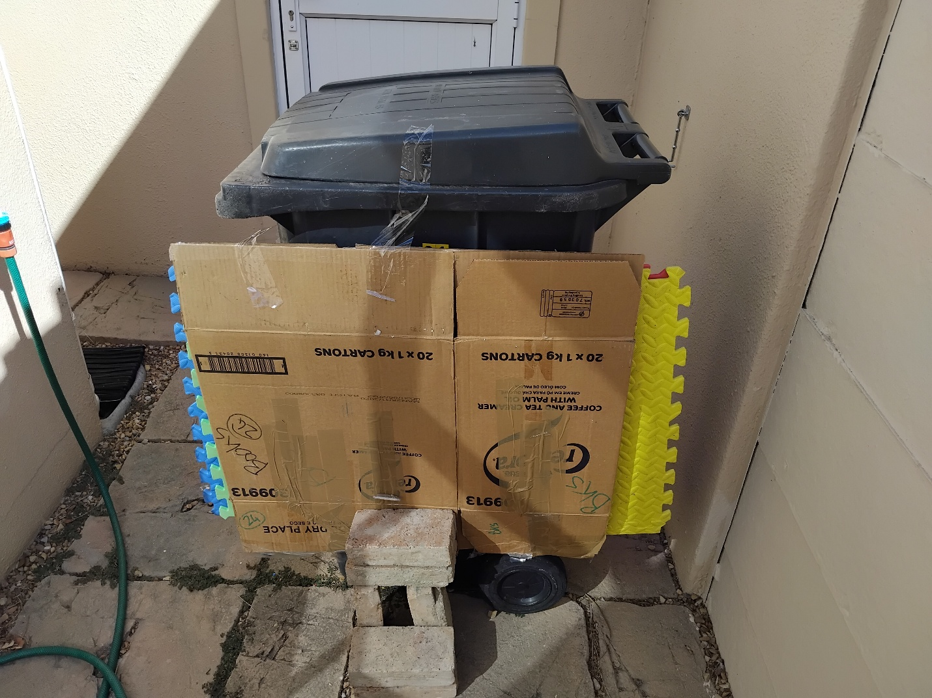
Safe target with double cardboard and 4 rubber mat backstop.
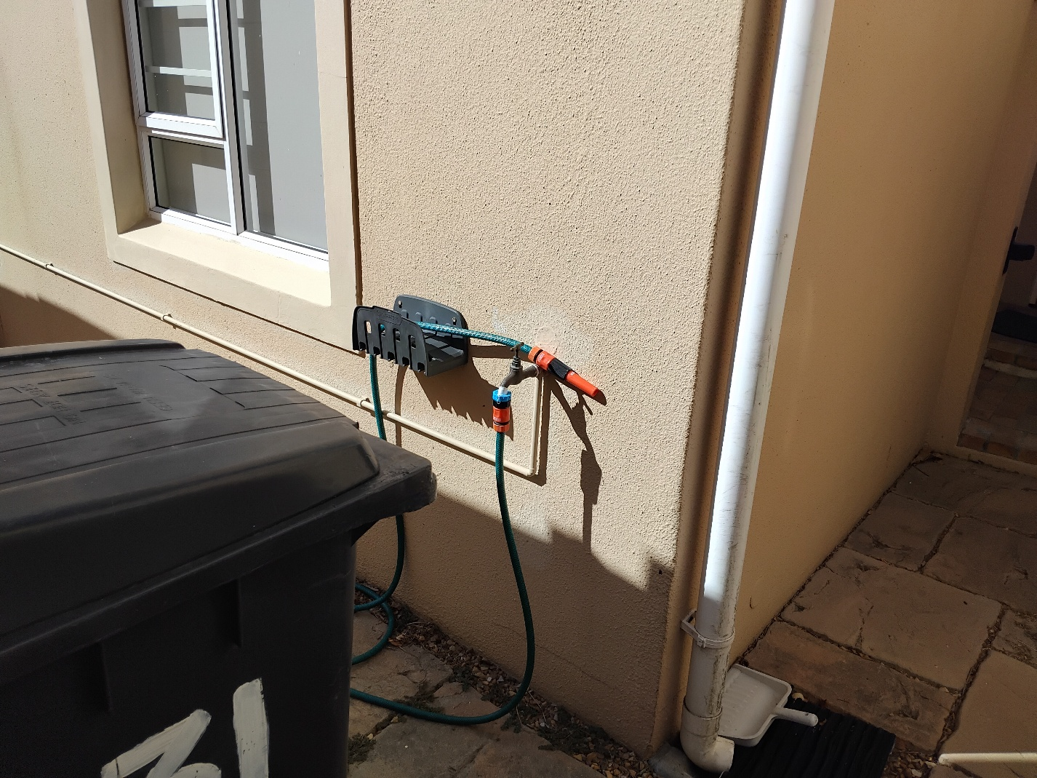
Placement of trolley bin, before the passage leading to the solid door/gate.
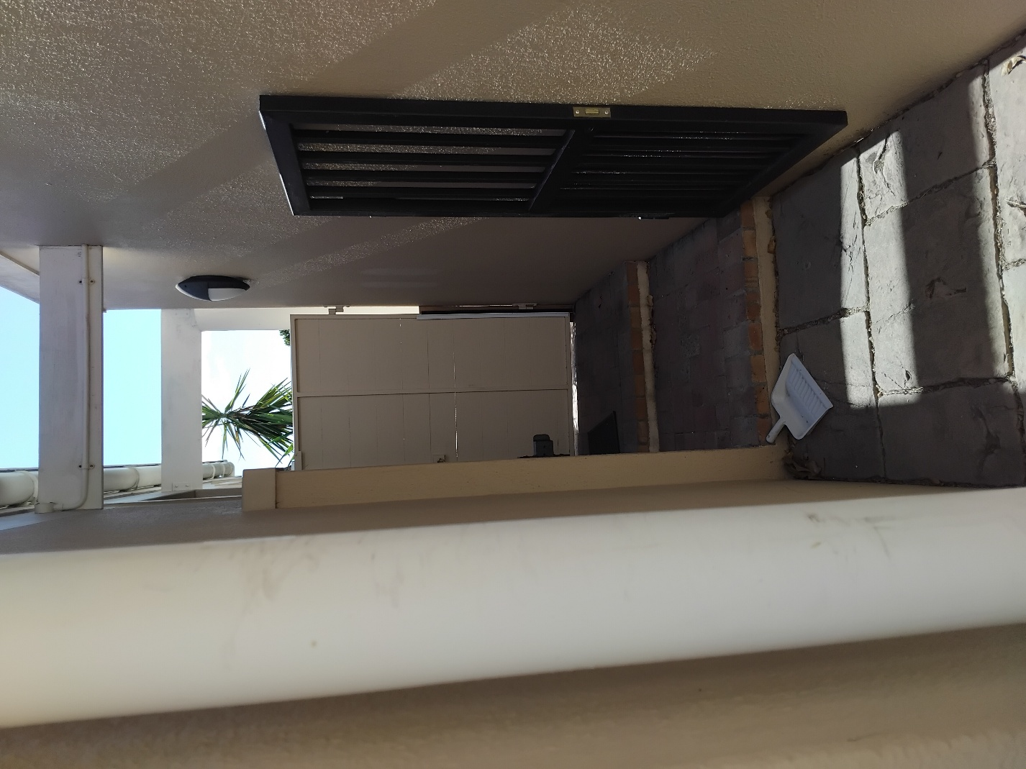
Solid door/gate
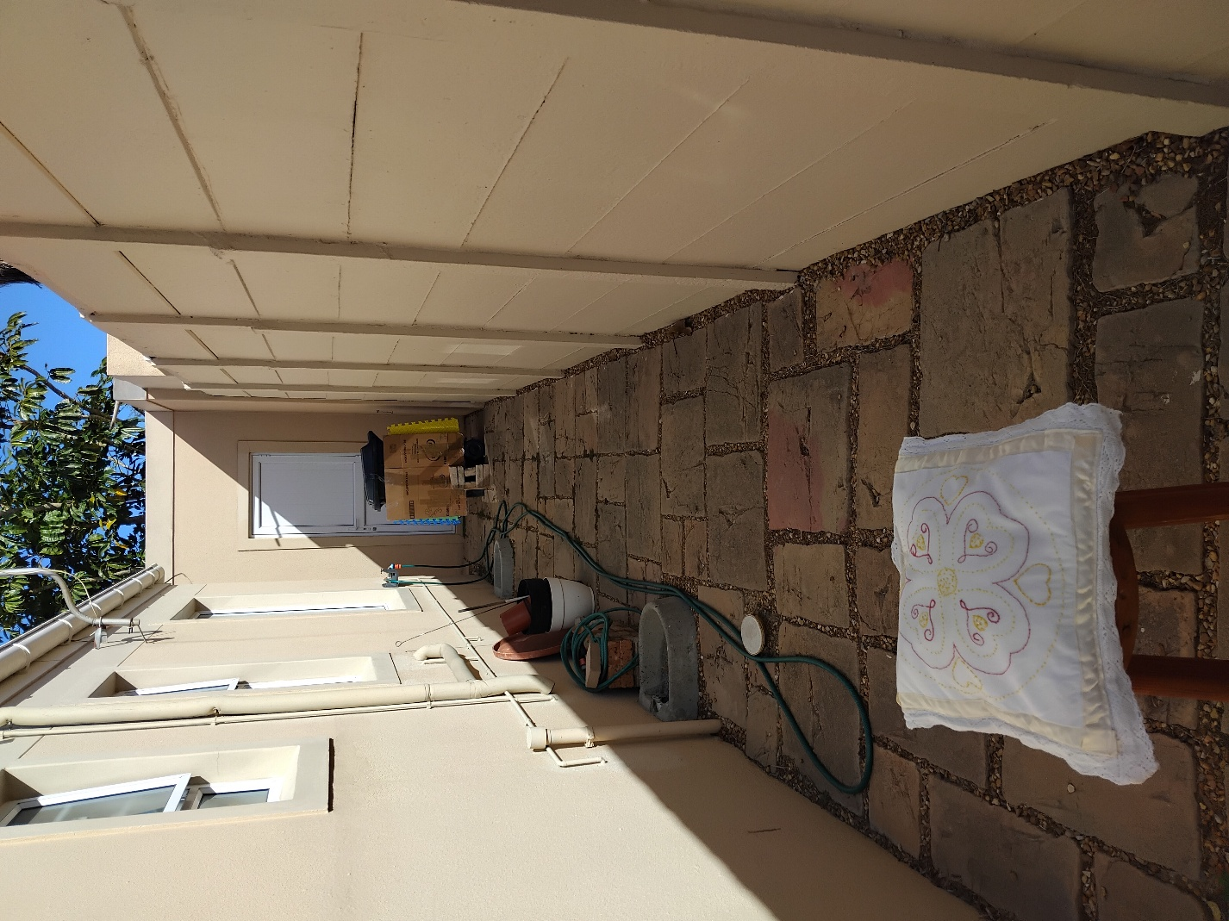
Shooting range area, showing stool with cushion used to steady aim of airgun.
Shows safe direction of shooting. There was no way that a pellet could have left the premises.
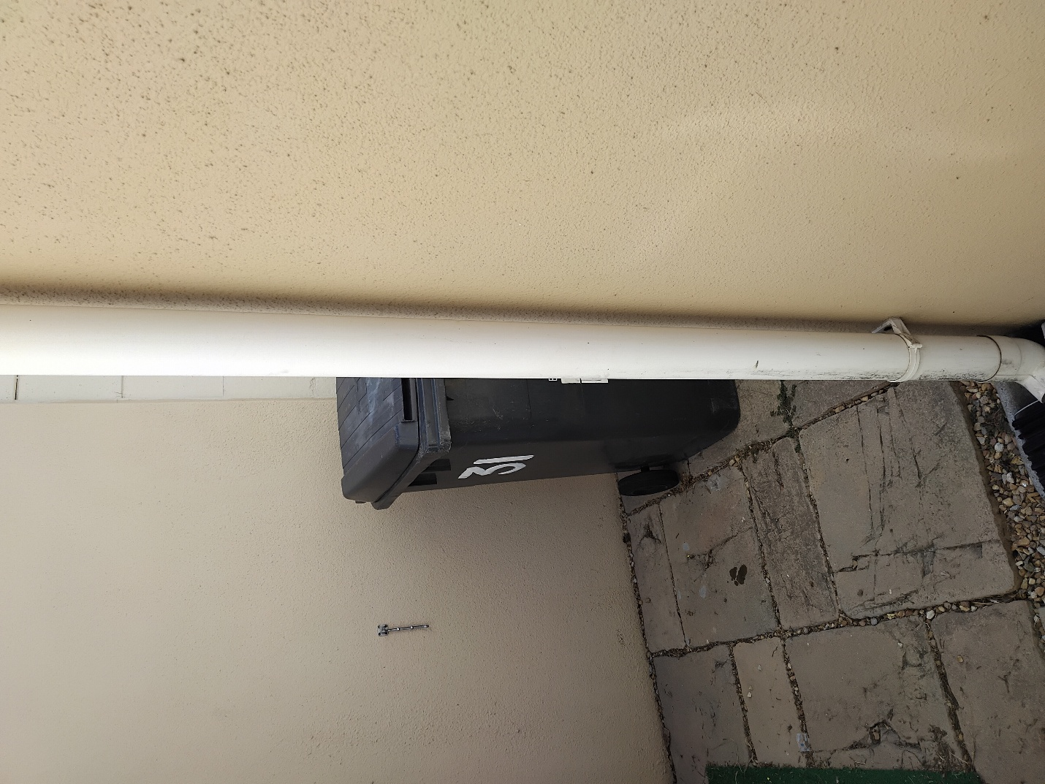
View of back of trolley bin from the solid door/gate.

