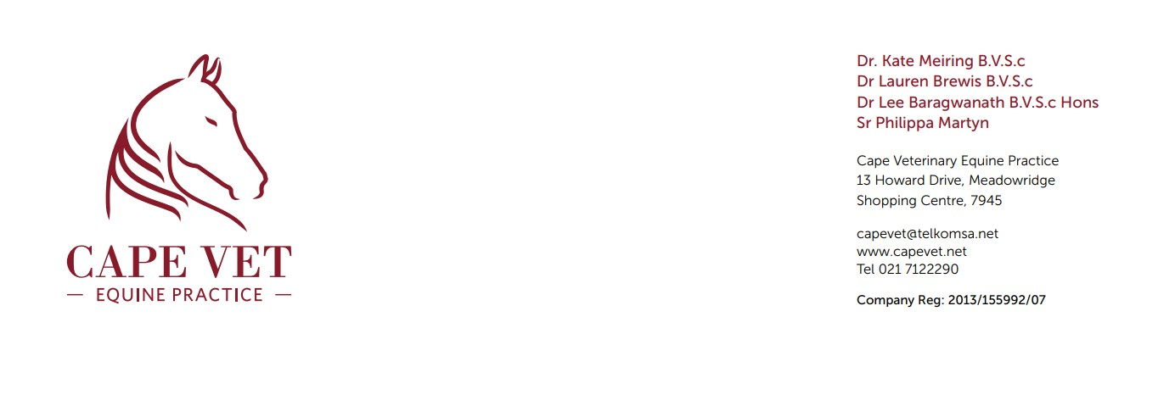TO WHOM IT MAY CONCERN:
On Thursday 6th March 2025 at approximately 10h00 Inspector Mark Syce presented me with a young, emaciated colt who had been confiscated the previous day.
Animal Details:
SPCA admission number: A57842
Species: Equine Breed: Hackney Sex: Colt Colour: Chestnut
Age: 3.5 years Name: None
Clinical Examination:
The colt was starving when he was presented to me, he was eating his teff nett greedily. Temperature 37.2, pulse 40 and respiration 16, colour is light pink, where are all normal. His teeth were moderately sharp, which can cause discomfort, but there was no obvious ulceration, and he was able to eat and chew well. He had a body score of 2/5 with no muscular. Please see images below.
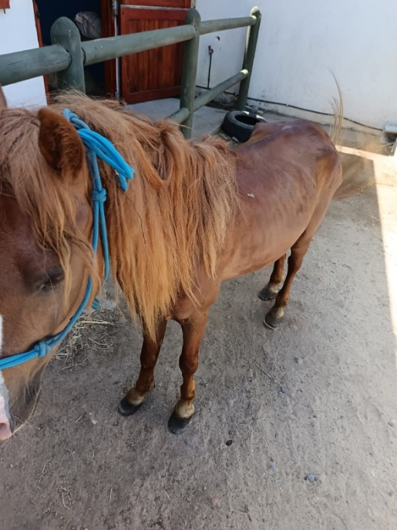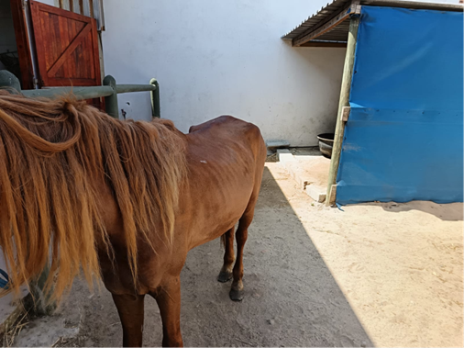
Prominent spine and prominent hip bones

Although he was absolutely starving, he was easy to work with and when trotted in hand, was reluctant to move but sound when he did trot out. The feet were badly neglected, in need of trimming.
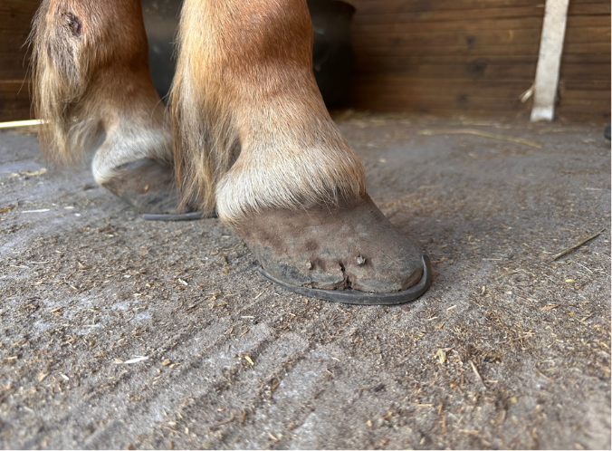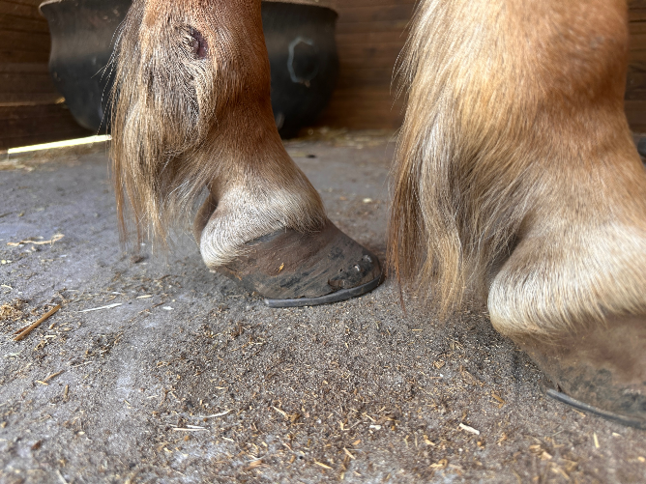
No animal should have to suffer these painful and inhumane living conditions, he has suffered unduly and should not be neglected any further.
Please feel free to contact me should you have any further questions.
Kind Regards,
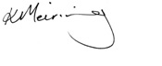
Dr Kate Meiring
0823238703

