8 Faure Street  Malmesbury  022 487 1157 | 42 Main Street  Riebeek-Kasteel  082 089 1234
PO Box 298, Malmesbury, 7299
E-mail: admin@groenkloofdierekliniek.co.za
Website: www.groenkloofdierekliniek.co.za
Emergency no.: 081 855 0301
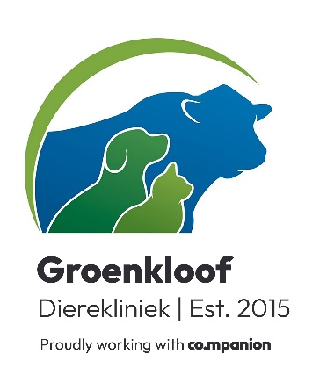
19 February 2025

To whom it may concern,

Re Warning nr 13620, issued at Ndabeni.

# No microchip number was provided, and the wrong name was given to the dog. Please provide a microchip number in future as this will enable us to ID the dog correctly.
# Please do not issue these requests on a Friday. As a veterinary practice we are open and available on a limited basis on a weekend. It makes it very difficult to provide a report in due time.

On 18 February Eike (Sasha), GSD, Microchip number 933071000243095 was brought to our clinic for an examination.

The main request was that a general check-up should be done specifically regarding the hips.
Under general anaesthesia x-rays were taken and the following was found:
- Severe degeneration of R/femur head and neck as well as osteophytes.
- Severe flattening of R/femur head.
- Dorsal bone loss on R/femur head
- Mild flattening of L/femur head with osteophytes
- Bone loss on dorsal aspect of L/femur head

Conclusion:
Dog was found unfit for work and euthanized.

If any further information is required, please feel free to contact me.

Vriendelike groete/Kind regards

Dr NJ Heyns
Tel: 022 487 1157
8 Faurestreet, Malmesbury
