PHOTOGRAPHIC EVIDENCE

Address photos taken: C/O First road and 1st Avenue, Grassy Park, Cape Town
Owner of animal/s: Ms Cody-Leigh George / Mr Mark George
Date photos taken: 24 February 2025
Photos taken by: Insp. RP Philander
Photos taken with: iPhone 11 Cell Phone
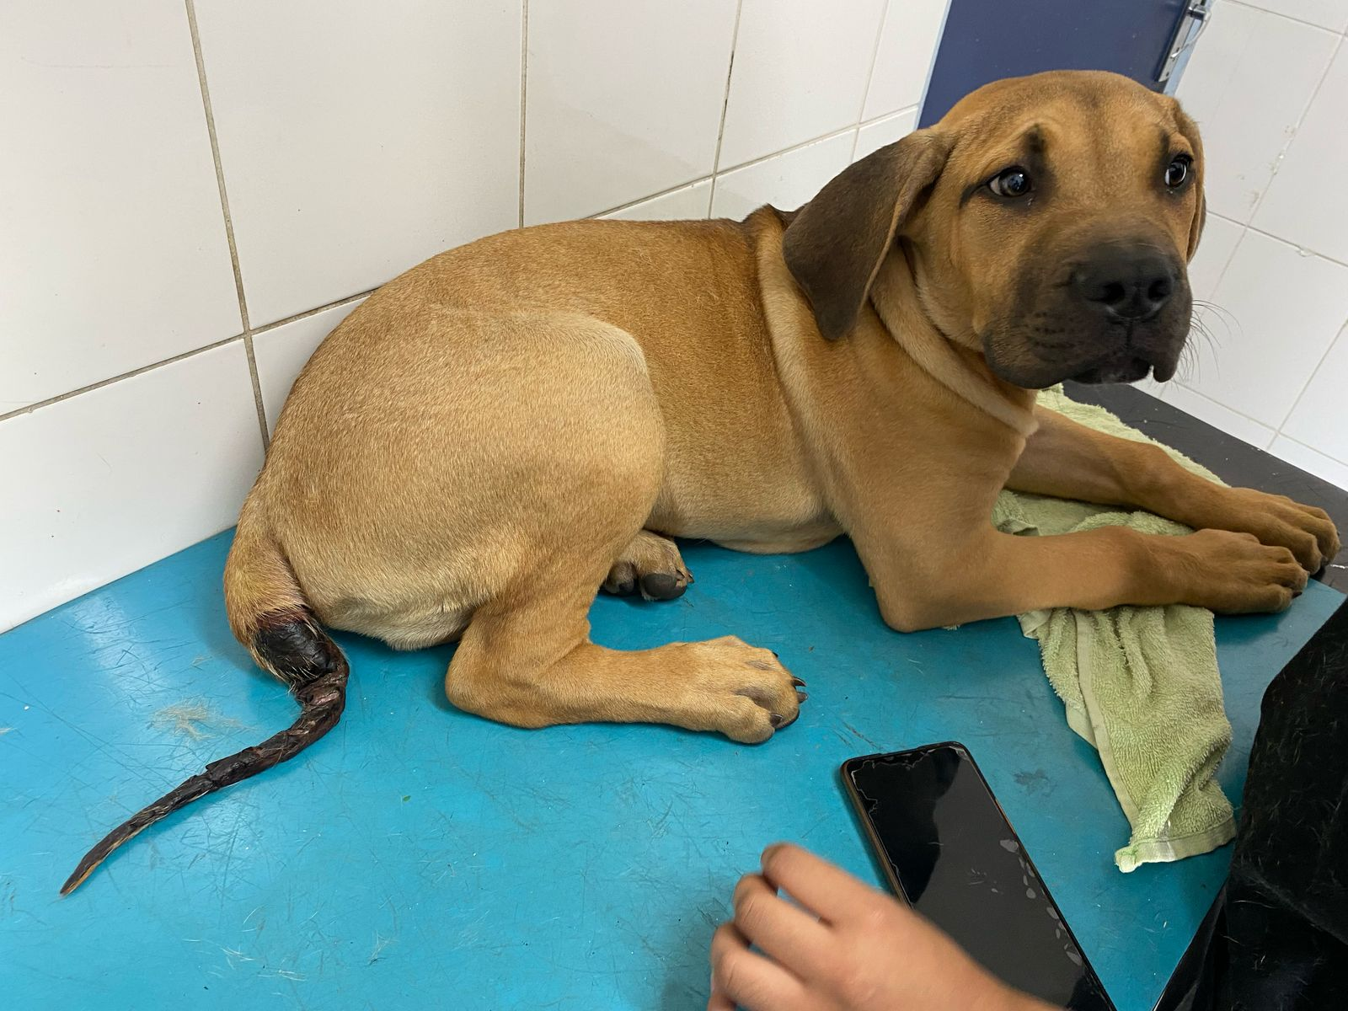
Picture 1:
Full view of dog named at the SPCA Hospital, consultation room 3
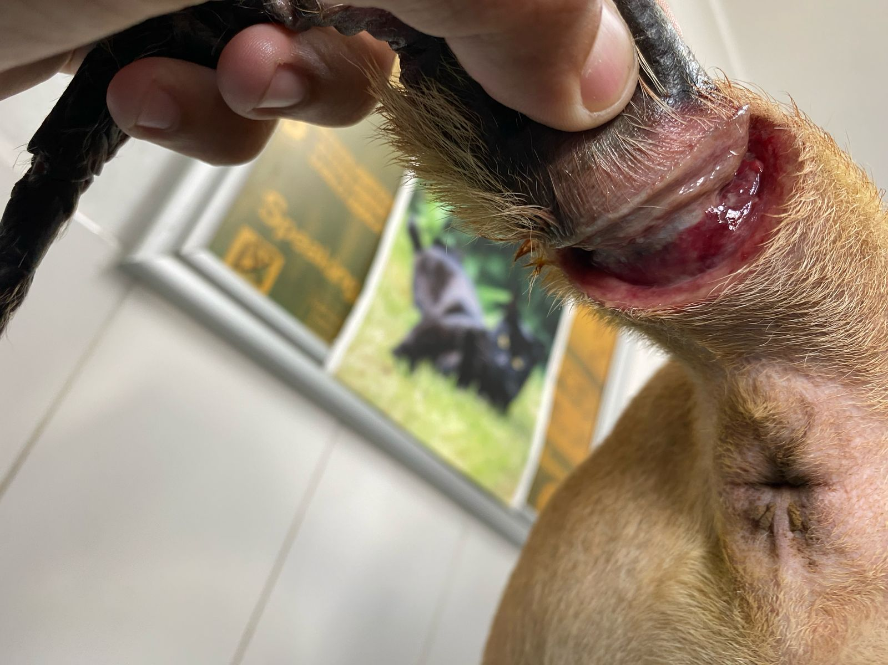
Picture 2:
Close up of the cut that was made on the dogs’ tail, photo taken in consultation room, SPCA Hospital
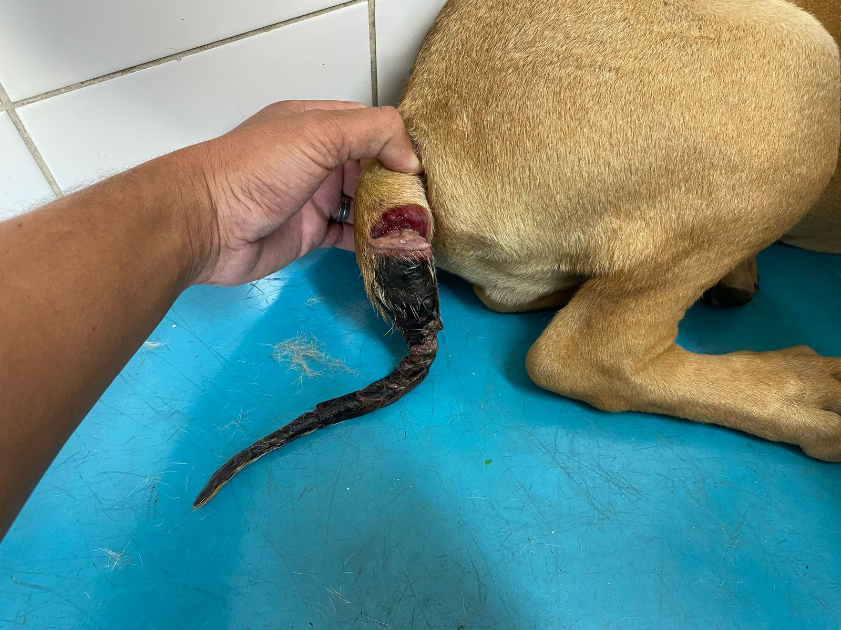
Picture 3:
Full view of the dogs’ tail and the deep cut on the tail at the SPCA Hospital

