To Whom It May Concern,

Re: Support And Fostering of Rescue Animals

This letter serves to confirm that Ami Chantel Stemmet, with ID number 9005220539084, residing at 39 Tulbagh Road, Richwood, 7441, is currently assisting me with rescuing animals. Ami is also fostering animals on my behalf until they are placed in permanent homes.

She also takes them to the vet when needed and we cannot help them anymore on our own.

I appreciate her dedication and support in caring for these animals during the rescue and rehoming process.

If you require further information, feel free to contact me.

With heartfelt thanks,

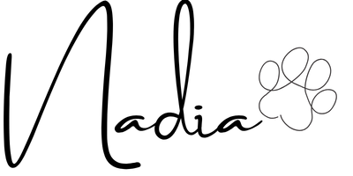

Nadia Diedericks
Founder, Loving Paws NPC
079 596 3336

