
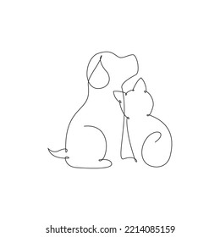
184 Blue Downs way, Tuscany Glen,
Blue Downs, 7100
Tel: (021) 909-1599
Email: bluedownsanimalclinic@outlook.com

Blue Downs Animal Clinic
Reg. No. CK 1995/024524/23
Practice No: Fcl 97/0026

06/09/2024

TO WHOM IT MAY CONCERN

Owner: Mrs Magnolian Joubert,
44 Princess drive, Condor Park,
Eersteriver, 7100.
Contact no: 068 197 5639

Patient: Nisha, X GSD, Female
DOB: 2016

Weight: 15.35kg
Review Wounds. Crusts possibly scratched off. Cleaned wounds and applied acriflavine glycerine.

Duplocillin 1.5ml. Dispensed prednisone 5mg x 14 tabs; Bioscrub for wound cleaning
Follow up scheduled for 16 September 2024.

Kind regards

Blue Downs Animal Clinic Team

