
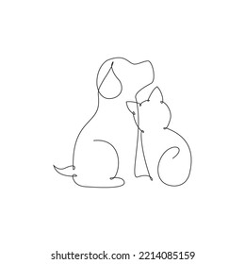
184 Blue Downs way, Tuscany Glen,
Blue Downs, 7100
Tel: (021) 909-1599
Email: bluedownsanimalclinic@outlook.com

Blue Downs Animal Clinic
Reg. No. CK 1995/024524/23
Practice No: Fcl 97/0026

23 August 2024

TO WHOM IT MAY CONCERN

Owner: Mrs Sharon Ross
Address: 23 Beauville crescent
Malibu Village
Blue Downs, 7100
Contact no: 0787282355/Elroy: 0610304793

Patients: Lady a cross GSD female (DOB:03/2023) And Whiskey ac cross Rottweiler Male |(DOB:
02/09/2021)

Lady Weight: 17.5kg
Whiskey Weight: 24.8kg

I hereby confirm that I have, this day at the request of Mr E Ross, Examined his two dogs, Lady (bitch GSD) and Whiskey (male RW). Both dogs are very thin and underweight. They both appear to be clinically healthy and no signs of parasites or illness present.

The owner changed from feeding them with Montego dog food to Rimax (a lower cost food) at the same rate of daily feed. On this they began to lose weight.
I have advised him to return to the feeding of Montego and explained how the feeding instructions on the bag should be followed. The dogs will be re-examined and weighed in two weeks time and to assess the effect of a better feeding regimen.

We’ll do a check up in 14 days time.

Kind regards

Blue Downs Animal Clinic Team
DR JC Austin

