INSP198757 INVESTIGATION FINDINGS

It was said by the complainant that the mother of the suspect is Monica on 062 595 4856.

The number has been registered as ‘Monica November’ on TrueCaller.
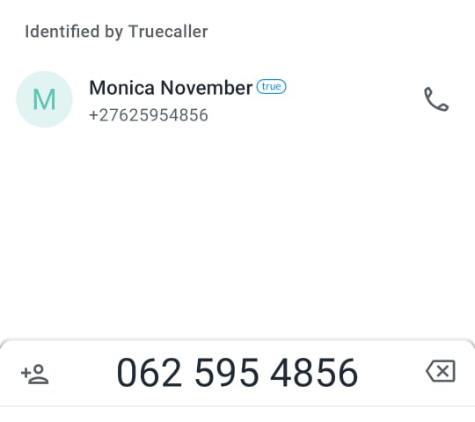

On Facebook, a Monica November that was friends with 2 x ‘Jethro November’ was found.
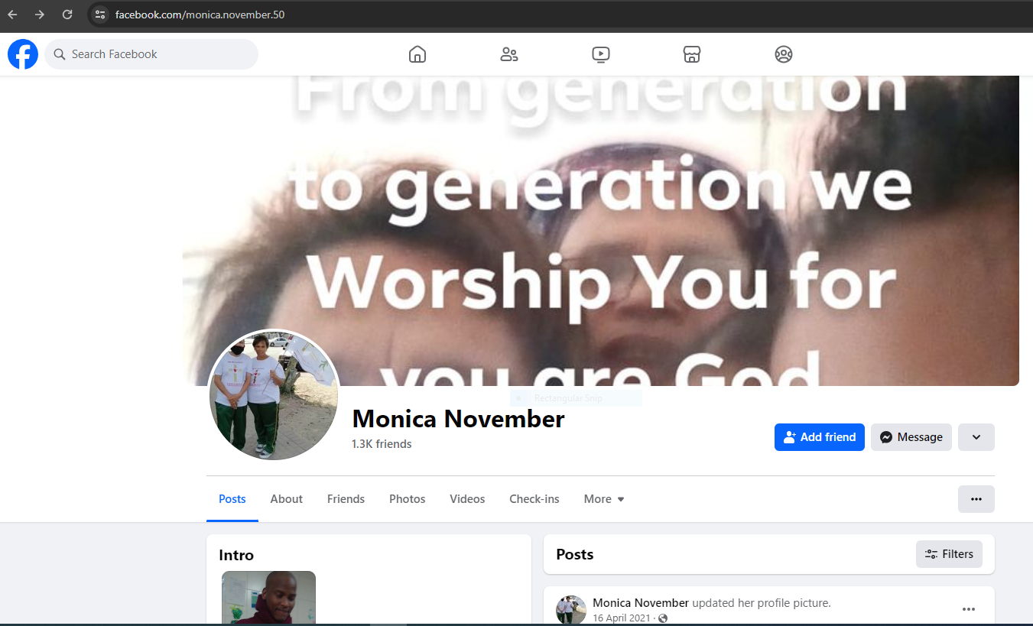
https://www.facebook.com/monica.november.50

Using this profile, Monica November made a post about Jethro November’s, her son’s, Facebook page.

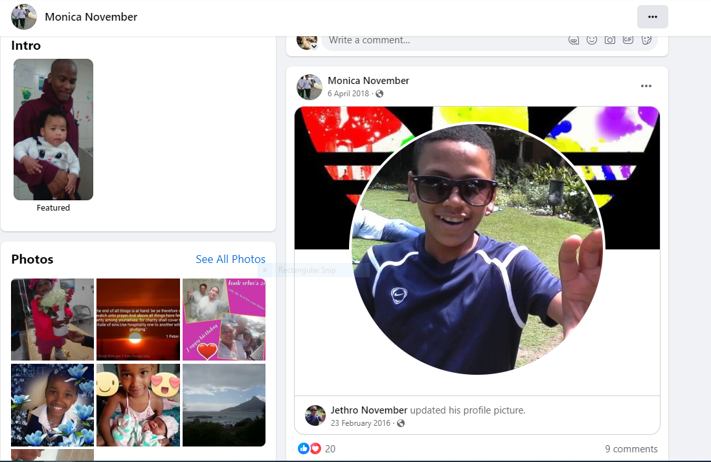

The post was made 6 years ago and stated that Jethro was a teenager.

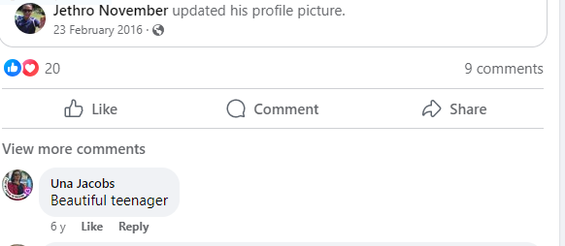

Currently, there is now only 1 Jethro November that she is following.

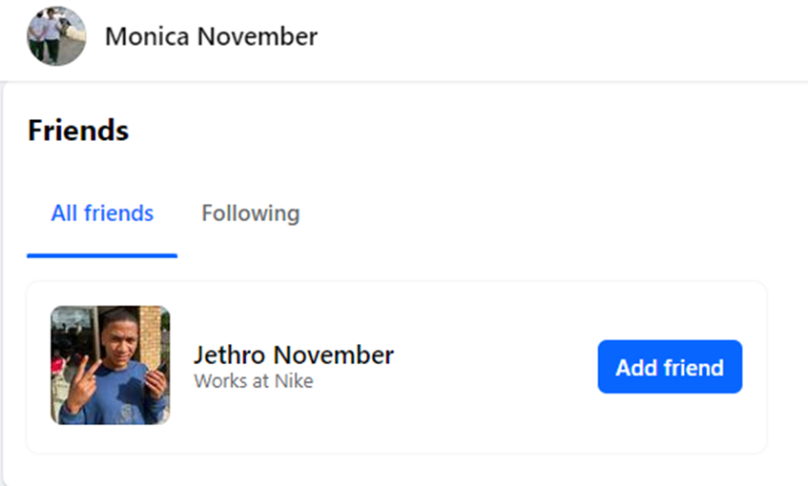

https://www.facebook.com/jethro.november.3
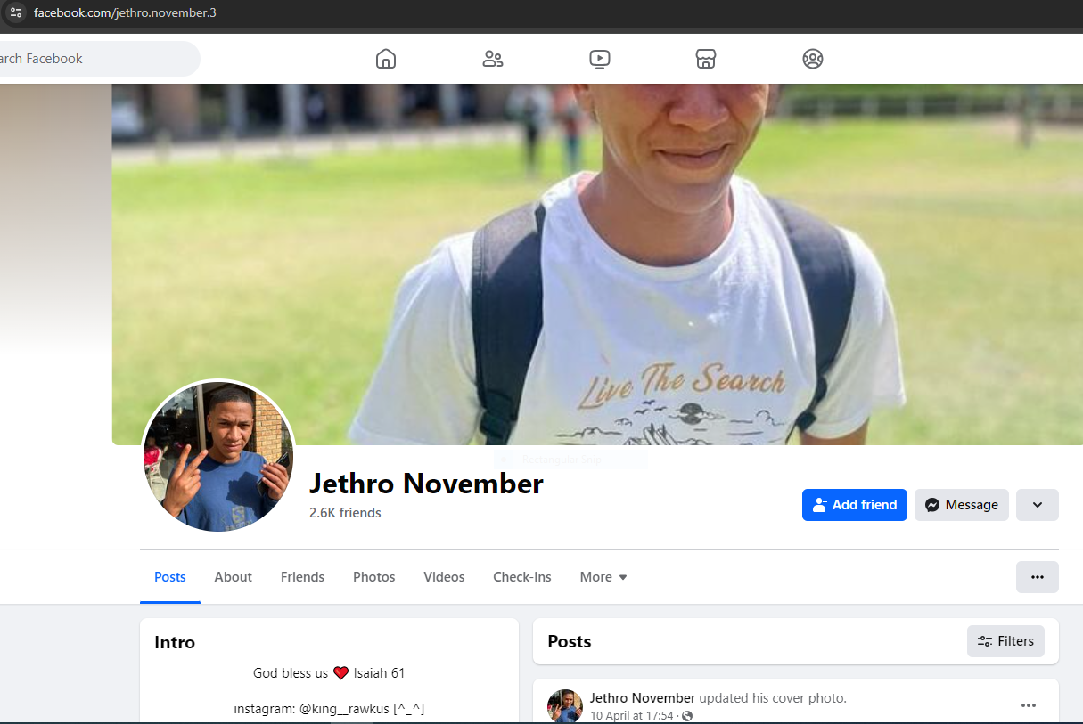

Viewing this profile, it means that Jethro matriculated in November 2023. Therefore, he must be at least 17 years old but is most likely older.

