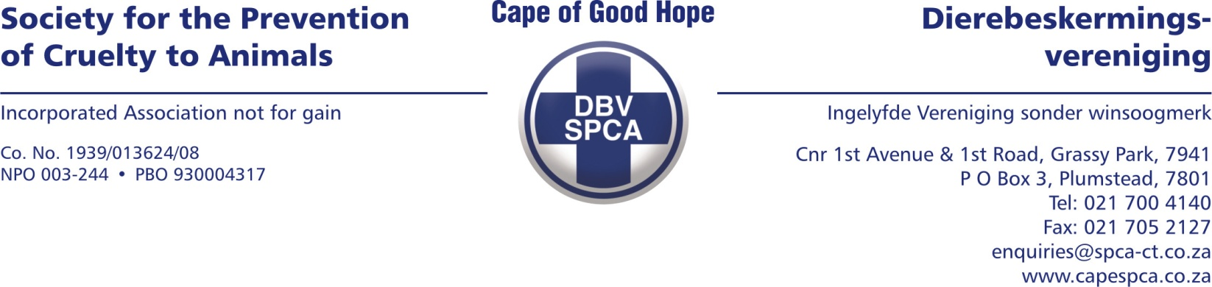

VETERINARY REPORT

To whom it may concern, the below animal was confiscated by Jeffrey Mfini from 111 Cypress Way, Westridge , Mitchell’s plain on the 15/2/24 at approximately 9;40 am.

ANIMAL DETAILS

Species: Canine
Breed: Pitbull Crossbreed
Sex: Female
Age: Puppy
Tattoo/Microchip/Other: Nil
Name: No name
Description: Black and white
Weight: 4.52kg
Admission number: A29870

EXAMINATION FINDINGS

Inspector Jeffrey brought the canine to the examination theater, where the puppy demonstrated alertness and responsiveness despite manifesting signs of mild dehydration. Clinical parameters were generally within normal limits, except for the observed slight dehydration.

Notably, the puppy exhibited a distressing state, evidenced by the severity of dirtiness and a burdensome infestation of ticks and fleas. Unfortunately, obtaining a comprehensive vaccination or deworming history proved unattainable, further complicating the assessment of the puppy's overall health and well-being

COMMENTS

In my assessment, there is a discernible indication that the animal has undergone a period of neglect, as evidenced by the notable olfactory presence of urine and the pronounced state of uncleanliness.
Yours sincerely
Dr Lerato Nedzanani (BVSc)
Veterinarian

Date compiled: 15/02/2024

VETERINARY REPORT

To whom it may concern, the below animal was confiscated by Jeffrey Mfini from 111 Cypress Way, Westridge , Mitchell’s plain on the 15/2/24 at approximately 9;40 am.

ANIMAL DETAILS

Species: Feline
Breed: DSH
Sex: Female
Age: Kitten
Tattoo/Microchip/Other: Nil
Name: No name
Description: White/ Tabby
Weight: kg
Admission number: A29866

EXAMINATION FINDINGS

Inspector Jeffry Mfini brought the kitten to the examination theater, where it was observed to be in a critical condition.

The feline presented with a collapse, severe pain, significant dehydration, and an unmistakable odor of urine. Notably, the body temperature was recorded at 38.5 degrees Celsius, and the mucus membranes displayed a pallid hue. Additionally, a severe flea infestation was evident, with observable fleas and a body condition score of 2/9 as per the Purina Body Condition System.

X- rays confirmed the heniation

Upon abdominal examination, a protrusion approximately the size of a small peach was palpated. Given the overall poor condition and the extent of distress, a decision was made to euthanize the kitten.

COMMENTS

In my assessment, it is apparent that the animal underwent considerable distress attributable to severe herniation, leading to profound pain. Regrettably, the kitten did not receive requisite veterinary intervention, enduring prolonged suffering without access to pain medication or appropriate treatment until the humane decision to euthanize was made.

Yours sincerely
Dr Lerato Nedzanani (BVSc)
Veterinarian

Date compiled: 15/02/2024

VETERINARY REPORT

To whom it may concern, the below animal was confiscated by Jeffrey Mfini from 111 Cypress Way, Westridge , Mitchell’s plain on the 15/2/24 at approximately 9;40 am.

ANIMAL DETAILS

Species: Feline
Breed: DSH
Sex: Female
Age: Kitten
Tattoo/Microchip/Other: Nil
Name: No name
Description: White/ Tabby
Weight: 1.22kg
Admission number: A29867

EXAMINATION FINDINGS
Inspector Jeffry Mfini brought the kitten to the examination theatre, where it was observed to be bright, alert, and responsive, albeit with indications of slight dehydration and a noticeable scent of urine.

The recorded body temperature was 37.5 degrees Celsius. The feline also exhibited a severe flea infestation, with fleas observed throughout the entire body, and a body condition score of 2.5/9 as per the Purina Body Condition System.

It was evident from the poor body condition and the distinct odour that this kitten had experienced neglect, suggesting that it had not been maintained in an environment conducive to expressing natural behaviours.
COMMENTS
In my assessment, it is evident that the animal must have initially lived in conditions that were presumably appealing, given its initial state of alertness and responsiveness. However, the subsequent observed signs of neglect, such as the slight dehydration, odour of urine, severe flea infestation, and poor body condition score, indicate a lack of proper care and attention over time.

Yours sincerely
Dr Lerato Nedzanani (BVSc)
Veterinarian

Date compiled: 15/02/2024

VETERINARY REPORT

To whom it may concern, the below animal was confiscated by Jeffrey Mfini from 111 Cypress Way, Westridge , Mitchell’s plain on the 15/2/24 at approximately 9;40 am.

ANIMAL DETAILS

Species: Canine
Breed: Crossbreed
Sex: Male
Age: Adult
Tattoo/Microchip/Other: Nil
Name: Sporty
Description:
Weight: 17.0kg
Admission number: A29869

EXAMINATION FINDINGS

Inspector Jeffery Mfini brought the patient into the examination theatres.

Upon presentation, the patient exhibited a state of brightness, alertness, and responsiveness, with all clinical parameters falling within normal limits. However, the patient's coat was found to be infected with ticks and fleas.

Notably, the patient displayed signs of aggression towards other dogs, suggesting a lack of socialization. This behavioural observation indicates a potential deficit in exposure to social interactions with other dogs, contributing to the observed aggression.

COMMENTS
In my assessment, it appears that the animal was not well-maintained, given the presence of a significant tick and flea burden. Such infestations can adversely affect the quality of life for the patient and potentially predispose them to hemiparasites. Addressing these external parasites is crucial not only for the animal's immediate well-being but also for the prevention of potential health complications associated with such infestations.

Yours sincerely

Dr Lerato Nedzanani (BVSc)
Veterinarian
Date compiled: 15/02/2024

VETERINARY REPORT

To whom it may concern, the below animal was confiscated by Jeffrey Mfini from 111 Cypress Way, Westridge , Mitchell’s plain on the 15/2/24 at approximately 9;40 am.

ANIMAL DETAILS

Species: Canine
Breed: Pitbull
Sex: Female
Age: Adult
Tattoo/Microchip/Other: Nil
Name: Zoey
Description: Brown and white
Weight: 17.86kg
Admission number: A29868

EXAMINATION FINDINGS

Inspector Jeffrey brought the patient to the examination theater.

The patient displayed alertness and responsiveness upon presentation, accompanied by heightened nervousness. A slight dehydration was noted, although clinical parameters were within normal limits. Additionally, the patient was identified as being heavily pregnant, with a body condition score of 4/9.

The patient presented with notable dirtiness, a tick burden, and an apparent skin condition, likely stemming from the irritation caused by the pervasive ticks and fleas covering her body. Addressing these concerns is imperative for both the immediate well-being of the patient and the health of her unborn offspring.

COMMENTS

In my assessment, there is a discernible indication that the animal has experienced a period of neglect, as evidenced by the noticeable odour of urine and the marked level of dirtiness observed. This neglect likely contributed to the overall state of the animal's hygiene and well-being.

Yours sincerely
Dr Lerato Nedzanani (BVSc)
Veterinarian

Date compiled: 15/02/2024

