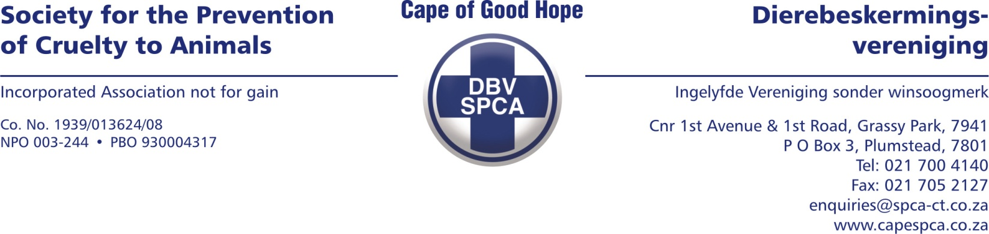

VETERINARY REPORT

To whom it may concern:

On 26 September 2024 at 16:40 , SPCA Inspector Lee Prins confiscated a dog from 5 Bax Street, Bothasig area due to refusal of Veterinary treatment.

ANIMAL DETAILS

Species: Canine
Breed: Mixed breed; medium size
Sex: Female
Age: +- 7 years
Tattoo/Microchip/Other: Nil
Name: A 34299
Description: Long-haired coat, tan coloured. Admission 34299

EXAMINATION FINDINGS

- Description: Severe attrition of incisors and canines, couple of molars missing. Atrophy of gluteal muscles, weak hind quarters. On X-rays findings were as follow:
  - Severe lumbo-sacral spondylosis and ankylosis (bridging spondylosis)
  - Severe left hip dysplasia
  - Severe arthritic changes seen bilaterally in stifle region.
- Duration: Chronic.
- Cause : Most likely old age. Since spondylosis and arthritis is a degenerative, non-curative disease. It will only get worse as time proceeds. Because of the pain in hindquarters and back, this contributes to the dog being reluctant to walk and leads to atrophy of the muscles.
- Prognosis: Poor . Since arthritis and spondylosis is a painful and non-curative condition, this dog is suffering unnecessarily. This dog is also not suitable for adoption. Since the dental state of this dog is poor, eating abilities is limited and will contribute to poor body condition of the dog.
- Recommendation : Recommend for ethics , since the dog is in pain and old aged.
COMMENTS

I recommend that we euthanize this dog , since it is a degenerative and painful condition that will worsen over time. We do not wat this dog to suffer.

Yours sincerely,
Dr K Henzen (BVSc)
Veterinarian
Date compiled: 02 October 2024

