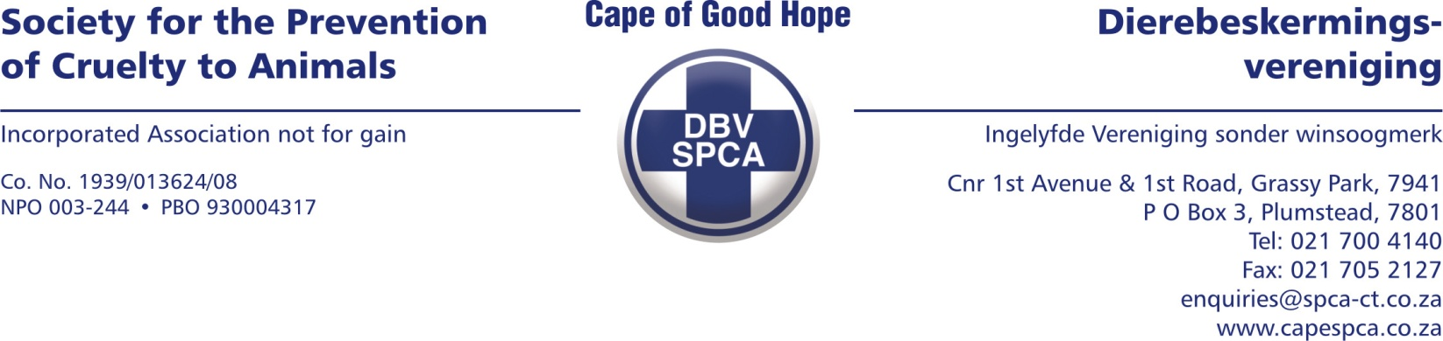

VETERINARY REPORT

On 19 April 2023, the following animal was presented to me at the Cape of Good Hope SPCA. The dog was confiscated by Inspector Lwazi Ntungele of the Cape of Good Hope SPCA.

ANIMAL DETAILS

Admission number: 97035
Species: Canine
Breed: Crossbreed
Sex: Female
Age: Adult
Tattoo/Microchip/Other: Not detected
Name: ‘Teff’
Description: Small-medium size, brown and white.

EXAMINATION FINDINGS

The dog was presented to me for clinical examination on 19/04/2023, and already in a bad condition. The dog appeared to be very scared on initial examination.

The dog was severely emaciated and had clearly been deprived of sufficient food over a prolonged period of time.

The dog’s body condition score was 2 out of 10.

There were ticks and fleas present on the dog.

COMMENTS

The dog was presented in an emaciated condition which suggests that adequate and sufficient food was not provided to the dog on a daily basis.

In my opinion, this dog was not adequately cared for with the basic requirements of pet care not provided to the dog. The dog was underfed resulting in the dog’s unnecessary suffering. Providing food to a dog on a daily basis is a basic pet care requirement.

Yours sincerely

Dr Ettienne Pieterse (BVM)
Veterinary Surgeon

Date compiled: 21 April 2023

