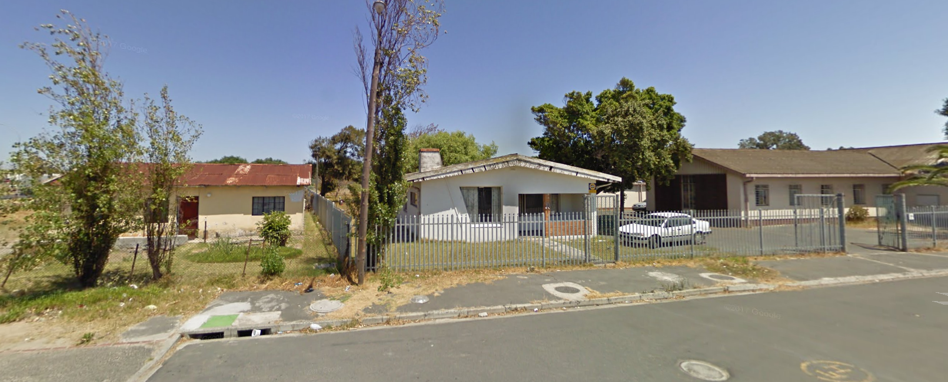
HOUSE WHERE THE DOGS ARE LIVING
Badisa, Elsies River
91, 6th Street, Elsies River

