PHOTOGRAPHIC EVIDENCE

Address photos taken: Cape of Good Hope SPCA situated on the c/o First Avenue and 1st
Road in Grassy Park
Date photos taken: 24 August 2023
Photos taken by: Insp. Carina Bodenstein
Photos taken with: Samsung A33 5G

Picture 1:
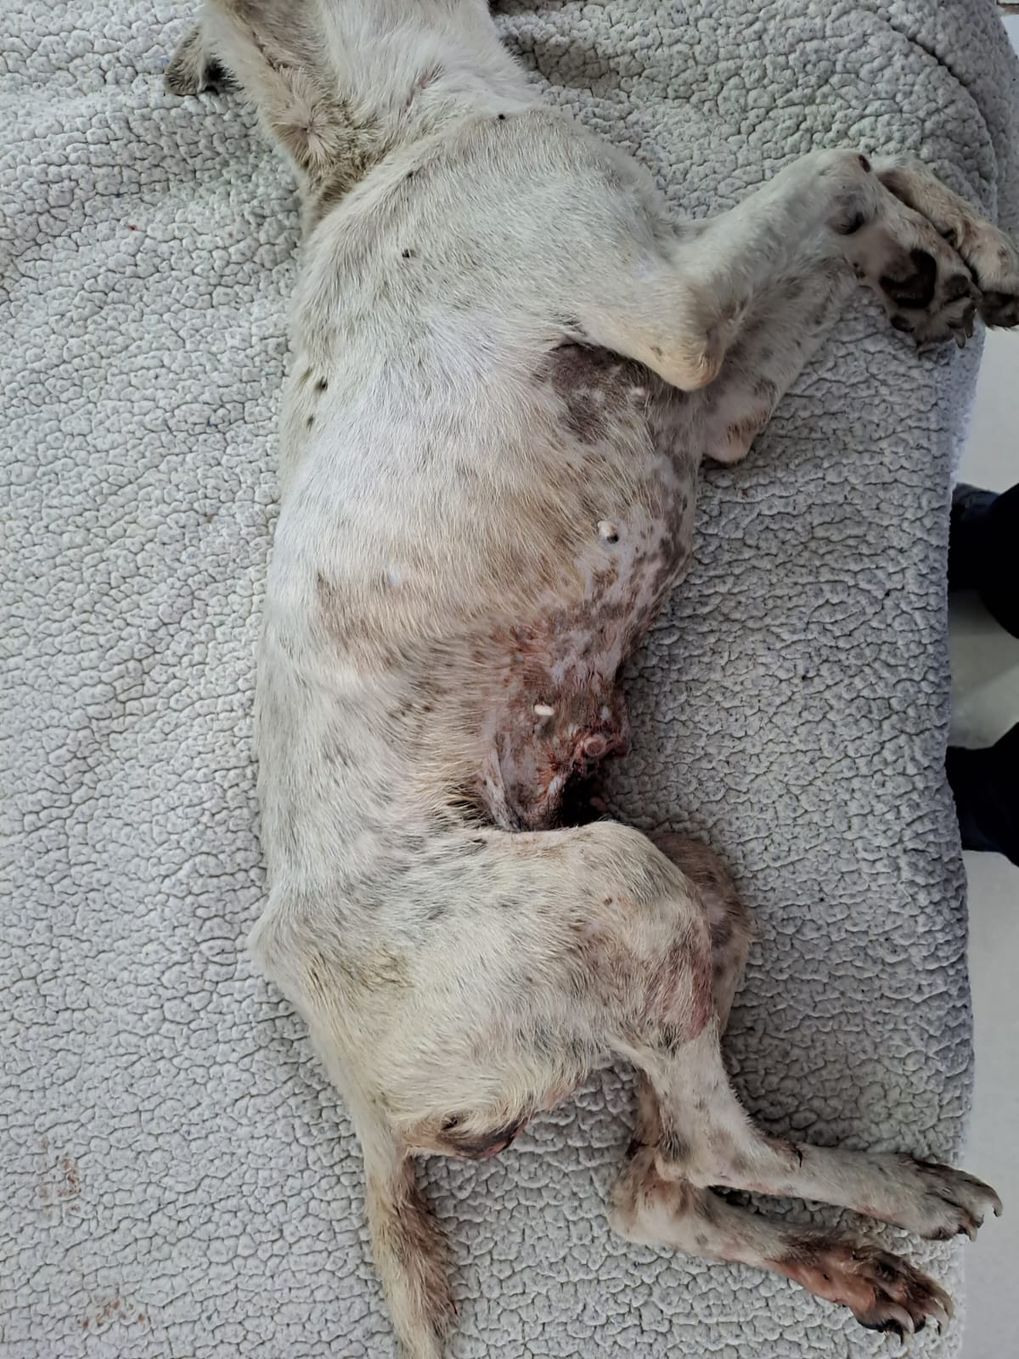
Right side – lateral view of the dog (Cross-breed type dog, white, female, adult). The dog’s underweight condition is clearly visible with the rib cage and hip bones clearly protruding. An infestation of ticks is also clearly visible on the withers and shoulder of the dog.

PHOTOGRAPHIC EVIDENCE

Address photos taken: Cape of Good Hope SPCA situated on the c/o First Avenue and 1st
Road in Grassy Park
Date photos taken: 24 August 2023
Photos taken by: Insp. Carina Bodenstein
Photos taken with: Samsung A33 5G

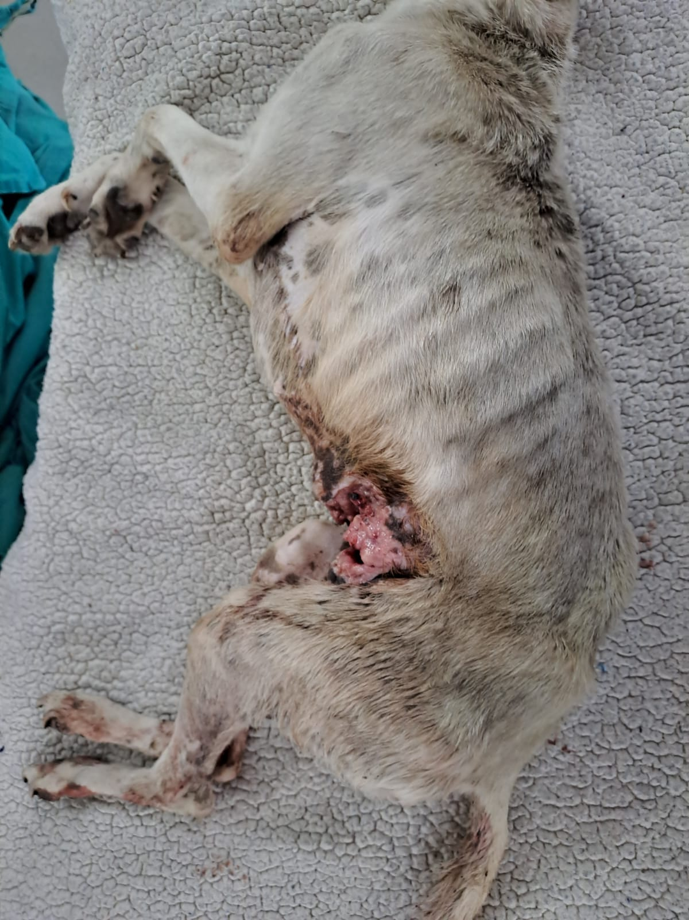
Picture 2:
Left side – lateral view of the dog (Cross-breed type dog, white, female, adult). The dog’s underweight condition is clearly visible with the rib cage and hip bones clearly protruding. The large open raw wound is also clearly visible at the flank and abdomen of the dog.

PHOTOGRAPHIC EVIDENCE

Address photos taken: Cape of Good Hope SPCA situated on the c/o First Avenue and 1st
Road in Grassy Park
Date photos taken: 24 August 2023
Photos taken by: Insp. Carina Bodenstein
Photos taken with: Samsung A33 5G

Picture 3:
Left side – lateral view of the dog (Cross-breed type dog, white, female, adult). The dog’s underweight condition is clearly visible with the rib cage and hip bones clearly protruding. The large open raw wound is also clearly visible at the flank and abdomen of the dog. Admission form “A1652” with the dog.

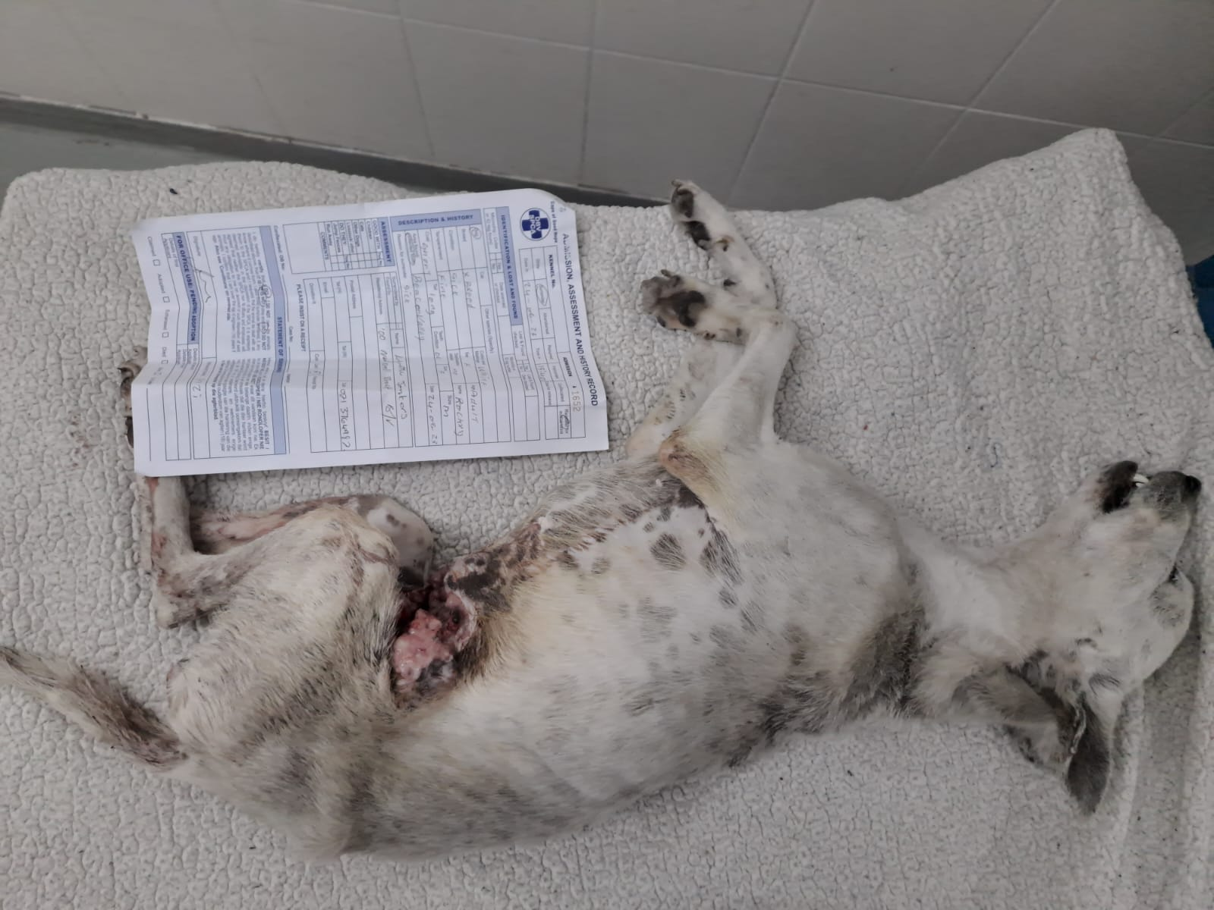

PHOTOGRAPHIC EVIDENCE

Address photos taken: Cape of Good Hope SPCA situated on the c/o First Avenue and 1st
Road in Grassy Park
Date photos taken: 24 August 2023
Photos taken by: Insp. Carina Bodenstein
Photos taken with: Samsung A33 5G

Picture 4:
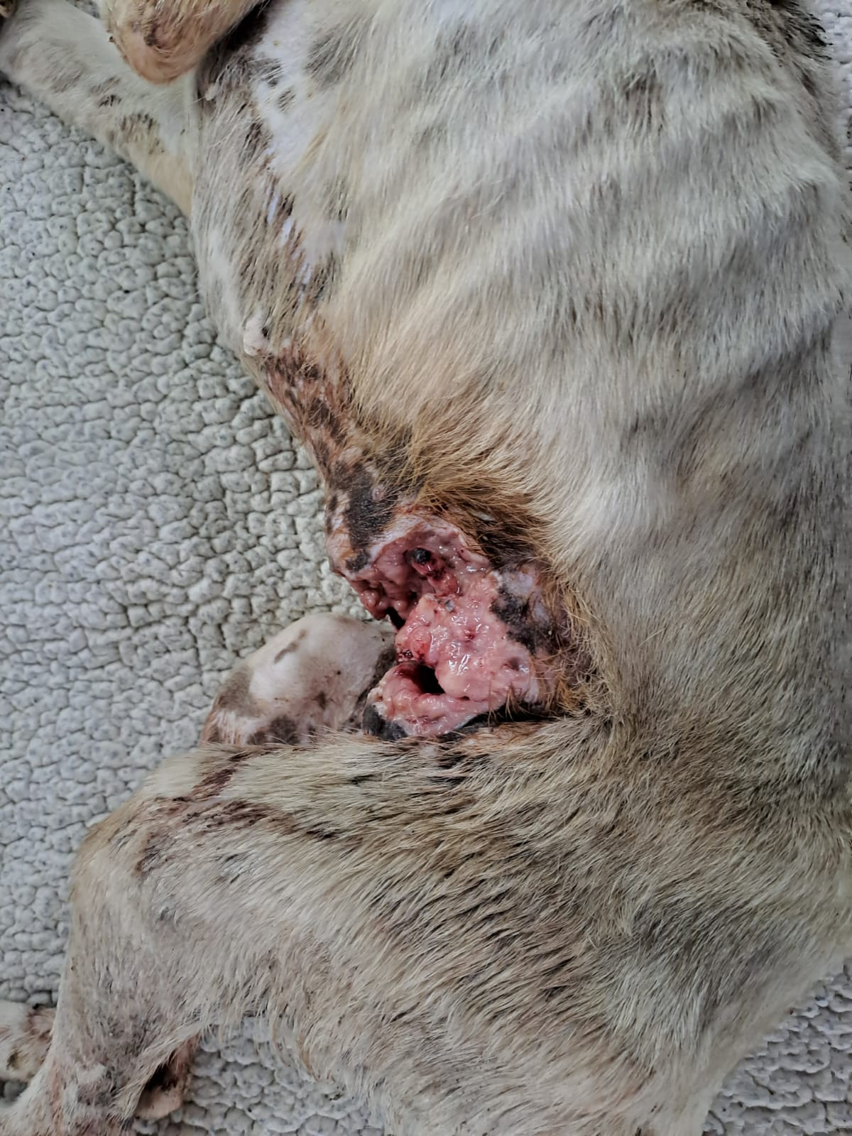
Close-up view of the left side – lateral view of the dog (Cross-breed type dog, white, female, adult). The dog’s underweight condition is clearly visible with the rib cage evidently protruding. The large open raw wound is also clearly visible at the flank and abdomen of the dog.

PHOTOGRAPHIC EVIDENCE

Address photos taken: Cape of Good Hope SPCA situated on the c/o First Avenue and 1st
Road in Grassy Park
Date photos taken: 24 August 2023
Photos taken by: Insp. Carina Bodenstein
Photos taken with: Samsung A33 5G

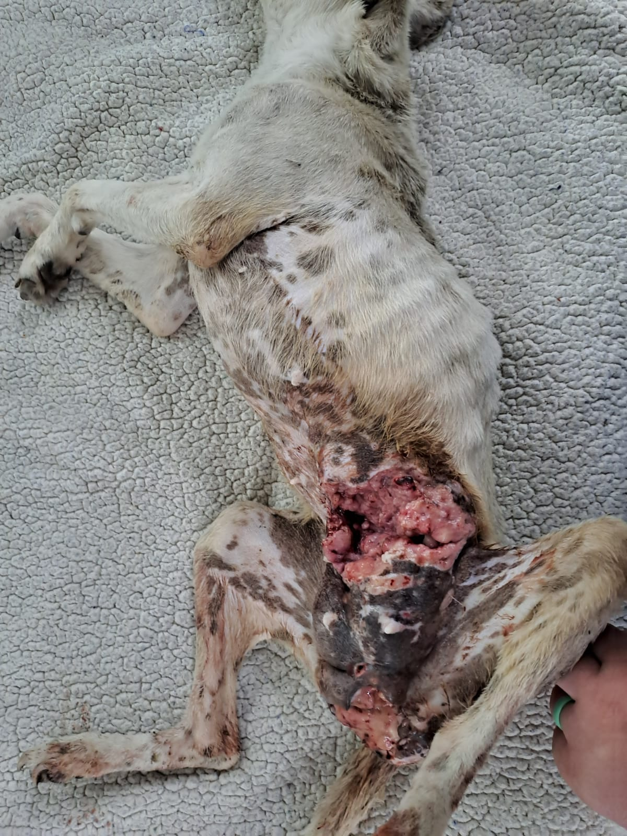
Picture 5:
Medial view of the dog (Cross-breed type dog, white, female, adult). The dog’s underweight condition is clearly visible with the rib cage evidently protruding. The large open raw wound is also clearly visible in the abdomen and genital area of the dog.

PHOTOGRAPHIC EVIDENCE

Address photos taken: Cape of Good Hope SPCA situated on the c/o First Avenue and 1st
Road in Grassy Park
Date photos taken: 24 August 2023
Photos taken by: Insp. Carina Bodenstein
Photos taken with: Samsung A33 5G

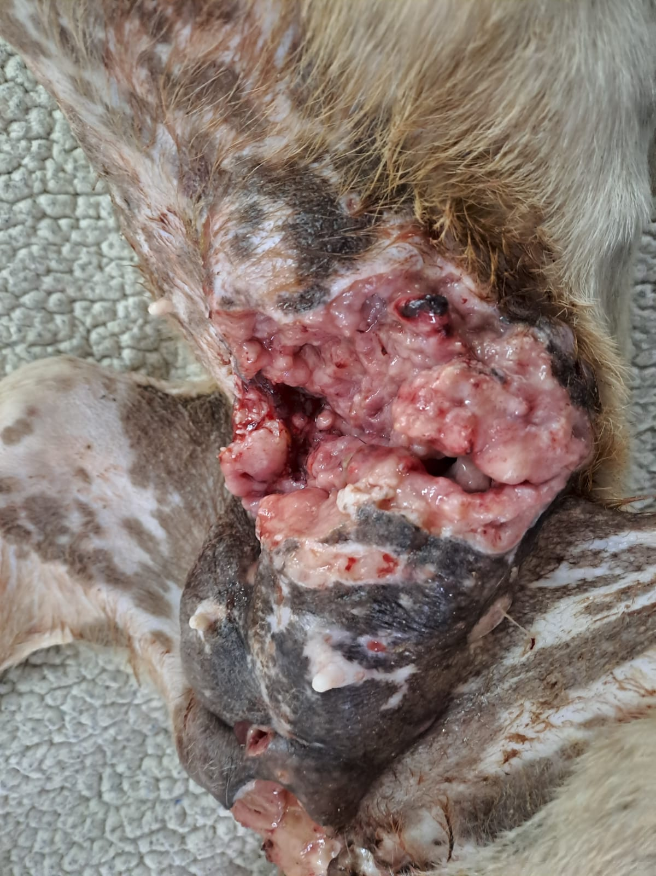
Picture 6:
Close-up medial view of the raw open abdomen wound. Raw flesh and old blood are clearly visible.

PHOTOGRAPHIC EVIDENCE

Address photos taken: Cape of Good Hope SPCA situated on the c/o First Avenue and 1st
Road in Grassy Park
Date photos taken: 24 August 2023
Photos taken by: Insp. Carina Bodenstein
Photos taken with: Samsung A33 5G

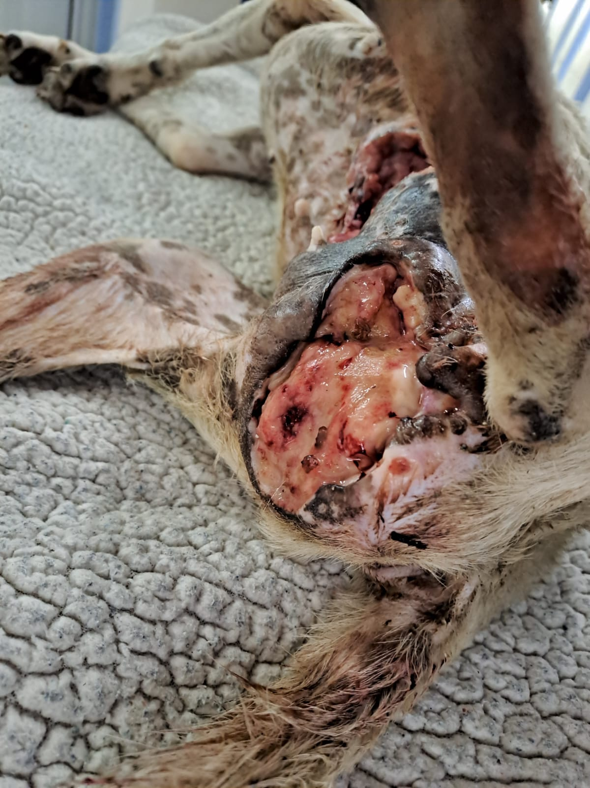
Picture 7:
Close-up medial view of the raw open genital wound. Raw flesh and old blood are clearly visible. The yellow particles observed are puss that was oozing out of the wound.

PHOTOGRAPHIC EVIDENCE

Address photos taken: Cape of Good Hope SPCA situated on the c/o First Avenue and 1st
Road in Grassy Park
Date photos taken: 24 August 2023
Photos taken by: Insp. Carina Bodenstein
Photos taken with: Samsung A33 5G

Picture 8:
Medial view of the entire wound measuring 17 centimeters in length.
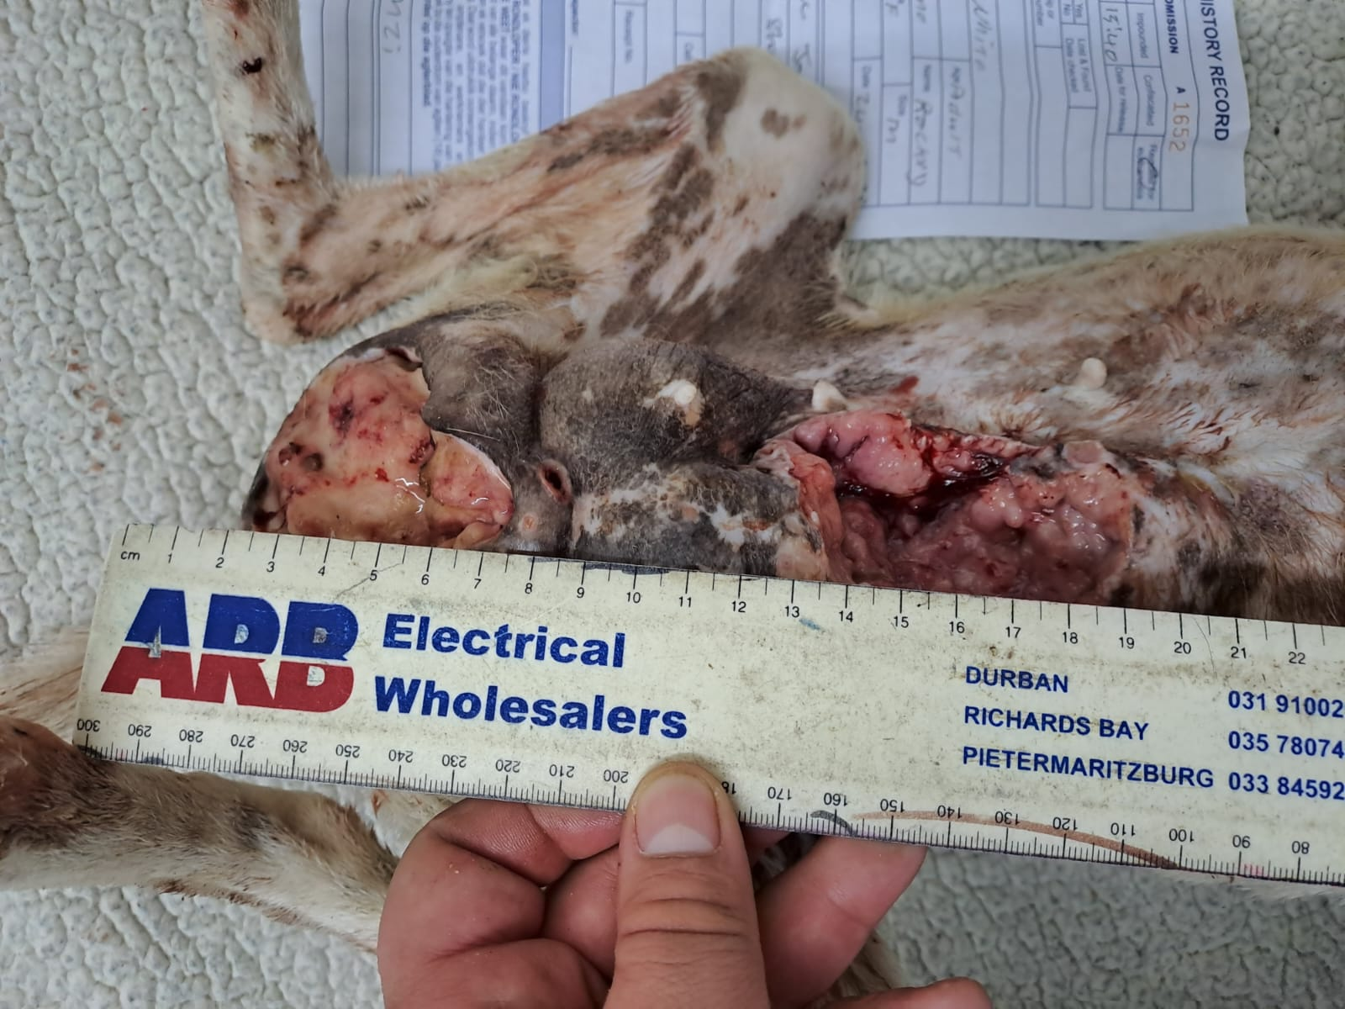

PHOTOGRAPHIC EVIDENCE

Address photos taken: Cape of Good Hope SPCA situated on the c/o First Avenue and 1st
Road in Grassy Park
Date photos taken: 24 August 2023
Photos taken by: Insp. Carina Bodenstein
Photos taken with: Samsung A33 5G

Picture 9:
Medial view of the abdomen wound measuring 6.5 centimeters in length.
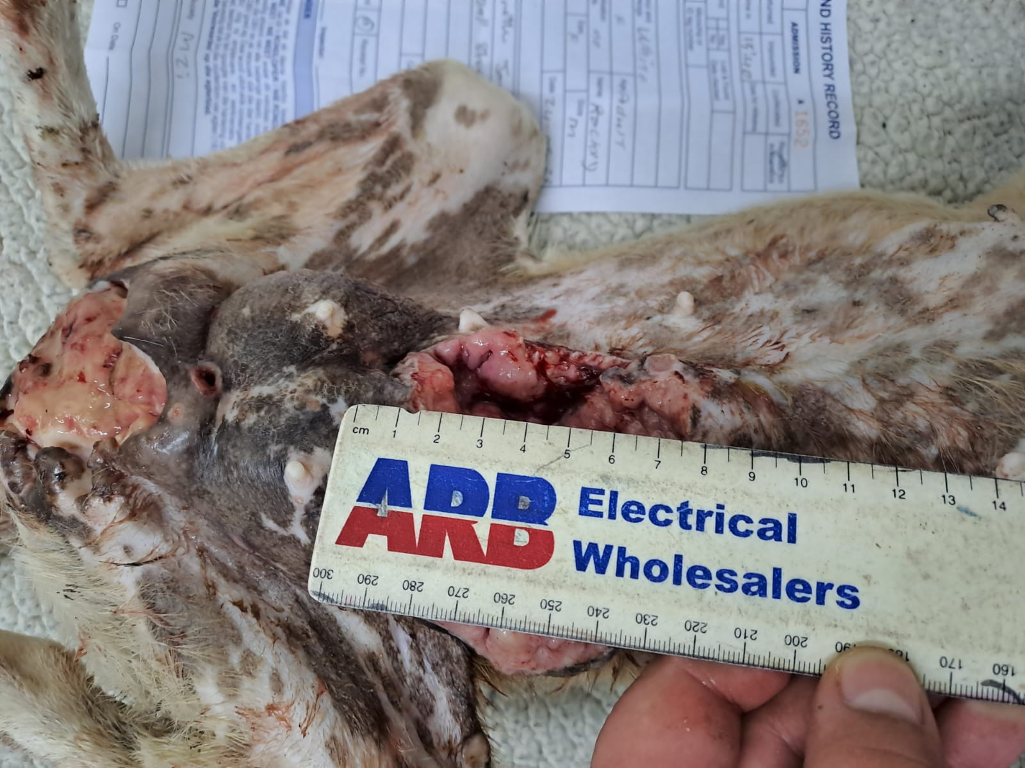

PHOTOGRAPHIC EVIDENCE

Address photos taken: Cape of Good Hope SPCA situated on the c/o First Avenue and 1st
Road in Grassy Park
Date photos taken: 24 August 2023
Photos taken by: Insp. Carina Bodenstein
Photos taken with: Samsung A33 5G

Picture 10:
Medial view of the abdomen wound measuring 7 centimeters in width.
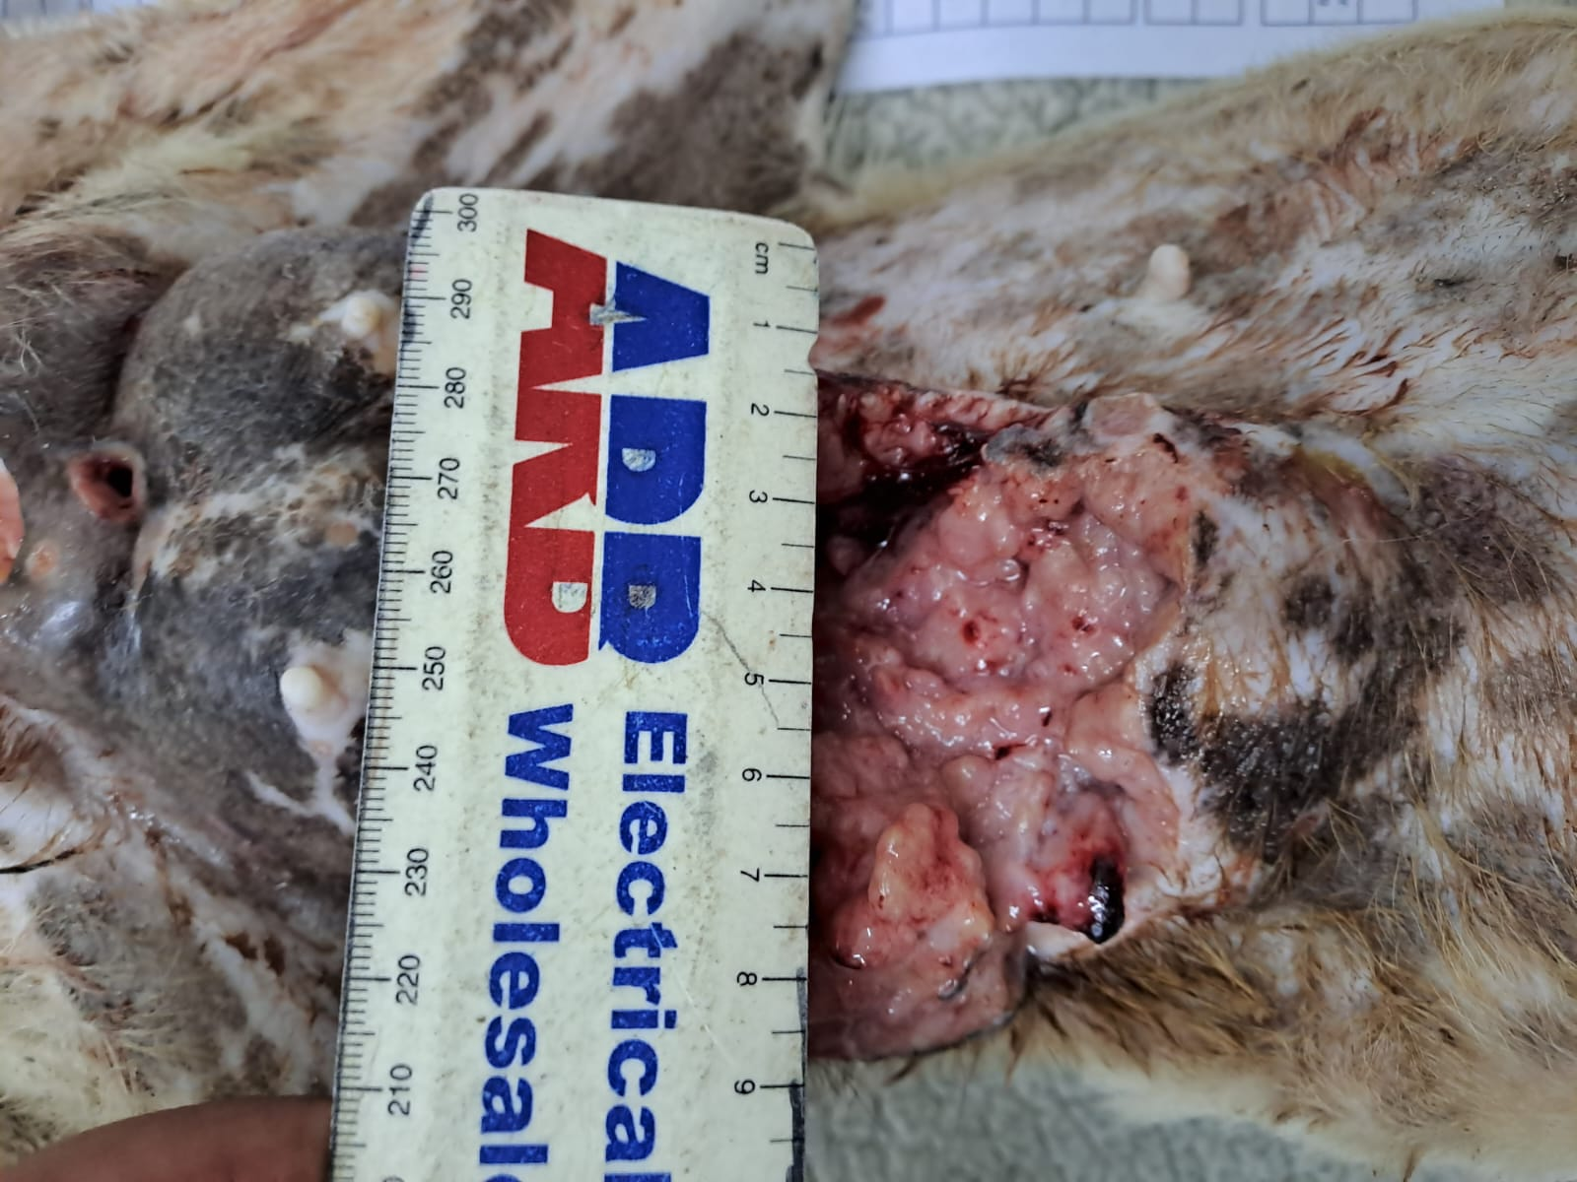

PHOTOGRAPHIC EVIDENCE

Address photos taken: Cape of Good Hope SPCA situated on the c/o First Avenue and 1st
Road in Grassy Park
Date photos taken: 24 August 2023
Photos taken by: Insp. Carina Bodenstein
Photos taken with: Samsung A33 5G

Picture 11:
Medial view of the genital wound measuring 7 centimeters in length.
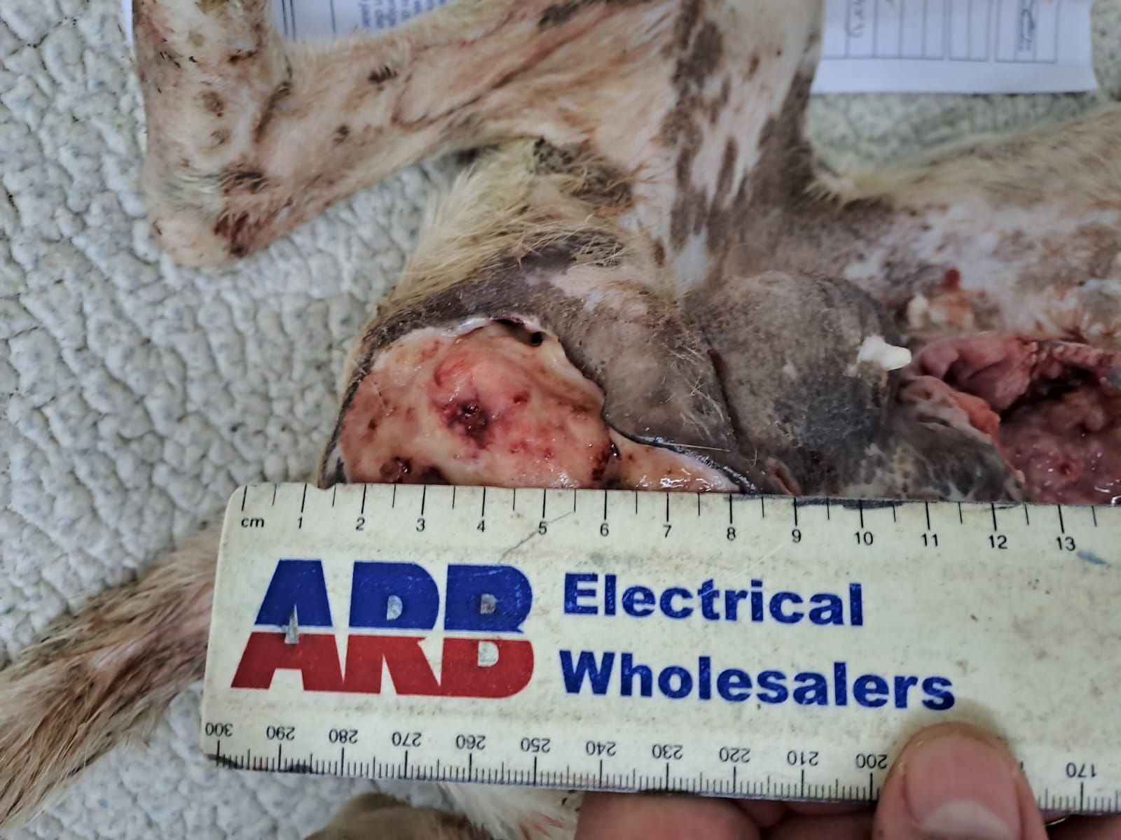

PHOTOGRAPHIC EVIDENCE

Address photos taken: Cape of Good Hope SPCA situated on the c/o First Avenue and 1st
Road in Grassy Park
Date photos taken: 24 August 2023
Photos taken by: Insp. Carina Bodenstein
Photos taken with: Samsung A33 5G

Picture 12:
Medial view of the genital wound measuring 6 centimeters in width.
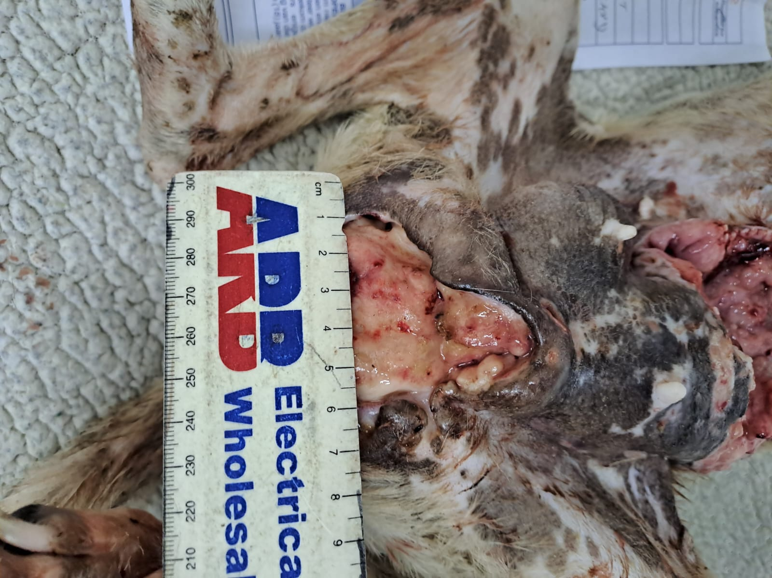

PHOTOGRAPHIC EVIDENCE

Address photos taken: Cape of Good Hope SPCA situated on the c/o First Avenue and 1st
Road in Grassy Park
Date photos taken: 24 August 2023
Photos taken by: Insp. Carina Bodenstein
Photos taken with: Samsung A33 5G

Picture 13:
Admission Form “A1652” front page with the owner’s details captured and the Statement of Surrender signed by the owner.
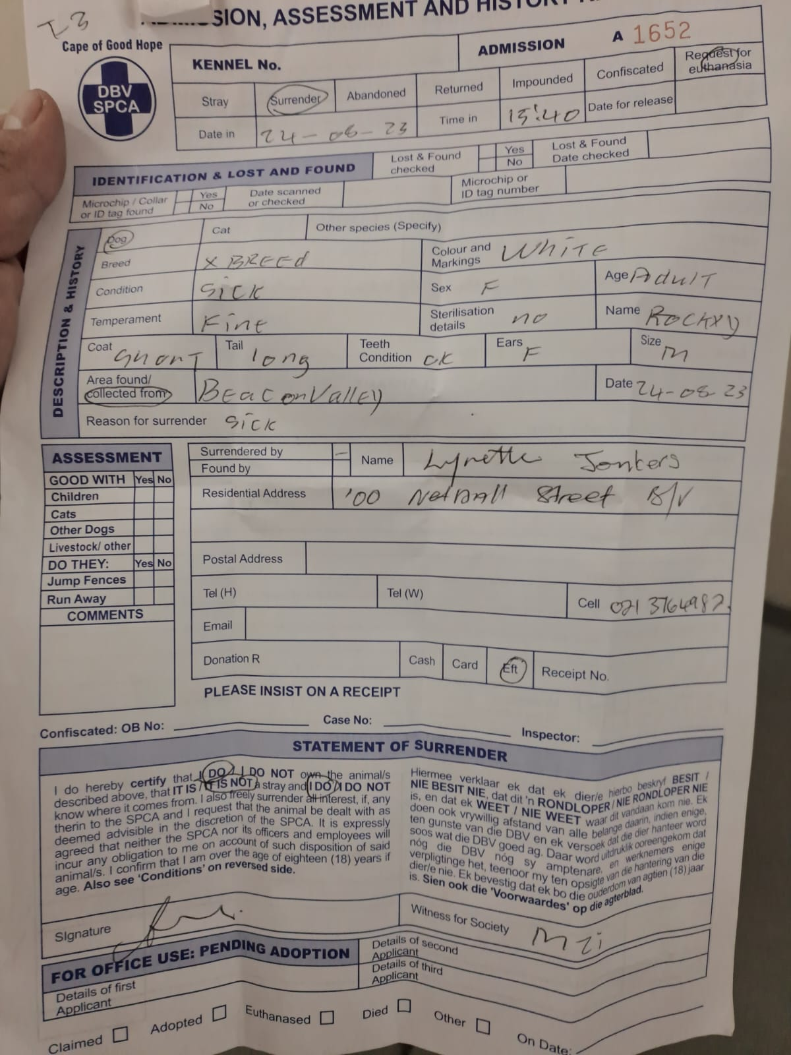

PHOTOGRAPHIC EVIDENCE

Address photos taken: Cape of Good Hope SPCA situated on the c/o First Avenue and 1st
Road in Grassy Park
Date photos taken: 24 August 2023
Photos taken by: Insp. Carina Bodenstein
Photos taken with: Samsung A33 5G

Picture 14:
Admission Form “A1652” back page where the owner signed and requested for euthanasia.
