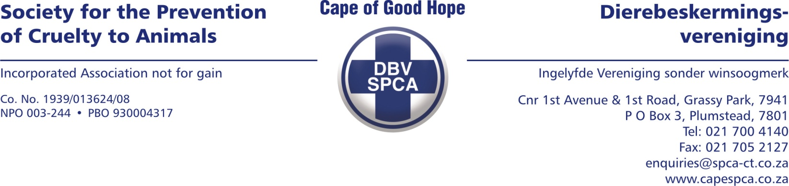

SWORN AFFIDAVIT

I, the undersigned

MZIKAYISE MFINI
(ID 810225 5954 08 6)

Do hereby make oath and state that:

1.
I am an adult male Collection Officer employed as such by the Cape of Good Hope Society for the Prevention of Cruelty to Animals (“SPCA”) at corner of 1st Avenue and First Road, Grassy Park with contact telephone number/s 021 700 4158/9 and 0628004001 and email address inspectorate@spca-ct.co.za.

2.
The facts contained in this affidavit fall within my personal knowledge unless indicated otherwise or unless it appears so from the context. The facts are also, to the best of my knowledge and belief, both true and correct.

3.
On the 24th of August 2023, at approximately 14H00, I received a call from the Cape of Good Hope SPCA Inspectorate Department Control room informing me to collect an unwanted dog that is allegedly sick from an individual identified as Ms. Lynette Jonkers (“the owner”) residing at a property known as number 100 Netball Crescent in Beacon Valley (“the property”).
3.1.
Upon my arrival, I was greeted by the owner. The owner took me to where the dog was. I observed a Cross-breed type dog (white, female, adult, whom they named “Rockxy”). I got a fright when saw the dog as all I could see was the large open hole in the stomach of the dog. The dog did not move much and I had to pick the dog up to load the dog in my SPCA-branded bakkie. The owner informed me that the dog has been in this condition for almost a month now and that it only got worse after each day went past. I admitted the dog under admission number “A1652” and asked the owner to complete the Statement of Surrender where the owner stated that she do own the animal, that it is not a stray and that she knows where the dog comes from. The owner also signed the Statement of Surrender. I informed the owner that the dog is not looking good and informed the owner to sign the request for euthanasia form as well, which she did. After I loaded the dog into my vehicle, I left the property and drove to the Cape of Good Hope SPCA Hospital, situated in Grassy Park.

3.2.
When I arrived at the Cape of Good Hope SPCA Hospital off-loading bay, Inspector Carina Bodenstein (“Bodenstein”) met with me to examine the dog (refer to Carina Bodenstein’s statement). Bodenstein humanely euthanized the dog as the dog was suffering and looked like the dog was in pain as the dog did not move much. After Bodenstein humanely euthanized the dog, she took the dog to the veterinarian.

4.
I am of the opinion that the owner intentionally and negligently caused the dog to suffer unnecessarily as they saw the dog medically deteriorating every day for almost a month but did not help the dog.

5.
I know and understand the content of this declaration.
I have no objection to taking the prescribed oath.
I consider the prescribed oath to be binding on my conscience.

_____________________________
DEPONENT

The deponent has acknowledged that he knows and understands the contents of this affidavit/declaration, which was signed and sworn to before me at ____________________ on this the _____ day of ________________ 20___, the regulations contained in Government Notice No R1258 of 21 July 1972, as amended, and Government Notice No R1648 of 19 August 1977, as amended, having been complied with.

_____________________________
COMMISSIONER OF OATHS

Full names:

Designation:

Business address:

