

NSPCA ASSIGNMENT
6. SECURITY COMPANY INSPECTION

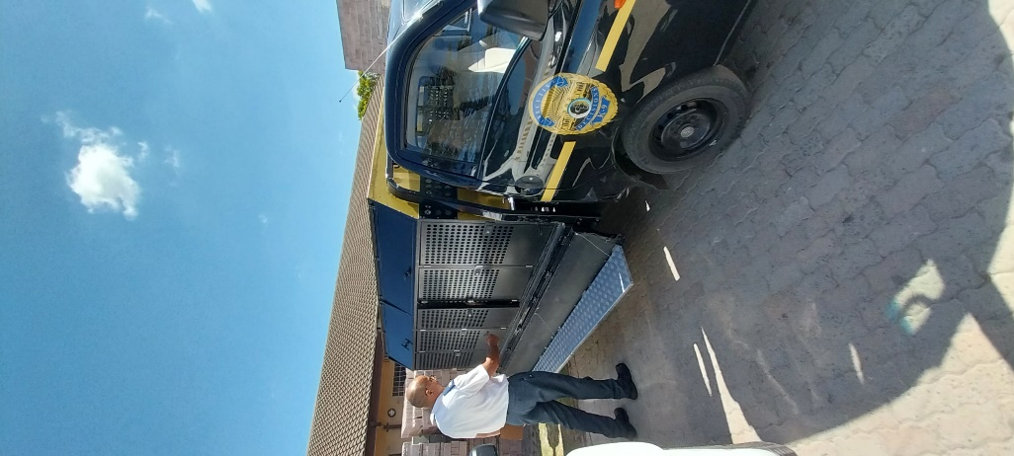

05

TREVOR RODNEY

SECURITY COMPANY INSPECTION

Details
Date: | 05/11/2022
Time: | 09H50
Case Number | 177158
Address: | 1 Fourteenth Avenue, Philippi, Cape Town.
Attending Staff: | Jason Jacobs
Reason for inspection: | Pro-active

Facility details
Security Company: | Executive Decisions
Name & Surname: | Donovan Josias
Contact number: | 021 012 5864
Email | info@executivedecisions.co.za
Website | http://www.executivedecisions.co.za/index.html

BACKGROUND

Executive Decisions, established in 2000, is a high-end multifarious security company, offering a wide range of security-related services. Their K9 facility where the dogs are kept when they are not being worked is in Philippi, Cape Town.

Their services include tracking, detection, executive protection, crowd control, special events, surveillance, close protection, and loss and or risk evaluation. The K9 division is used mainly for protection and detection. Their detection ranges from narcotics, explosives and even stowaways at Cape Town harbour, which is a popular and busy seaport.

Dr. Rachelle Shuttleworth is their veterinarian of choice, especially when they have young dogs or puppies. They use TAH in Goodwood as a backup. All their dogs’ veterinary records are up to date.
Each kennel has adequate space and the kennels were clean and had plenty of ventilation. They have a kennel assistant that lives onsite. There is also a dipping area at the one end of the kennels and there are fire hoses located in each row of kennels.
They use Royal Canin for the younger dogs and Optimizor Premium is the preferred choice of dog food.
Dipping is every second week; they use Dazzle and or F10

The main handler / trainer, Jason, is onsite most days, except when he is doing training offsite or at training-specific locations.
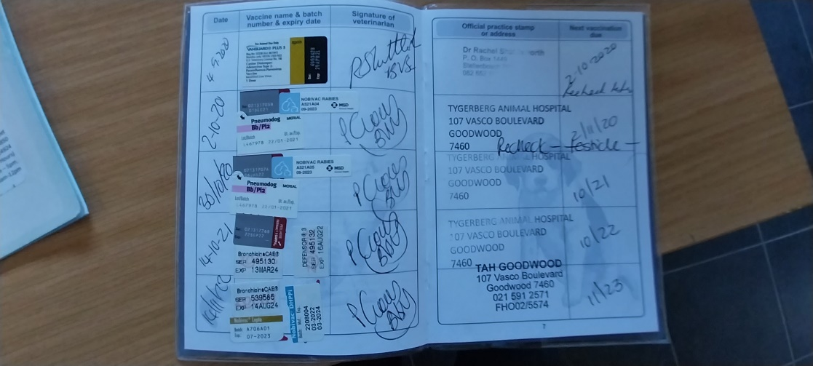
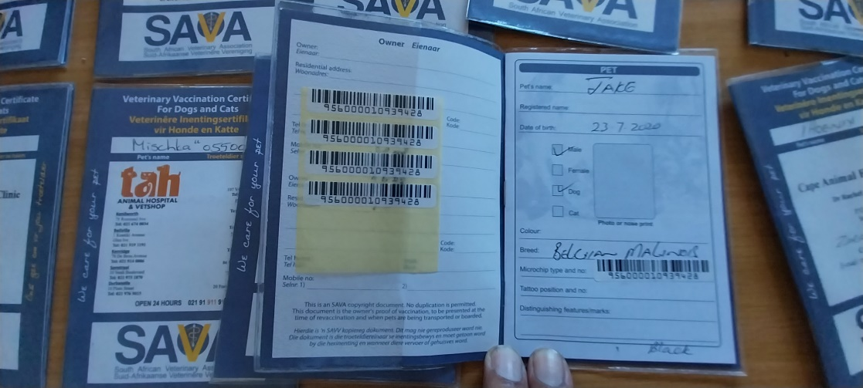
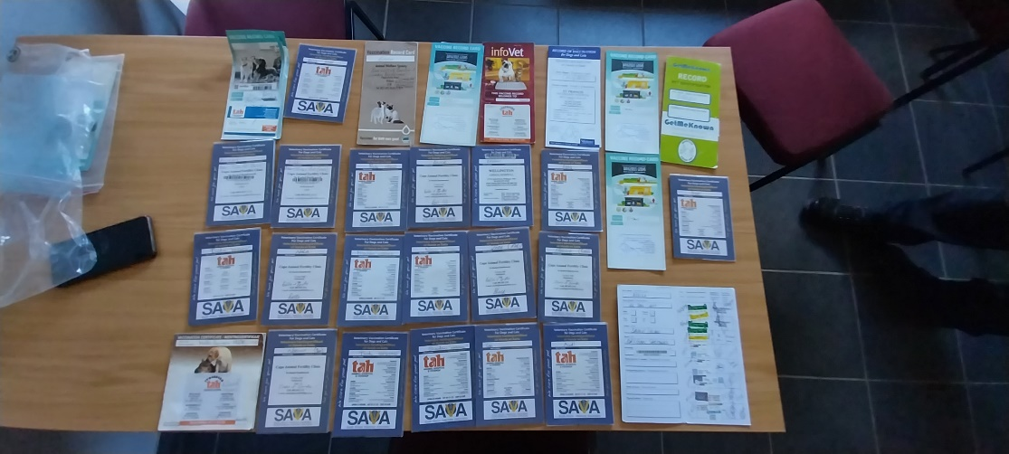
Figure 1 - The Veterinary records for each dog

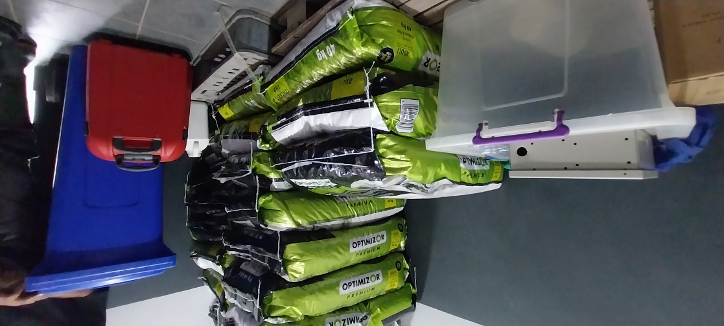
Figure 2 - The dog food that is stored off the ground and in a clean storeroom.
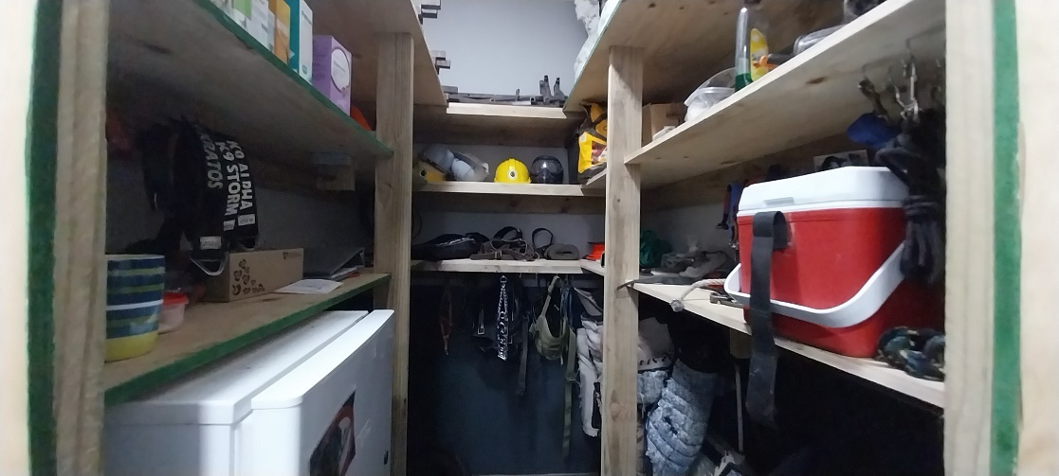
Figure 3 - The equipment and storeroom the training equipment is stored.
REPORT / FINDINGS

I was accompanied by Inspector Theo Arendolf to do a proactive at their kennels which is located at 1 Fourteenth Avenue, Philippi. The dogs all appear to be healthy and in good condition. No signs of kennel stress or any other condition. We could not find any concerns at this site.

Performing Animals Protection Act

This company is in possession of a valid License in terms of the Performing Animals Protection Act Number 24 of 1935. It allows them to utilise 35 dogs for detection or training work and 15 dogs for safeguarding. They currently have a total of 24 active dogs now. There are some dogs that can do detection as well as safeguarding. Their PAPA Licence is valid and expires on 07th March 2023.

A copy of their PAPA Licence is attached as Annexure A.

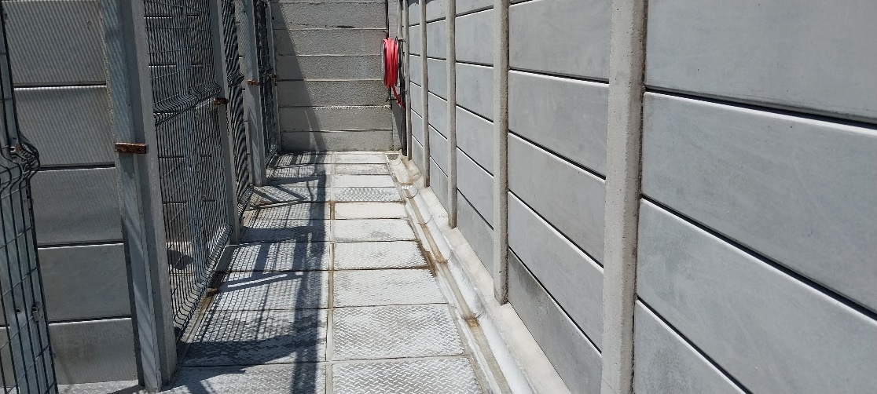
Figure 4 - There is a fully functional firehose at the end of each row of enclosures
ENCLOSURES

They have a total of 50 enclosures at this property. Enclosures are in three rows of fourteen enclosures in each row, giving you a total of forty-two enclosures in the main section. They also have four quarantine enclosures which is located far away from the runs. The runs are spacious and grassy. There are fire hoses in each row of kennels. The front of the kennel uses Clear Vu© fencing, which is durable and plastic coated, to last longer and prevent injury to the dogs. They use Clear Vu© fencing throughout their enclosures and runs. The cement floor of the enclosures’ slopes towards the entrance of the kennel which allows for easy cleaning and drainage. Each enclosure measures 3m x 4m. Entrance to each row of enclosures is via a solid sliding gate and is secured with a heavy-duty cane bolt. The runs are
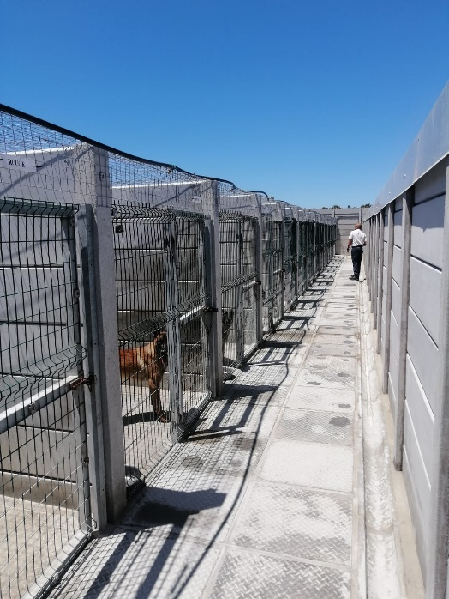
Figure 5 - One of the three rows of enclosures where each dog has its own enclosure

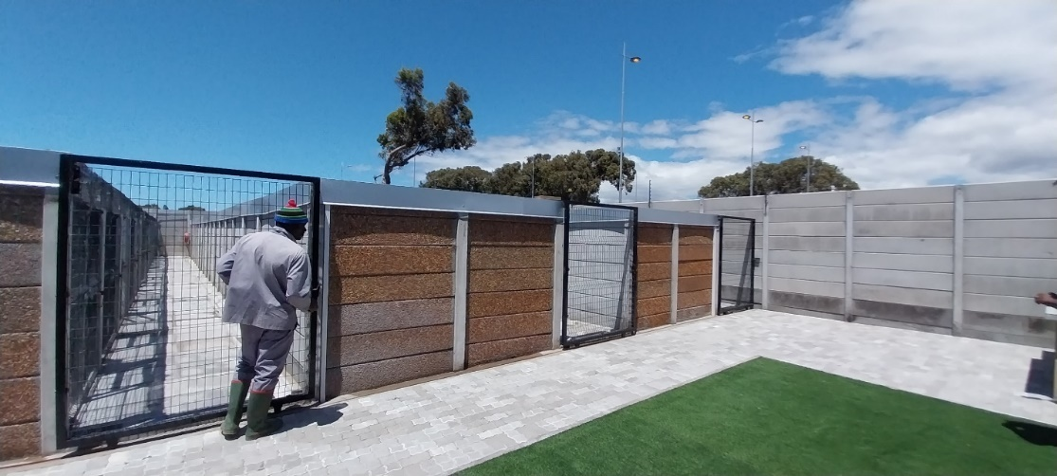
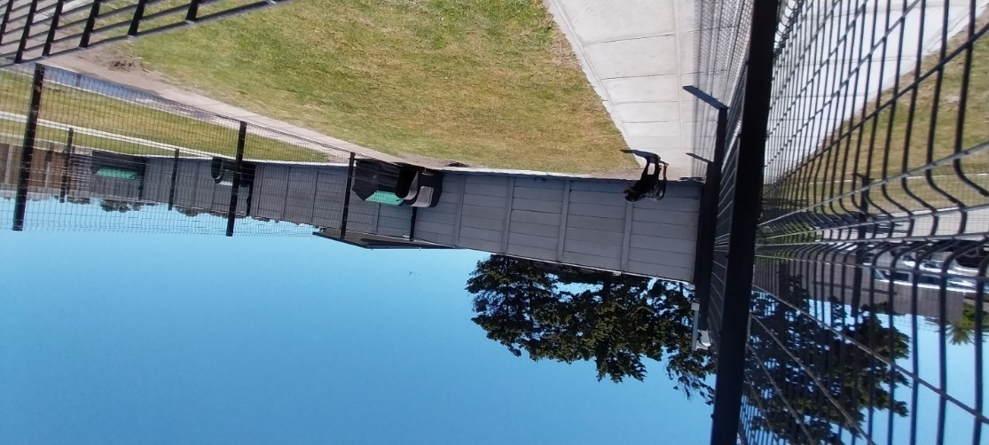
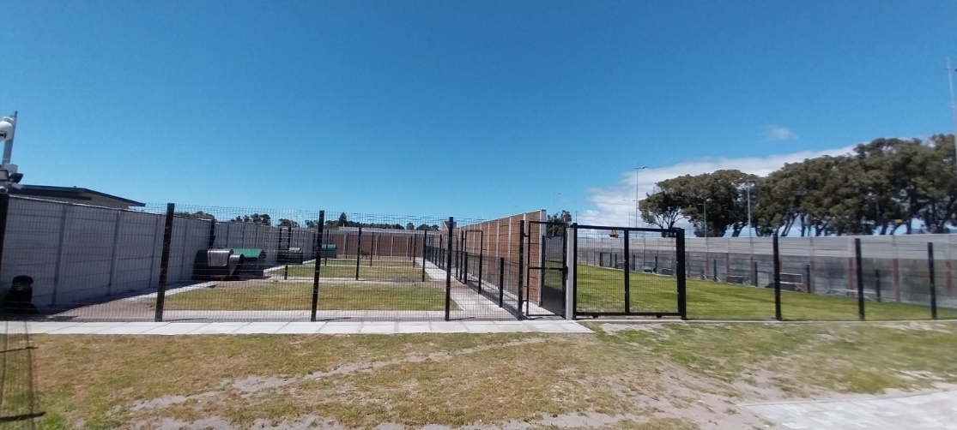
Figure 7 - Another view of the run, to show the spaciousness of the run
Figure 8 - Access to the enclosures is via a solid lockable gate
Figure 6 - The runs where the dogs are exercised for at least an hour every day

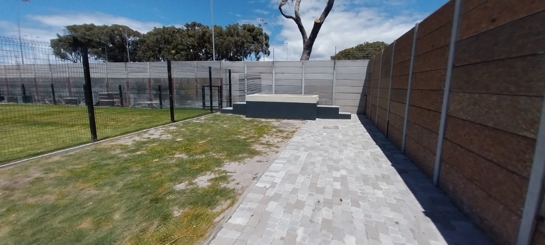
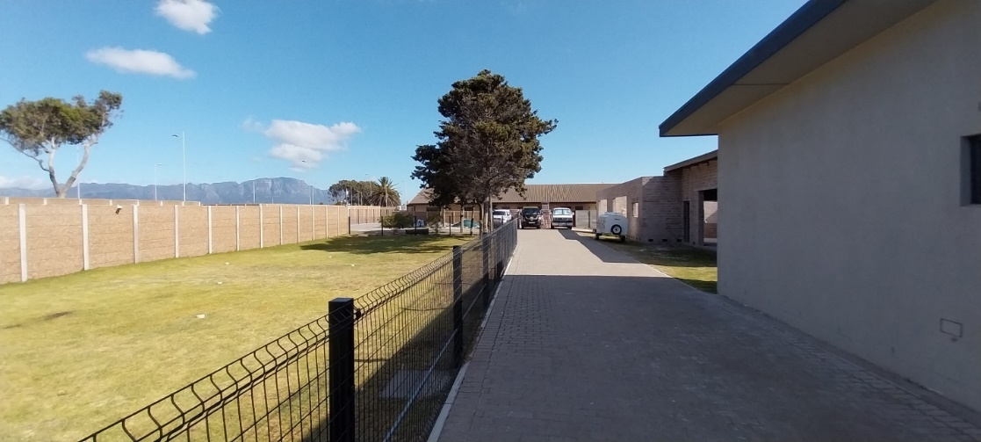
Figure 10 - The dipping bath
Figure 9 - Another run, which is used mainly for training. On the right is one of their older trailers that were used but is only used now in case of emergency, or if none of the trailers or K9 sedans are not available.
WATER

The dogs have large water bowls which are replaced, clean and filled every day, or when needed. When the dogs return to their enclosures after returning from their shift, they are given a clean water bowl with fresh clean water. The used water bowels are cleaned as soon as it is removed from the enclosures. The dogs do not work onsite but accompany the handler, who travels with fresh water for the dog in the K9 vehicles. They differ from other security companies in that they do not have dogs that patrol designated sites, so the time spent working is much less than other working dogs.

DOGS

Their working dogs of choice are Belgian Malinois and Rottweilers.

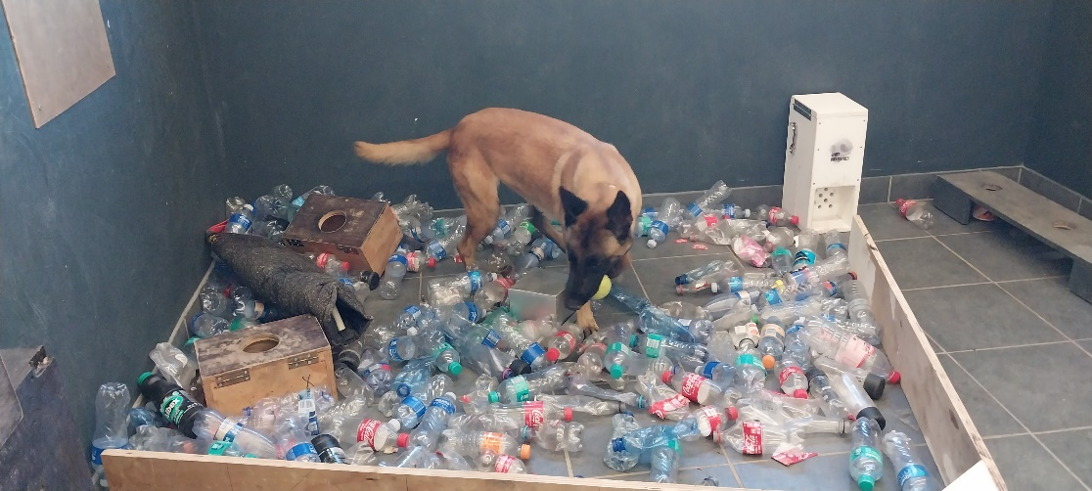
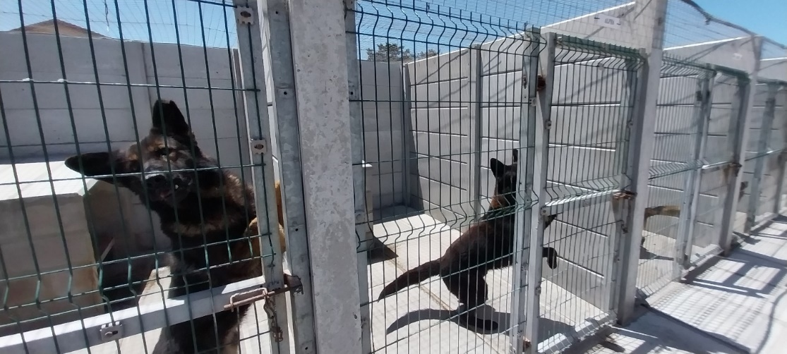
Figure 12 - One of the Belgian Malinois dogs being trained for detection
Figure 11 - Two of the dogs that were onsite during the time of our inspection

TRAILERS

There was one trailer at the property during the time of our inspection, but it has been replaced by a customised vehicle which appears to be safe and adequate to transport up to ten dogs. They also have K9 sedans, where the dog is caged on the back seat. Previously they used bakkies with a cage at the back, but this was replaced by the K9 sedans. The K9 sedans are used when they do detection work with the handler.
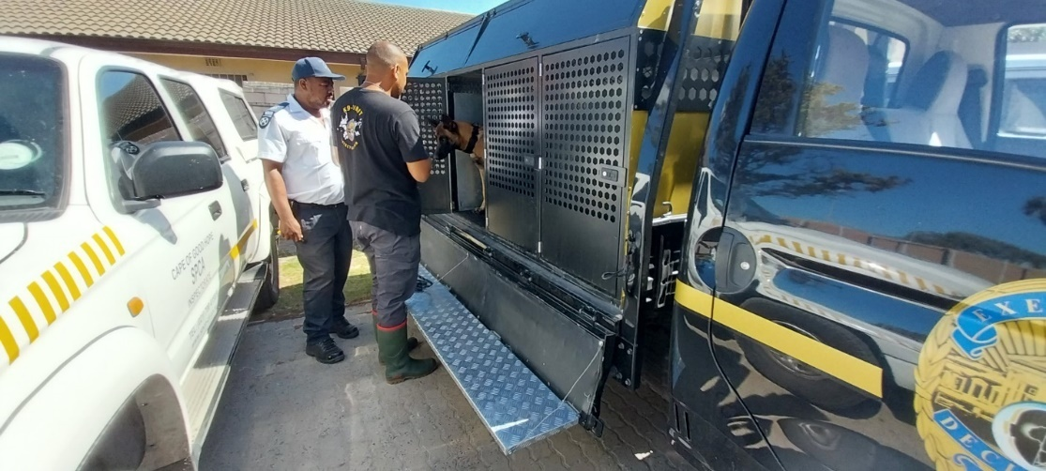
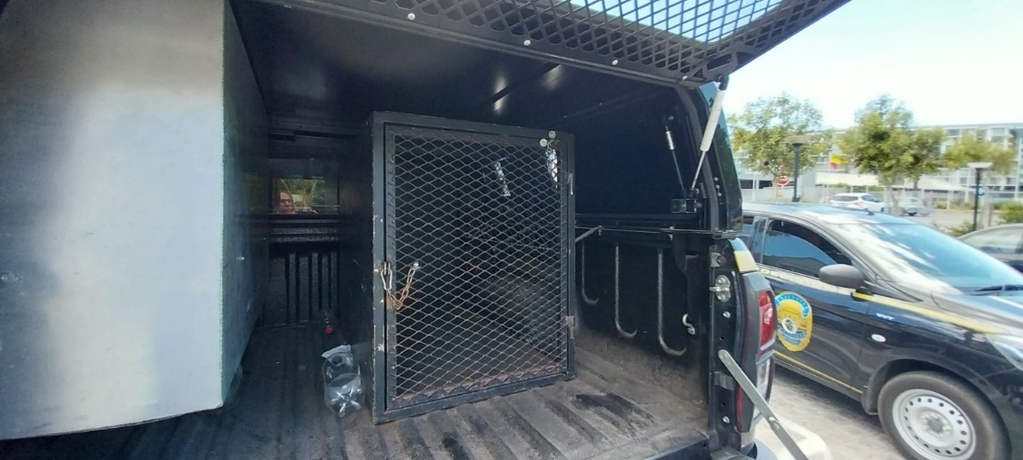
Figure 14 - The fully customised K9 transport vehicle which has the capacity for 10 dogs
Figure 13 - The older vehicle that used to house a dog but has been replaced by the K9 Sedans

CLEANING AND FLY CONTROL

Kennels and enclosures are cleaned twice a day.

LEGISLATION

The following legislation is applicable:
- Animals Protection Act Number 71 of 1962
- Regulation 468 (issued in terms of Section 10(1)(b) and (c) of the Animals Protection Act)
- Performing Animal Protection Act Number 24 of 1935 (as amended in 2016)
- Performing Animal Protection Act Regulation, 2016
- City of Cape Town Animal By-law, 2010
- Private Security Industry Regulation Act 56 of 2001

ACTION TAKEN

We did not observe any contraventions in terms of the Animals Protection Act nor the Performing Animals Protection Act.
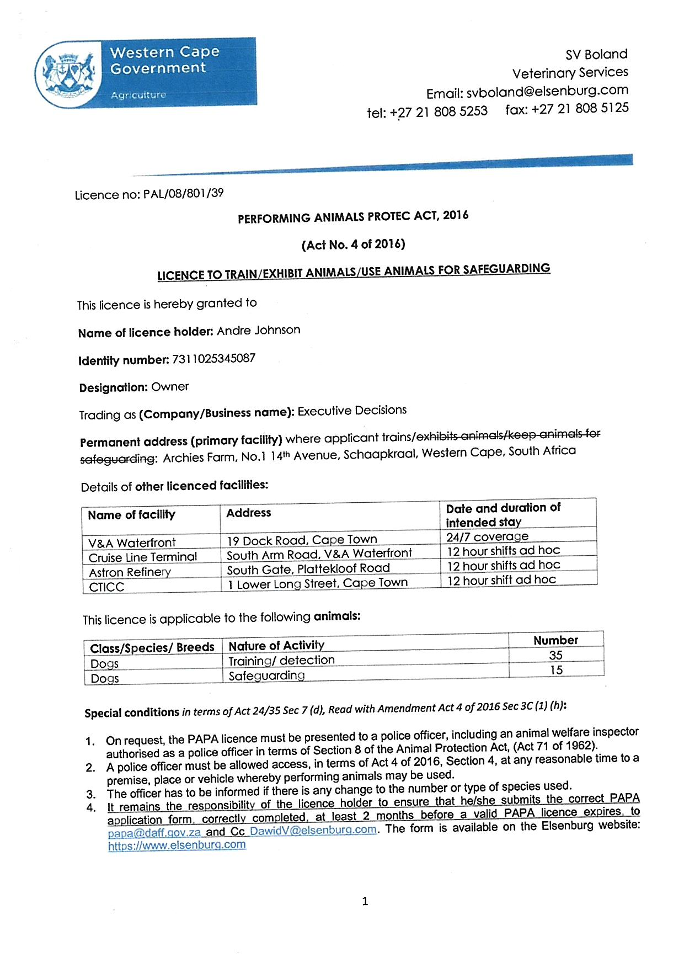
Annexure A

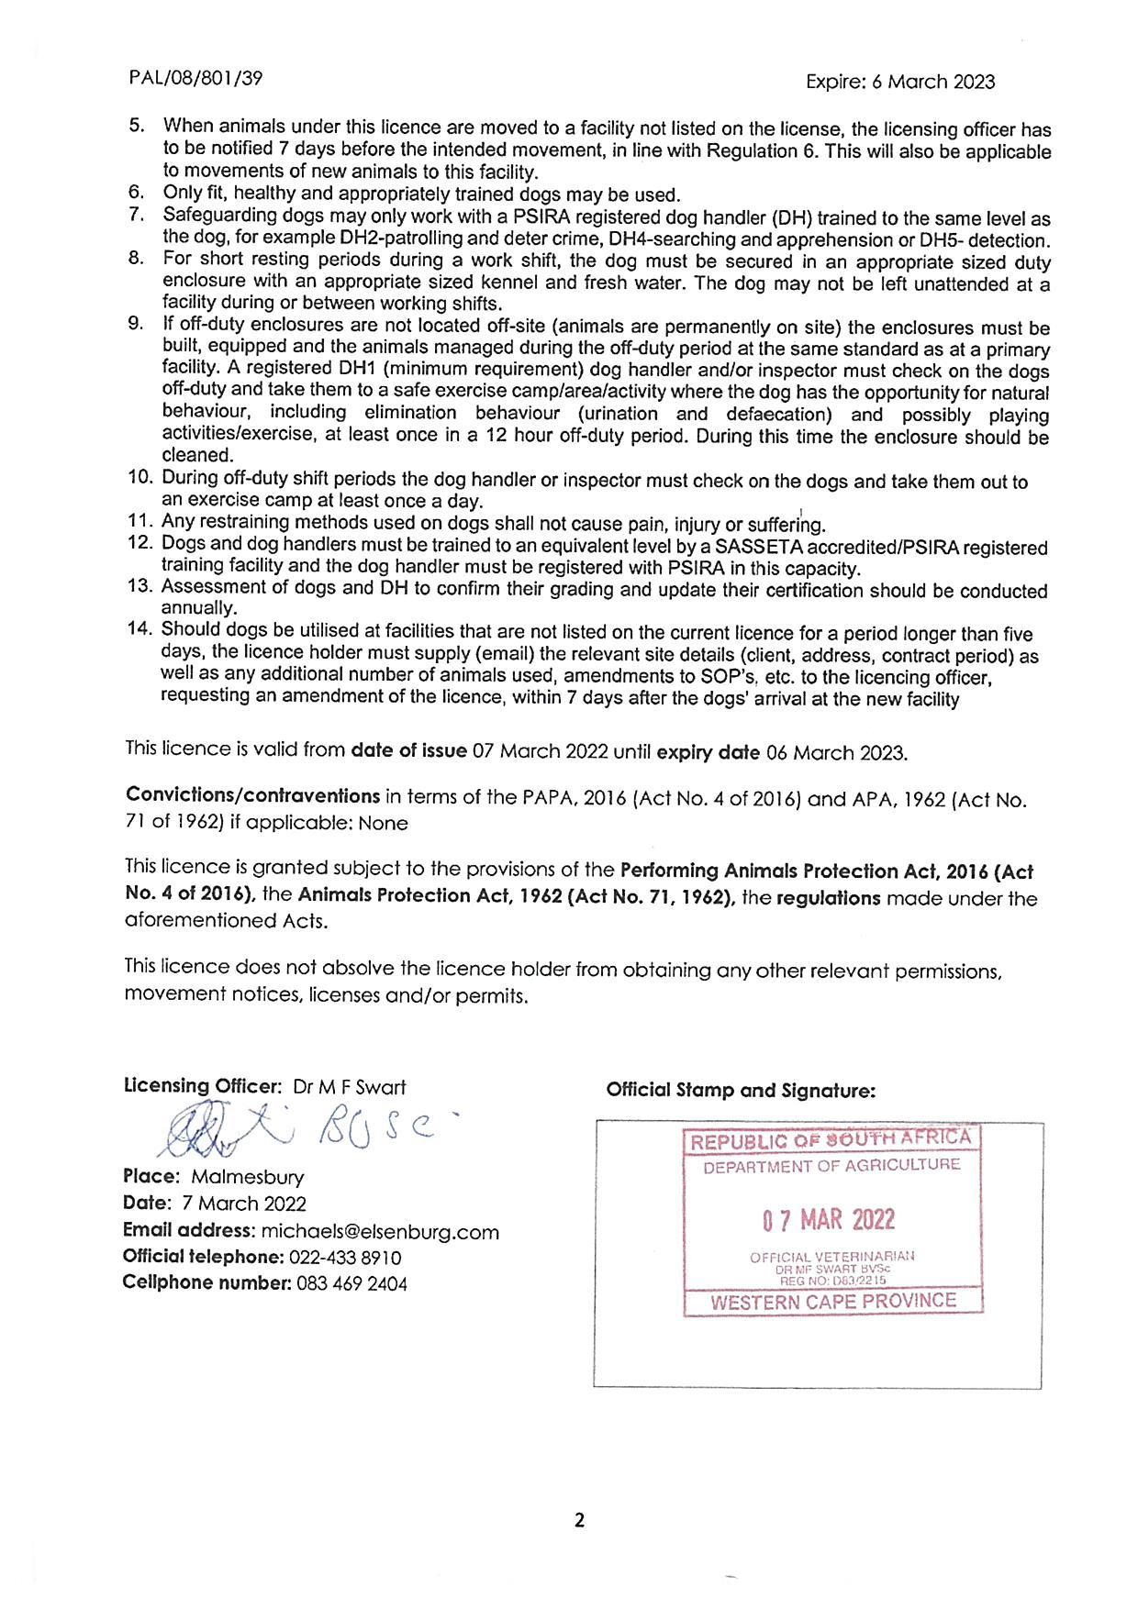
Annexure A continued.

