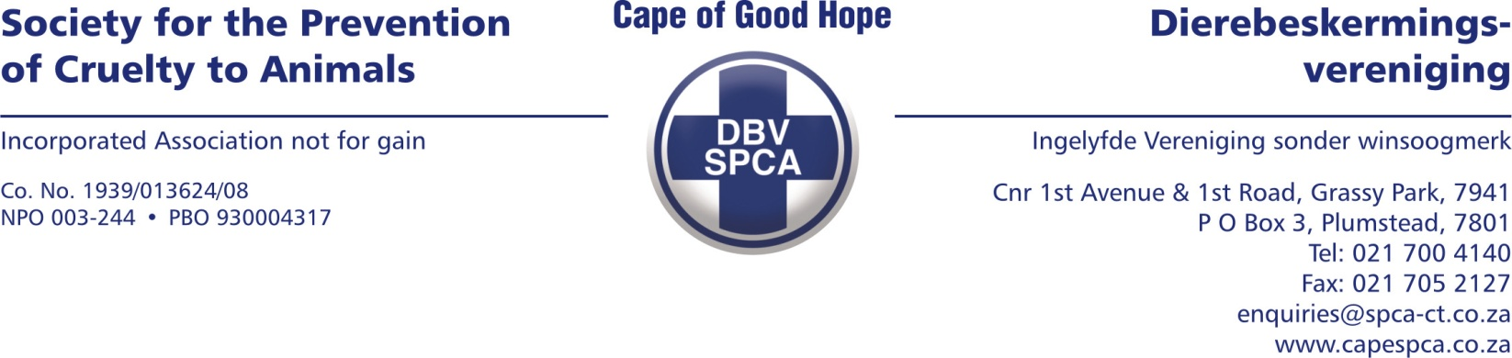

VETERINARY REPORT

To whom it may concern

Please find below the veterinary report for Admission Number 90118, confiscated on the 31/01/2023. The dog is collected from Ocean View.

ANIMAL DETAILS

Species : Canine
Breed: Pitbull
Sex: Male, Intact
Age: Adult
Name: Lastis
Description: Tan and white

EXAMINATION FINDINGS

Upon initial presentation, the patient looks extremely malnourished with a body condition score of 1.5/9. The mucous membrane color is pink and the capillary refill time is one second. The dog is bright, alert, and responsive. The abdominal palpation is comfortable. No abnormalities were detected on heart and lung auscultation. The mobility of the patient seems to be normal. There where a noticeable amount of flea dirt on the skin coat.
Overall the main concern, in this case, is severely underweight which can be due to malnourishment. The dog was given a dewormer as well as flea/tick treatment upon arrival at the SPCA.
The dog is currently being fed four times a day. The patient should recover easily with the correct nutrition.

COMMENTS

In my opinion this patient suffered unnecessarily due to not seeking veterinary care regarding weight loss or not getting the correct nutrition. The patient currently has a very good appetite.

Yours sincerely

Dr Fraser Martens (BVSc)
Veterinarian

Date compiled: 01/02/2023

