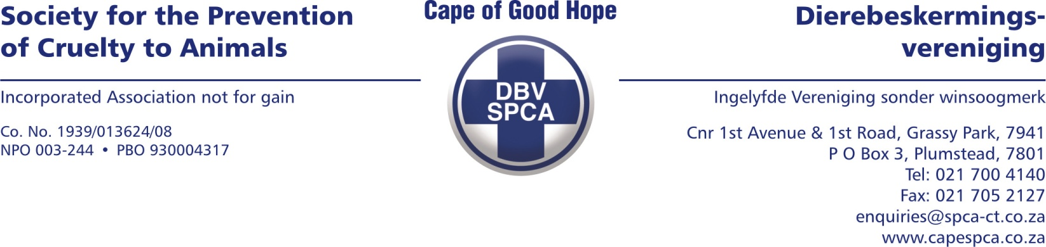

VETERINARY REPORT

To whom it may concern

Please find below the veterinary report for Admission Number 90207.

ANIMAL DETAILS

Species : Canine
Breed: Pitbull
Sex: Male, neutered
Age: Adult
Name: Unknown
Description: Black/white

EXAMINATION FINDINGS

A biopsy and culture and sensitivity were done from the main lesion site on the right front limb.
The histopathology results indicate that this is squamous cell carcinoma. This is an aggressive skin cancer. The lesion on the leg also indicated an E. coli and Streptococcus bacterial infection which the E. coli bacteria seem to be resistant for the majority of antimicrobials.

COMMENTS

It is advised to humanely euthanize the animal due to the extend and spreading of the cancer. Attached is the histopathology and bacterial culture results.

Yours sincerely

Dr Fraser Martens (BVSc)
Veterinarian

Date compiled: 16/02/2023

