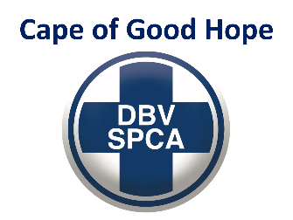

INSPECTION REPORT

INSPECTION DETAILS

Facility name: Reptile Garden
Address: Mondeor Road, Somerset West, Cape Town, Western Cape (Monkey Town property)
Manager: Bjorn Unger
Tel: 084 776 3537
Email: bjorn@reptilegarden.co.za

Inspection Date: 11 January 2022 | Case number: INSP162123
Start Time: 14:43 | End Time: 16:00
Inspectors: Inspector Werner Taljaard & Wildlife Officer Jon Friedman

Nature of complainant:
Pro-active inspection following complaint at Monkey Town

- FINDINGS

Reticulated python enclosure:
- Numerous flakes of old skin shedding inside enclosure.
- insufficient water for large python.
- 1x animal observed.

African rock python enclosure:
- old faeces on substrate.
- insufficient water for bathing.
- 1x animal observed.

Yellow anaconda enclosure:
- numerous faeces in water bowl.
- enclosure insufficient size for large snake.
- exposed heat bulb (burn hazard).
- 1x animal observed.

Boa constrictor enclosure:
- water bowl insufficient size for animal.
- 1x animal observed.

Madagascan ground boa enclosure:
- old faeces on substrate.
- 1x animal observed.

Blood python enclosure:
- enclosure insufficient size for large snake.
- inadequate / unsuitable substrate.
- 1x animal observed.

Honduran milk snake enclosure:
- drinking water container dry.
- 1x animal observed.

Corn snake enclosure:
- old skin shedding in cage.
- 2x animals observed.

Taiwanese rat snake enclosure:
- old faeces on substrate.
- 2x animals observed.

Bearded dragon enclosure:
- old faeces on substrate.
- 1x animal observed.

Green mamba enclosure:
- old skin shedding in cage.
- exposed heat bulb (burn hazard).
- 1x animal observed.

Boomslang enclosure:
- animal appears underweight (juvenile).
- 1x animal observed.

Copperhead enclosure:
- old skin shedding in cage.
- 1x animal observed.

Forest cobra enclosure:
- insufficient water
- 4x animals observed.

Spectacled cobra enclosure:
- old skin shedding in cage.
- snake was busy feeding on a dead rat. 2 other dead rats observed in enclosure.
- 1x animal observed.

- ACTION TAKEN

Warning number 12210 issued.

- FOLLOW-UP ACTION

Follow-up inspection to be conducted on 19 January 2022.

Werner Taljaard
Inspector

