Ad ITiisslon F o l' rn 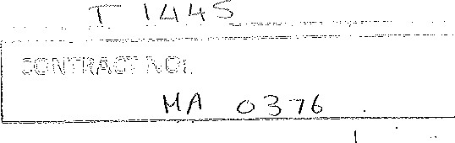
Appilcatk)l') for adopt}oil
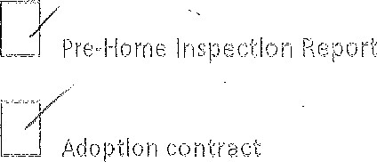
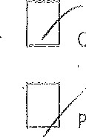
copy of Docugnervt o t DfIvePs 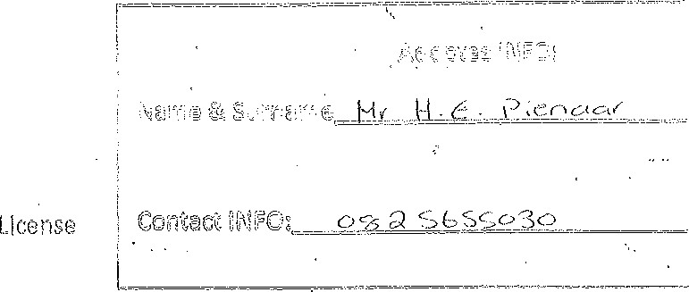
Proof of Resldence
Letter from Body Corporate
Sterilizat!on Contract and Date of sterlllzatlon
Copy of Vacclnation Record/ Certificate
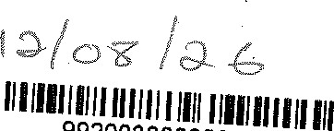
Mlcrochlp
Mlcrochlp Registratlon- chlp numbér
992003000650640
OC
Completed by: Date: 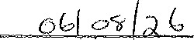
Manager: Date:
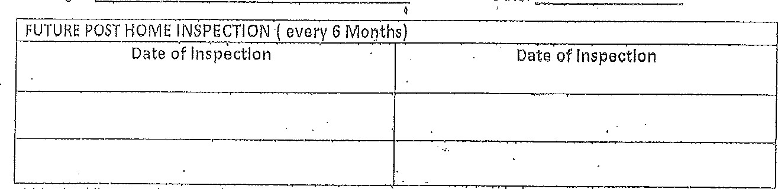
This checklist must be completed and attached to the front of every adoptlon that has been processes, Al/ documents relating to a single adoptlon must be Icept together In åslng/e bundle, In order of checklist,



APPLICATION TO ADOPT AN ANIMAL
PLEASE NOTE: We retain the right to decline this application
The following documents to be attached: ID, proof for residence, proof thal pets are allowed.
NAME Prof/Dr/Mr/Mrs/Ms (including initials):
HOME ADDRESS:
ID NO.: DI/ J/ 0/430 gli Z)
POSTAL ADDRESS:
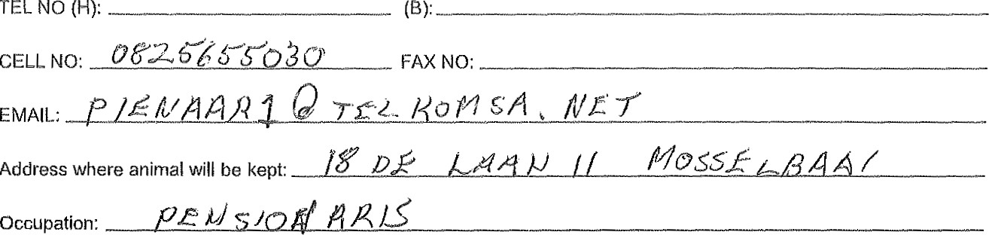
TEL
Do you own or rent your property: BCS Do you have consent from owner / Body Corporate?
Are you a student with consent to keep pets: YES/N
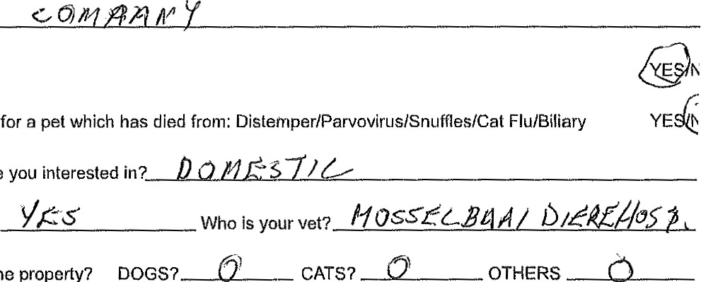
Reason for wanting animal:
Is
the
animal
a
replacement
Is the animal for yourself?
What breed of dog or cat are you interested in?
Can you afford private fees?
How many animals live on the property?
What are the sexes of your animals? DOGS: Male Female CATS: Male
Are all your animals sterilised? Give details
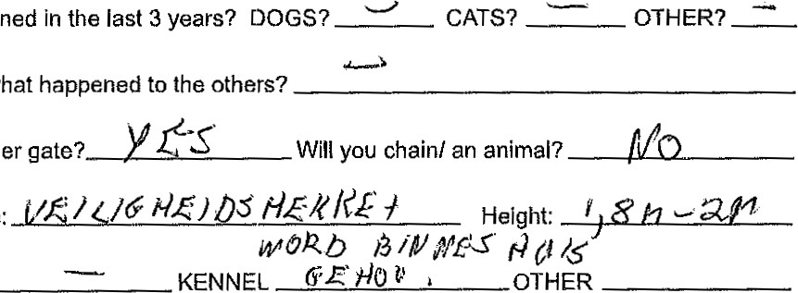
How many dogs and cats have you owned in the last 3 years? DOGS?
Which animals do you still have, and what happened to the others?
Is your propelty fenced and has a proper gate?
Full description of the fencing and gate:
What shelter is provided: OUTDOORS
C)
Have you previously had pets from an SPCA? Are there children under 10 in your household?
100
Pre Home Inspection Fee: Receipt No: 10 35C
Declaration: The above information is true and correct
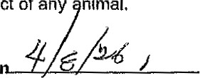
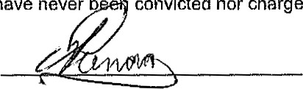
I confirm that I have never b convicted nor charged with cruelty or neglect of any nimal,
SIGNATURE OF APPLICANTDate of applicatio
ADMISSION Non
TOELATlNGSNRa
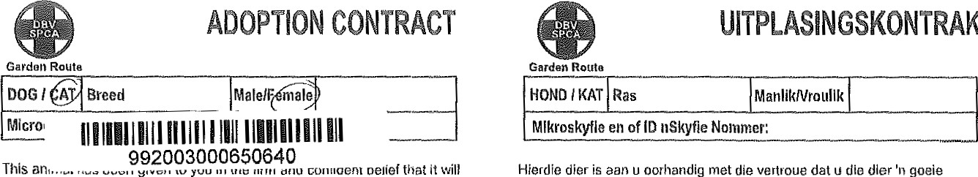
UITPLASINGSKONTRAK

receive a good home with responsible and loving care. Ownership an anilngl yields much pleasure and satisfaction. {t also has its obligations and responsibilities. The fact that the animal hag been in our care usually indicates that someone has, in the past, failed to recognise these responsibilities.
I do hereby confirm and undertake that:
- I am over eighteen (18) years of age.
- All family members agree to the adoption and will abide by the conditions in the contract.
- I wilt not pan with possession of the animal except to return It to the SPCA if for any reason I am unable to keep it. 'n the event that I fail to do so, agree that I Will be liable to pay to the SPCA all costs which they may incur in obtaining confirmation that the animal has been homed to a suitabte person, with suitabte premises. tn the event that this is not the case, I also agree that I will be liable for all costs which the SPCA may incur, including all legal costs on an attorney and cheni scale, In recovering possession of the animal.
- wilt give the animal a fair chance to adjust to its new home.
- I understand that donations are not refundable or transferable,
7, witl feed and house the animal to the Society's satisfaction,
- I will not chain or cage the animal, and understand that if it is found chained or caged, it will be removed from my care immediatety.
- I can afford the services of a private veterinary practitioner.
- I will ensure that vaccinations are kept up to date and in the case of Injury or Illness profess!onal veterinary treatment WII' be provided.
- I understand that in casa of illness (not injury) occurring within the first seven (7) days of adoption. I may bring the animal to tho Society to be attended to by its veterinarian (at the discretion of the Society) at no charge to myseW.
- I will ensure that the animal is sterilised as stipulated by the Society. 13. I undertake 10 ensure that the animal has identification at all times, either in form of a microchip or a collar and tag - only elasticated or quick release collars may be used for cats.
- My property is adequately enclosed and at no time shall I knowingly allow my dog to roam the streets.
- Will notify the Society within forty-eight (48) hours should Iha animal die or go missing.
I know and understand the "By-Laws pertaining to animals" of the Municipality In whlch I reside.
I Will permit an authorlsed officer of Society to Visit my premises from time to time, to be assured that the animal is being treated in accordance with this Policy, and I will allow the Society to repossess the animal, if in the Society's opinion, the terms of this policy are not being reasonably adhered to.
I will not use or allow the animal to be used as a watchdog on any industrial or commercial premises.
19. I will notify the Society of any change of address in writing by reglstered post with seven (7) days.
agree to never ham, neglect, abuse or abandon the animal that adopt. I confirm that I have never been convicted nor charged With cruelty or neglect of any animal.
hereby declare that have read through the Adoptlon contract, and that I agree and acknowledge that the above contract is legal and binding.
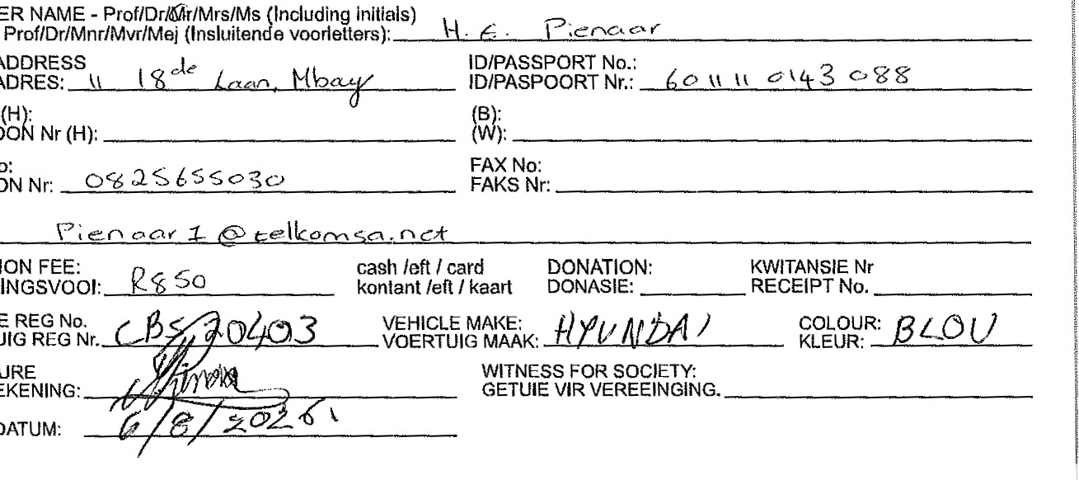
Wiste sat bied met verantwoordelike an liefdevolle sorg. Eienaarekap van 'n dier gee baie plesier en tevredenheid. Daar is 00k verantwoorde!ikhede en verpligünge wat nagekom nooet word. Die feit dat hierdie dier in ons sorg was, dui gewoonlik daarop dat iemand hulle plig versuim het.
ADOPTER
NAAM
-
HOME
ADDRESS
OONADRES:
EL
No
ELEFOON
ELL
No:
ELFOON
-MAIL:
_p0S.
DOPTION
ANEMINGSVOOI:
EHICLE
OERTUtG
IGNATURE
ANDTEKENING:
ATE
1
DATUM:
Ek onderneem en bevestig dat:
- Ek ouer as agtien (18) jaar is.
- Aile familielede stem gaam oor die aannemlng en sal at die voojwaardes in die kontrak nakom.
- Indlen ek om enige rede nie tanger die dier kan versorg nie, onderneem ek om dit alleenlik aan dle DBV terug te besorg. As ek om enige rede nie daartoe in Staat is om die dier te hou nie sal ek nie besit van die dier afstaan nie tensy ek dit aan die DBV terugbesorg. Ingeval ek nie so optree nie. aanvaar ek aanspreeklikheid om alle onkostes aan die DBV te betaal wat hulle mag aangaan in die verkryging van bevestiging dat die dier by 'n geskikte persoon met aanvaarbare huis en erf gehuisves is, ingeval dit nie die geval is nie, aanvaar ek 00k aanspreekiikheid vir alle onkostes wat die DBV mag eangaan, insiuitende die regskostes votgens 'n prokureur en kliänt skaat, in dio terugbesorging van die diet.
- Ek sal die dier 'n redelike kans gee orn aan sy nuwe tuigte gawoond te raak,
- Ek begtyp dat donasles nie ocrdraagbaar is of terugbetaal word nie.
- Ek onderneem om dle dier te versorg en te hulsves na dle Vetenlglng se tevredenhetd.
- Ek sat nle die dier vasketttng of gehok hou nie, en aanvaar dat indien die dier wel in my besit vasgeketting of gehok gevind word. die Vereniging dit dadelik sal verwyder.
Ek kan die dianste van 'n private veeartsnykundige bekostig.
10. Ek onderneem om die dier se nodiga inentings op datum te hou en In die geval van siekte of beserings sal ek •n veearts se diensta ebruik,
13. Ek verstaan dat, indien dia diar siek word (beserings uitgesfuit , binne sewe (7) dae van aanneming, 6k die dier na die Verenig ng mag bring vir behandBling deur sy veearts sonder enige koste (volgens die Vereniging se diskresie).
- Ek ondemeem om toe te sien dat die dier gesterjhseer word soos deur dle Verenlglng voorgeskryf.
- Ek onderneem om my dier te Identifigeer ter alte tye met behulp van 'h mikroskyfie of halsband en naamplaatile - slags rekbandJies mag vir katle gebruik word.
- My erf is behoorlik omhein en ek sal nie toeleat dat my hond in die straat rondtoop nle.
15, Ek sal binne agt-en•veertig (48) uur dle Vereniging in kennis stel indien die dier sterf of verfore raak.
Ek verstaan en ken die "By-wette aangaande diere" van die Munisipaliteit waarin ek woonagtig is.
17. Ek sal toelaat dat 'n gemagtigde parsoon van die Veraniging my erf kan besoek van (yd tot tyd, om te versaker dat die dier wel versorg word SODS in die Uitplasingsbeleid uiteengesit. Ek sal toe'aat dat die Vereniging die dier in besit neem indien die voorwaardes en reéls van hierdfe beteld redellk nagekom word nle.
18, Ek sal nie dle dler gebruik of toelaat dat dle dier as •n waghond gebrulk word op enlge industriele of kcmmersiöte perseel nie. Ek sal die Vereniging binne sewe (7) dae per geregistreede pos in kennis stel van enige verandering van adres
Ek ondemeem om nooit die dier wat ek aanneem te mishande' venyaarloos of te verlaat nie.
Ek vorklaar hiermee dat ek nog nooit skuldig bevind of aangekla is van wraedheid of vefwaarlosing van enige dier nie.
Ek verklaar hiermee dat ek die Ultplasing Kontrak getees het, en dat ek bevestig en erken dat die kontrak wettig en blndend Is.
I

cash left / card DONATION: kontant left I kaart DONASIE:
VOERTUIG
WITNESS FOR SOCIETY:
GETUIE VIR VEREEINGING.

・←e、~コ3 の uaコ0>

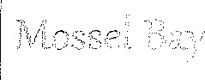 SOUTHAFRICA RE-KE-N4BGNiCiVlllriE•R: 5ヂD02145と02 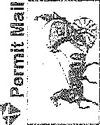
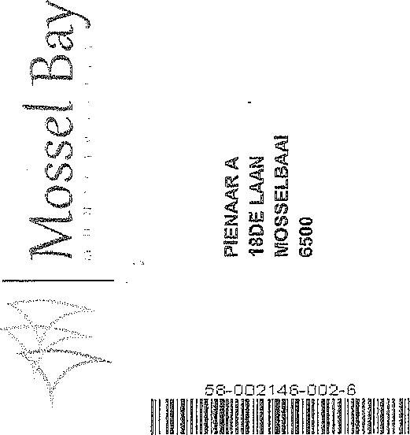
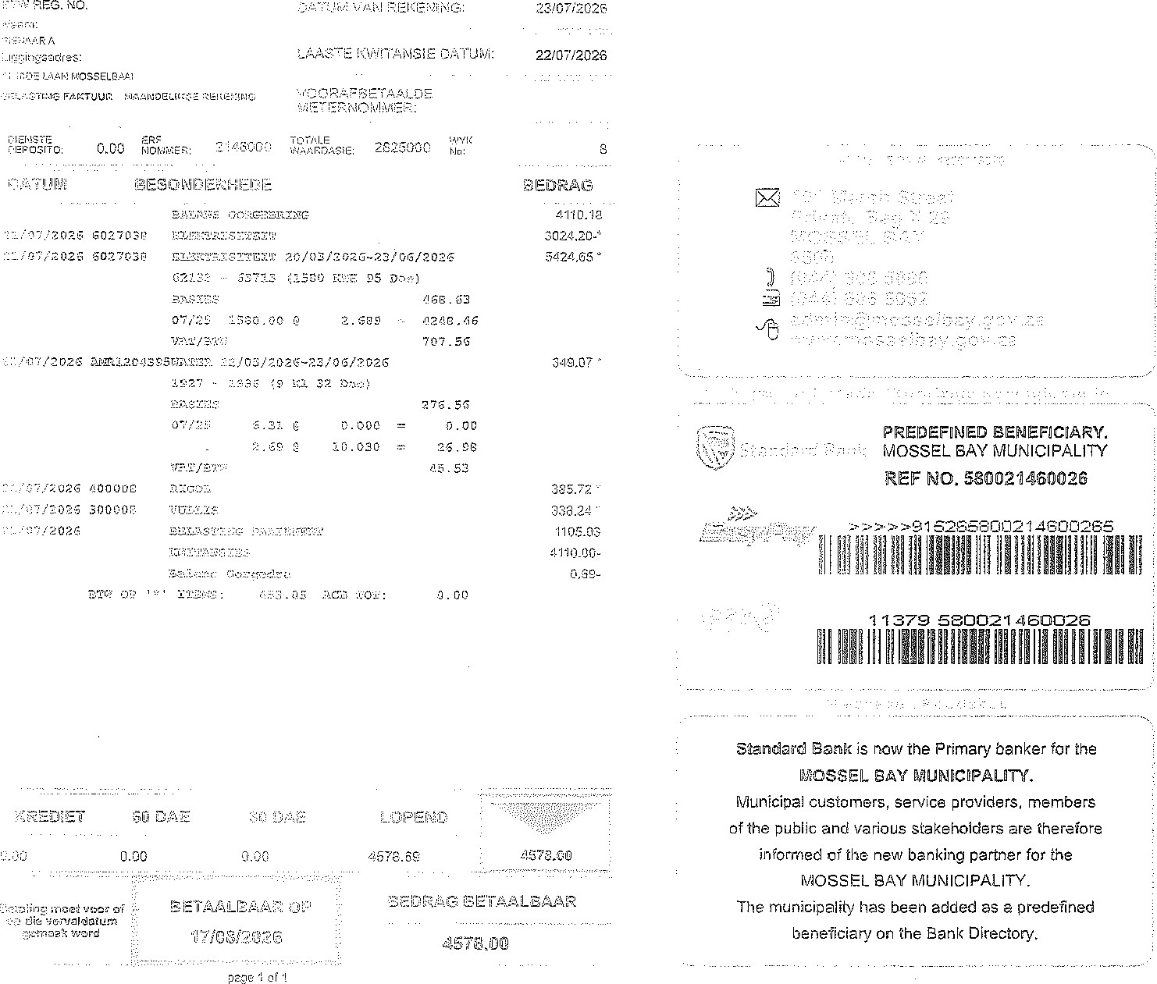 9690L0寸d
!
ド
UNDELIVERED
PLEASE
RETURN
TO:
Private
Bag
X
29
,
0556
bay,
6500
Foldand~ee「0コperfo「ation.



This card has been issued by the Department of HOJne Affairs in terms of the identification Act, Act 68 of 1997
It to Dep.slment orHorne Agates
For
(4 'i0072'i3E9
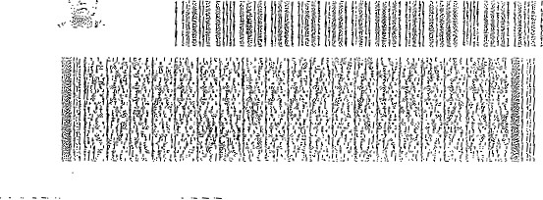
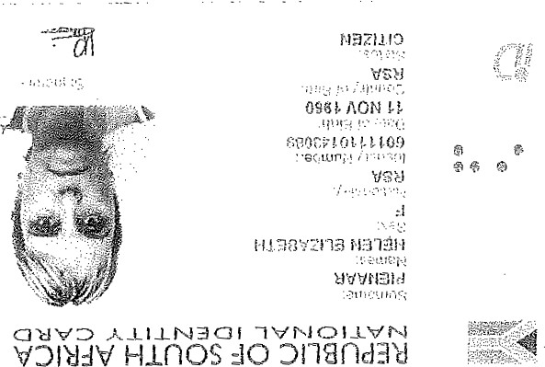



Department This Card has of been Home issued Affairs by in theterms of the
Identification Act. Act 68 or 1997
lountj
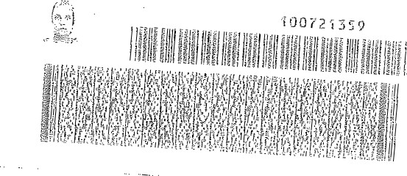
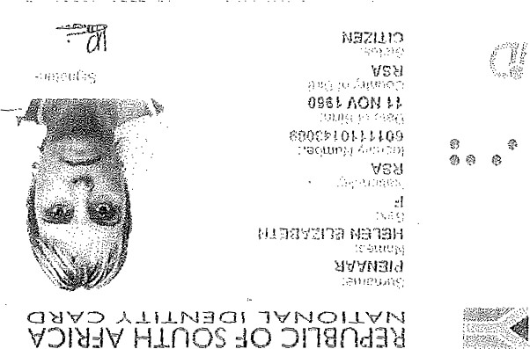




wvvuu,backhomezcoeza
852-8120 or or 027 8837
Email:
MICROCHIPPED ANIMAL REGISTRATION FORM

Please note that it is the Pet Owner's responsibility to ensure that the Pees details
992003000650640
 are registered on the BackHome Database
Vet Practice Name
Vet Practice Number * Vet Practice Phone - DaytiEne ^{i}
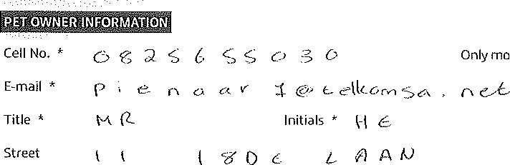
Only mobile numbers in South Africa, Botswana and Namibia wil be receiving SMS notifications.
Surname
Subu\b | Area Code
Country | Province
Phone - Day time | Phone Night time

OTHER-CONTACTS
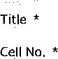 Initials * Surname
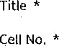 Initials * Surname
Surname
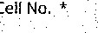
Cell
CHip.bETAlLS
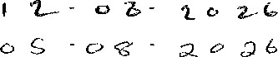
Registration Date *
Date of Implant *
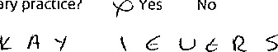
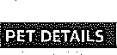
Was the Microchip implanted by this vetefinary practice?
Name of Vet who implanted the Chip
Pet Name | Date of birth
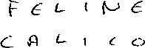
Species * Breed *
CotourMarkings
Gender Male Female Sterilised Yes No
KENNEL UNION OF SOUTH AFRICA '(KUSA) MEDICAL
Are you a KUSA Registered Member? | Yes | No | Medical Conditions
KUSA Registration Number |  |  | Medical Insurance Company
Pet Registered Name |  |  | Medical Insurance Policy Number
Medical Insurance Phone
PROTECTION OF PERSONAL INFORMATION E_AW
The client hereby agrees that his her personal information herein supplied and I or any is I' her personal information already in possession of the veterinarian may be P(ocessed by the said
Veterinacian and or it's office to bring about this agreement between the client an e terinarian. The client further agrees that the veterinarian may forward his her personal information to VIRBAC (Supplier of the Chip), in orde' for Virbac to lodge the clients pefsoaal inf at• on thei( database for tracking pu(poses. The client also agrees that where other relevant institutions need to trace a lost animal, and they use that code on Virbac's website they wili be giv ersonai information of the owner of said animal. The client also agrees that his I her personal information may be used by Virbac to forward him her a Newsletter as well as to send him I her information concerning pets. The client acknowledges that he / she has a right to object to the processing of its personal information for marketing purposes and unless expressly stat Q •se meby consents to it5 personal information being used by and Virbac RSA (Ltd) Pty for the above-mentioned purposes. SIGNATURE
- On-line Log onto wv•w.backhome.co.za. Complete the process. Virbac
- By e-mail Scan and E-mail the completed backhome@vlrbac.co.za or backhome.support.external@virbac.co.za
- By App Download the Virbac Backhome Africa App



ANNEXURE A
Additional household members and emergency contacts
Spouse details
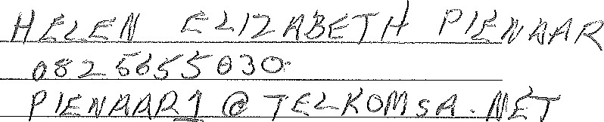
Contact nurreber :
Email address :
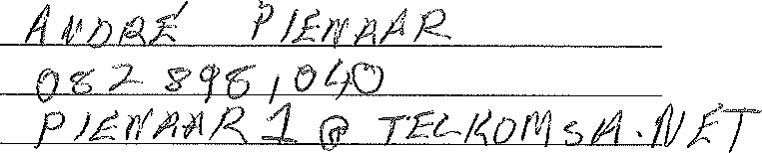
20 Additional family member/friend details o Full name : 0 Contact number:
- Email address :
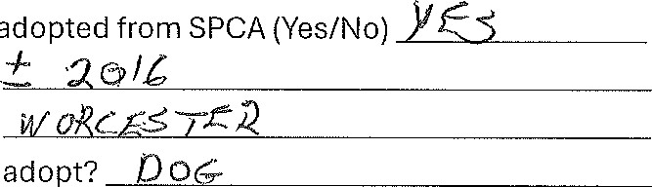
- If yes, when?
e
Have
you
previously
adopted
3.
Precious
SPCA
Adoption
e What animal did you adopt? DOG
I, the adoptee, confirm that I have read and fully understand the adoption contract in it's entirety.
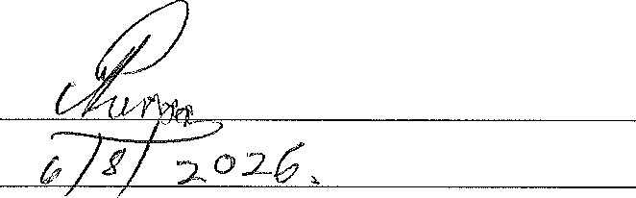
Signature Date



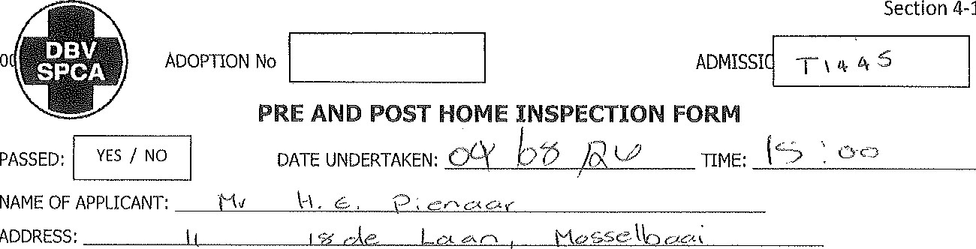
4-12a

HOME TEL No: CELL No:
SEX:
ANIMAL(S)
PRE- HOME INSPECTION:
PROPERTY DESCRIPTION
Type offence: |  |  |  |  |  |  |  |  |  |  | Height of fence: 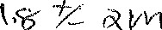
Any sign of Kennel/Shelter? |  |  |  |  |  |  |  | YES | / NOO |  | Any sign of Chain/Runner? |  | YES O / NO
Is the front yard separated from the back? |  |  |  |  |  |  |  | YES | / NO |  | If yes, what partitioning?
Any hazards? (pool, rubble, razor wire, eté) |  |  |  |  |  |  |  | YES | / NO |  | Specify:
Does appllcant live at the address? |  |  |  |  |  |  |  | YES | / NO |  | How many animals are on the property?
DESCRIPTION OF ANIMALS ON PROPERTY
 |  |  |  |  | 1 |  | 2 |  |  | 3 |  | 4 |  | 5
BREED
SEX
AGE
STERILIZED |  | YES |  |  | / NO |  | YES O / NO O |  |  | YES O / NO |  | YES O / NO | YES | / NO
OTHER INFOR ION / COMMENTS
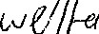re 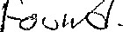
PROPERT{ APPROVED FOR THE FOLLOWING ANIMALS:
C] SMALL DOGS CATS
[Z MEDIUM DOGS
EQUINE
C)
LARGE
DOGS
INSPECTED
BY:
POST HOME INSPECTIONS
DATE | RESULT | REMARK | BY WHOM
DIAGRAM OF PROPERTY ON REVERSE OF THIS PAGE
New inclusion July 2013

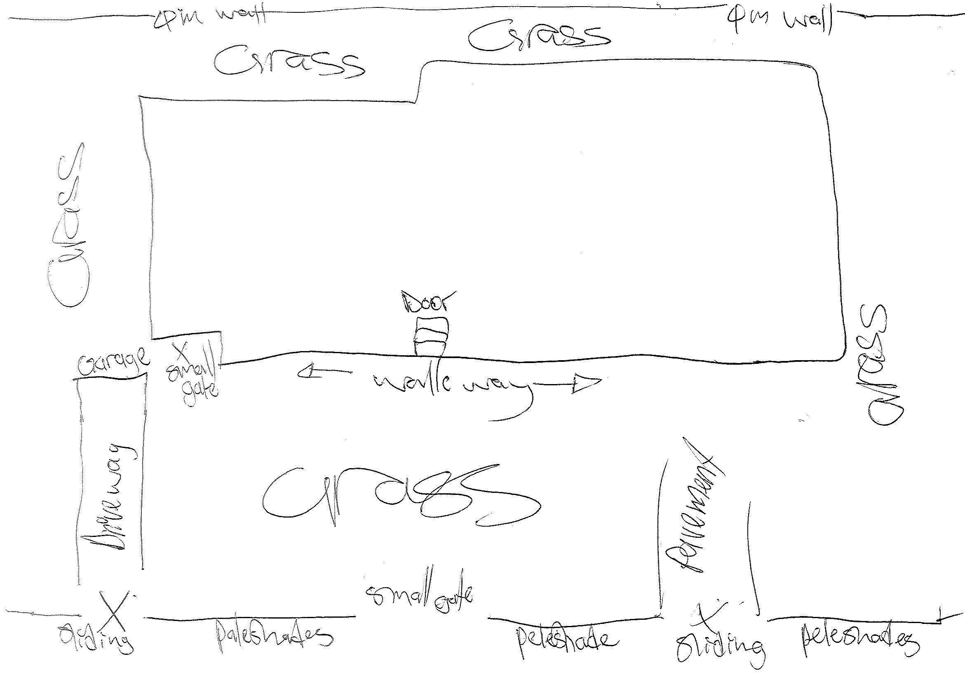

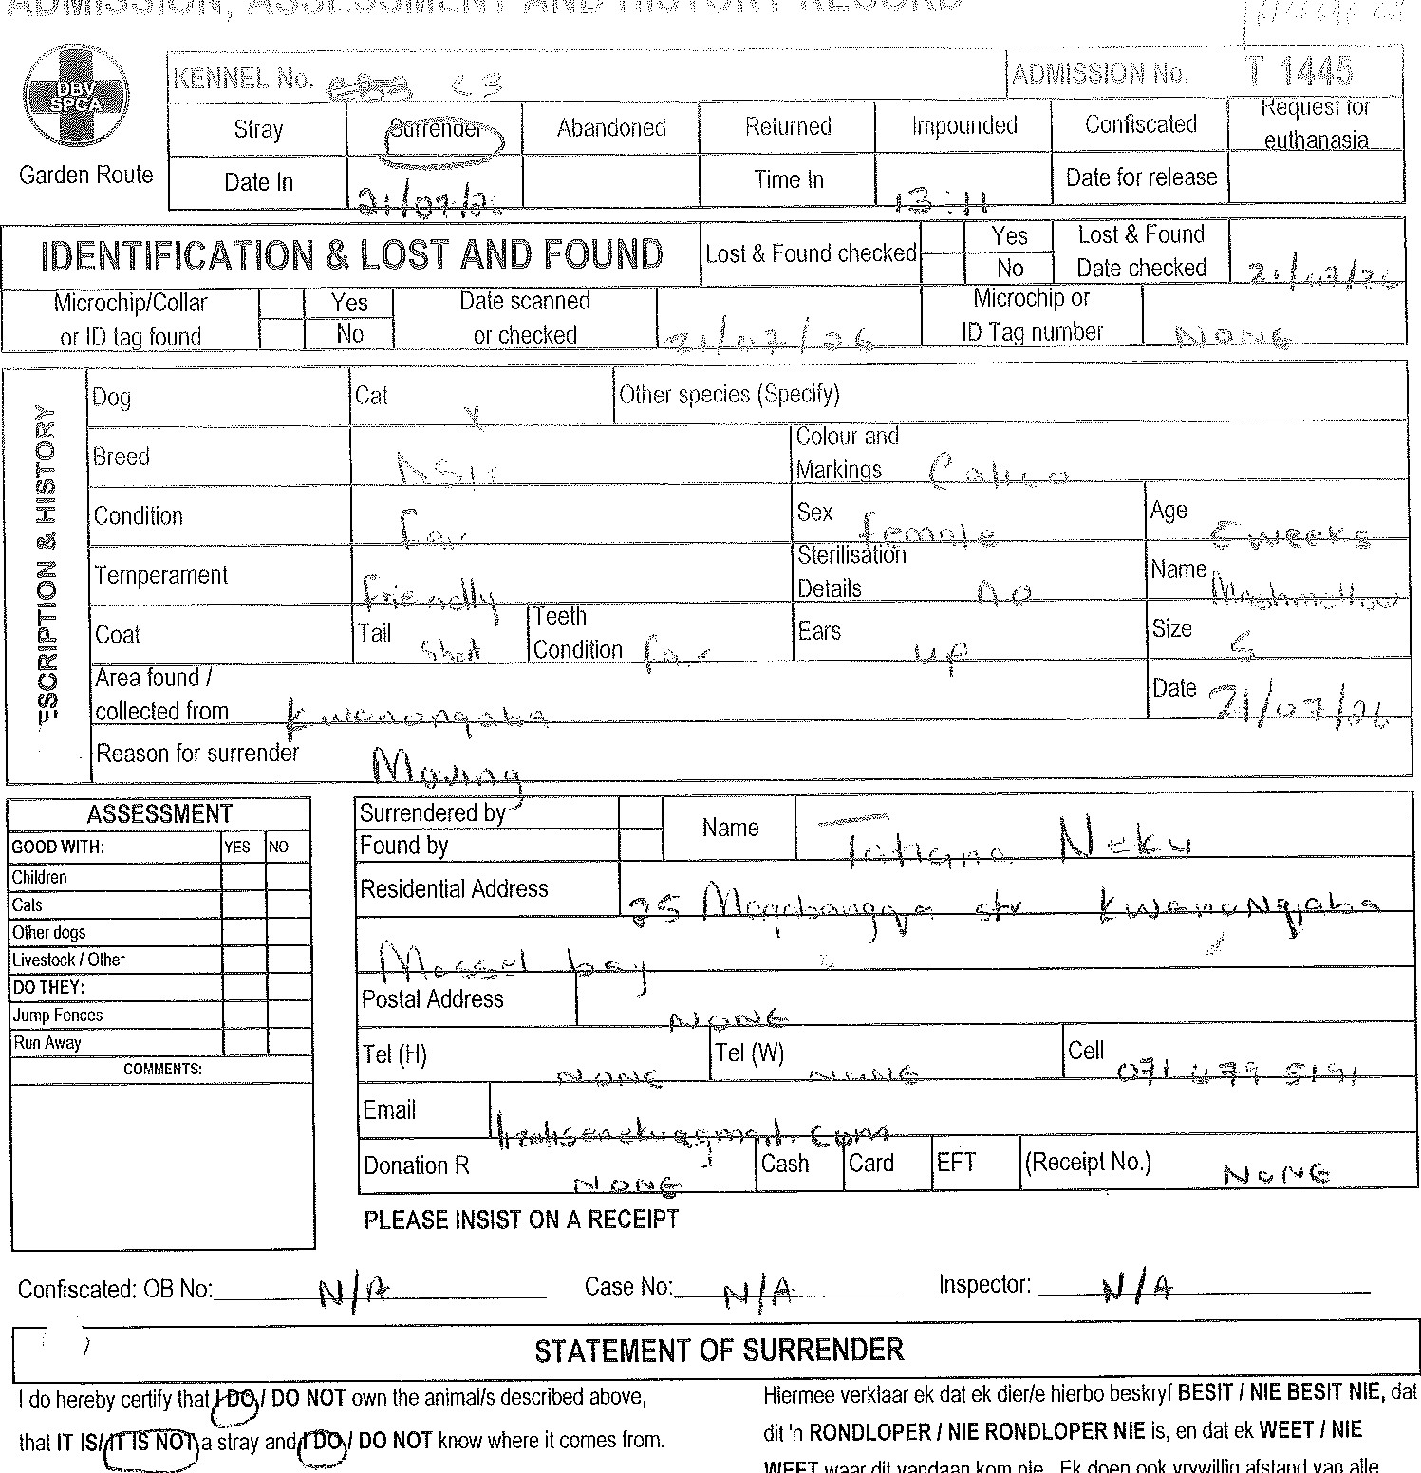
I do hereby I DO NOT own the animal's described above, Hiermee verklaar ek dat ek dier/e hierbo beskryf BESIT I NIE BESIT NIE, dat that IT ISI I DO NOT know where it comes from. dit 'n RONDLOPER I NIE RONDLOPER NIE is, en dat ek WE-ET I NIE
WEET
waar
dit
vandaan
kom
nie.
Ek
doen
00k
vrywillig
afstand
van
alle
I
also
freely
surrender
all
interest,
if
any,
therein
to
the
SPCA,
and
I
request

that the animal be deall with as deemed advisable in the discretion of the SPCA. It is expressly agreed that neither the SPCA nor its officers and employees will incur any obligation to me on account of such disposition of said animal's. I confirm that I am over the age of eighteen (18) years of age.
Also see "Conditions" on reversed side
belange daarin, indien enige, ten gunste van die DBV en ek versoek dat die dier hanteer word soos wat die DBV goed ag. Daar word uitdruklik ooreengekom dat nog die DBV nog sy amtenare, en werknemers enige verpligtinge het, teenoor my ten opsigte van die hantering van die dierle. Ek bevestig dat ek bo die ouderdom van agtien (18) jaar is. Sien 00k die
"Voorwaardes" op die agterblad.

Signature |  |  |  | Witness for Society 
 |  | FOR OFFICE USE: PENDING ADOPTION |  |  | Details of second A licant
 | etal so first A licant |  |  |  | Details of third  A licant
Claimed C] Adopted Euthanased [3 Died Other  On Date:
on the understanding ihai the Socieb/ Shali endeavout io place
 | it in a new home if unable to do so, effect its painless destruction. |  | volgens hut uiEsfuitlike diskresie noel die dien ve(stande dat die  Vereeniging sal poog orn dit in 'n nuwe huis te piaas of, indien hul nie in Staat is om dit te doen nie, om sy pyniose vernietiging te bewerksteliig.
2. | li in the opinion of a veterinarian or a qualified inspector in terms of | 2. | Indien, voEgens mening van 'n veearks of 'n gekwaliiseerde inspekteur in
 | Section 5 of Act 71 of 1962 (Animanls Protection Act) an animal |  | terme van Artikel 5 van Wei 71 van 1962 (Dierebeskermingswet) 'n dier
 | presented for admission is so diseased, severely injured or in such |  | aangebied word vir Iodating wat so siek, ernstig beseer of in sodanige
 | phusicaF condition that it should be destroyed for humanitarian reasons, |  | fisiese loestand is dal dil vir mensEikheidsredes vernietig behoori te
 | the Society shalÉ have the Fight to effect such destruction by approved |  | die Vereeniging die reg sai hé Oin so ^{I} n vernietiging te bewer!qsieliig deur
 | h u [oane methods |  | goedgekel.ll'de enenswaardige vneiodes
3. | Any charges endorsed hereon are due and payabte on request. | 3. | Enige koste hierop onderskryg is verskuldig en betaatbaar ap aanvraag.
 | The Society will not home any animal unsterilised. | 4. | Die Vereniging sal geen dier pfaas wat ongesteriliseer is nie.
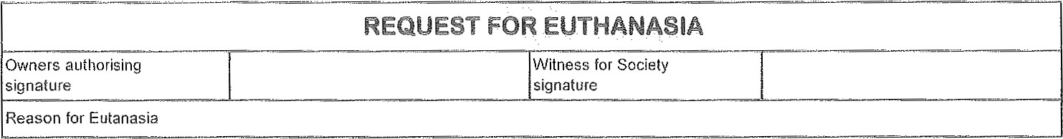
Euthanase Bottle No: Quantity used: AWA:

CLAIMANT
Name: Prof/Dr/MriMrs/Ms (including initials)

Residential Address:

Postal Address:

Email Address:

Reclaim Charge:
Added
Donation:
Cash/EFT/Card
(Receipt
No.)
ID/Passport No:
Vehicle Model Colour Reg. No:
Signature: Witness for Society
Microchip I Collar and ID tag given |  | Yes | Microchip I  ID tag details
Microchip I Collar and ID tag given |  | No | Microchip I  ID tag details
Date
MEDICAL RECORD
 | Date |  | Remarks |  | Treatment | Cost
 |  |  | 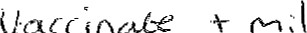
 |  |  |  |  | PTS APPROVAL
 |  |  |  |  | NAME | SIGN

CSW 乄
o一一00一=009一 09 09 一0 b一、 、0一000一 6W90一 •ON· 一snid '一-q~6w009 0N2、uaqua丄90、 09冖20亠000一一uenb一2d
-0、一 亠 一 upeA!qON'冖 0W09一0V8、 •ON 2乛~一d u…u 丶pe>一 … 6一~ 一 09 •ON•62H一0 •oeA!qON一一卜 'ON•6eE) e3eA!qoN
1V0 3LV0 1V0
0 9099000e00d66
冖一一 … 一山鷾n」LhäN3iS卜凷> 'ON一亠 卜 CiN N OF>

一 Ou RM…IT9
PRODUCT OATE PRODUCT
Vaccinationprotectsyourpetagainst'
。 DANGEROUSGERMS thatcanbe everywhere.
SHAREDTOYS
DOGPARKS
:'CONTAMINATED
-5H0 0 -NG
WATER
VISITINGPETS
HOUSEGUEST
300一NC CELETi
THECROOMER-
THE-ENVIRONMENT
SNAREDFOODORBEDDING
SIGNATURE PRACTECESTAMP
GARDENROUTESPCA
BillJeffervAvenue POBox 8
KwanonQaba George
Nlosselbav6506 6530
Cell…0」6584832~Office…046930824
EmergencyNO…07 287一76一
Consultin Hours
rvion-Fri…09…00,16…00 AnirnaiHeaith Saturdav…09…0一一,一1…00 CatervetSouthAfrica(Pty}Ltd,Reg.NO.一99U865 7
20SpartanRoad,Sa n6一9丶RSAlP乛ivateBagX202PIsando,一60PRSA
Te-…+27一一923938·Fax…+27一一3923一58、Sa3esFax…G866031777
uvww.msd-animai-health.co,za •NOV•211288一

i\IGPCA Operatlong Manuai 2020 Section Page,
STERMJASAHON CONTRACT
PLEASE READ CAREFULLY TF"S A LEGAL DOCUMENT

(')L 08 QC
CON
befiween SPCA atad.
Name
Address
Telephone Number,å (H)
to hav spayeY/ .heutered /  Animal s Name |  | applicable):
Descriptlon
On (due d\te)
on the
VeterInary•lHcispiliäj!,':! •
1 , Shouldg!t-k wlthout the of this for the any fees Incurred :
- If the sterlllsed on the the right to and NO that a member of the SPCA^{l}s the anlmal.
- This animal will be cancelled and a new one
- In the event of the within seven (7) days,
51 The owner undertakes to bring the seCtIön 1 above to of the Veterinary Practltloner who may, or witl be, consulted by the owner.
I have read and fully understand the conditions above, which I accept unconditionally,
Signature of new Owner: For SPCA:
CONFIRMATION OF STERILISATION:  Vet:  Date: | Slgned:



