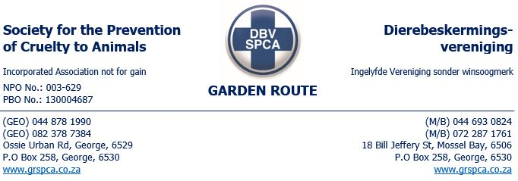

08/08/2024
Attention Public Prosecutor

The Mosselbay SPCA request that Mr. and Mrs. ___________be charged for animal cruelty under the following sections of the Animals Protection Act 71 of 1962:
(a )overloads, overdrives, overrides, ill-treats, neglects, infuriates, tortures or maims or cruelly beats, kicks, goads or terrifies any animal; or
(b) confines, chains, tethers or secures any animal unnecessarily or under such conditions or in such a manner or position as to cause that animal unnecessary suffering or in any place which affords inadequate space, ventilation, light protection or shelter from heat, cold or weather; or
(c) unnecessarily starves or under-feeds or denies water or food to any animal;
(e) being the owner of any animal, deliberately or negligently keeps such animal in a dirty or parasitic condition or allows it to become infected with external parasites or fails to render or procure veterinary or other medical treatment or attention which he is able to render or procure for any such animal in need of such treatment or attention, whether through disease, injury, delivery of young or any other cause, or fails to destroy or cause to be destroyed any such animal which is so seriously injured or diseased or in such a physical condition that to prolong its life would be cruel and would cause such animal unnecessary suffering; or

2(1) (q) causes, procures or assists in the commission or omission of any of the aforesaid acts or, being the owner of any animal, permits the commission or omission of any such act; or
2(1) (r) by wantonly or unreasonably or negligently doing or omitting to do any act or causing or procuring the commission or omission of any act, causes any unnecessary suffering to any animal; or

For any queries please contact me.
Regards

________________ Elize Goosen
Trainee Inspector

