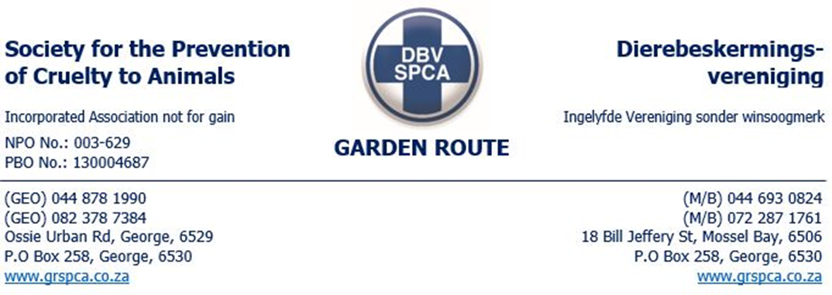
WARNING MBY5310

NAME & SURNAME: Mr.JP MOOLMAN DATE: 24/07/2025
PHYSICAL ADDRESS: 08 Danie de Jager Street Mosselbay
ID No.9009075172083 TEL. No. 0849419358
In respect of the inspection conducted today 24 July 2023 , the below contraventions were observed
You are hereby warned:
Your dog (male- rottweiler -black and tan ) was Presented and collected it had a choke chain around the neck .
CHECK/CHOKE CHAINS
Check/Choke chains - a metal chain formed into a loop that slips over the dog’s head and is positioned on the neck with one end of the loop attached to a lead. When the lead is pulled or jerked the chain tightens around the neck, chocking the dog. Choke chains can cause “mechanical or ischemical damage to the oesophagus, larynx, thyroid, and trachea”
Use of Check/Choke chains typically causes significant pain, fear, distress and lasting harm including:-
1. Severely sprained necks
2. Misalignment of cervical vertebrae
3. Swollen eyes, haemorrhaging of ocular blood vessels

4. Tracheal and oesophageal damage
5. Recurrent laryngeal nerve paralysis

The use of check/choke chains on dogs is outdated and inhumane. There are more progressive and humane methods of training and handling dogs
The SPCA movement in South Africa encourages the use of humane and holistic training methods.
It is our opinion that the use of these devices may constitute a contravention of the Animals Protection Act in terms Sections 2(1) (a) (f) and possibly other charges as well.
. OFFENCES IN RESPECT OF ANIMALS - (1) Any person who: (a )overloads, overdrives, overrides, ill-treats, neglects, infuriates, tortures or maims or cruelly beats, kicks, goads or terrifies any animal; or
(f) uses on or attaches to any animal any equipment, appliance or vehicle which causes or will cause injury to such animal or which is loaded, used or attached in such a manner as will cause such animal to be injured or become diseased or to suffer unnecessarily; or
Recommendations
dog must be castrated by a vet to improve its behaviour as advised by the behaviourist.
Dog must be seen by a veterinary on a regular basis to maintain good health .
This warning has been issued in terms of the Society for the Prevention of Cruelty to Animals Act No 169 of 1993.

Failure to comply with this warning may render you liable for prosecution under the Animals Protection Act No 71 of 1962 and/or Performing Animals Protection Act No 24 of 1935.

Any person who: - obstructs, hinders, or resists an officer authorised in terms of the Animals Protection Act No 71 of 1962 or conceals any animal shall be guilty of an offence in terms of Section 8(4) of the aforementioned Act.

SIGNED & ACCEPTED BY:
PLACE: Mosselbay SPCA TIME:
INSPECTOR: Thembinkosi Malinga

