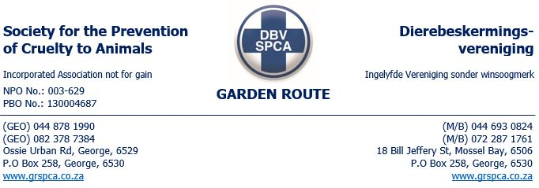
WARNING no:
This warning is issued in term of the Animal’s Protection act no 71 of 1962 and Performing Animals Protection ACT 24 of 1935:
Further to the removal of 40 cats from your property on the 4th of May 2024 – see attached list.
- It is a contravention of the Animals Protection Act no 71 of 1962 to-
(e) being the owner of any animal, deliberately or negligently keeps such animal in a dirty or parasitic condition or allows it to become infected with external parasites or fails to render or procure veterinary or other medical treatment or attention which he is able to render or procure for any such animal in need of such treatment or attention, whether through disease, injury, delivery of young or any other cause, or fails to destroy or cause to be destroyed any such animal which is so seriously injured or diseased or in such a physical condition that to prolong its life would be cruel and would cause such animal unnecessary suffering; or
- The property must be cleaned and kept clean and to be disinfected.
- The owner failed to provide vet treatment as the cats were infested with fleas.
- The cats untreated dental problems.

- The remaining five cats and a dog must be evaluated by a veterinarian and veterinary report for each animal must be provided to the SPCA.
- As discussed the SPCA will assist with the sterilisation of the male German Shepherd type dog at a reduced price. The dog will be collected by us, castrated and taken back on the ___ of MAY 2024, at a cost of R650.00

- In order to ensure the compliance as discussed the SPCA will conduct unannounced visits at the property from time to time. It would be a benefit for your animals and the SPCA to conduct inspection unobstructed, with access to perform such inspections, failing this, we will have no option but to make an application under warrant.

- (4) Any person who wilfully obstructs, hinders or resists an officer authorized under sub-section (1) in the exercise of the power conferred upon him or conceals any animal or thing with an intent to defeat the exercise of such powers, or who upon demand fails to give his name and address to such officer, shall be guilty of an offence and liable on conviction to the penalties set out in sub-section (1) of section two
You are hereby advised to apply to the Law Enforcement for a permit to keep the five cats.
All the above concerns MUST be rectified within the next 7 days.
This warning has been issued in terms of the society for the prevention of cruelty to animals act no 169 of 1993.
Failure to comply with this warning may render you liable for prosecution under the animal’s protection act no 71 of 1962 and /or performing animal’s protection act no 24 of 1935.
Any person who; obstruct, hinder or resist an officer authorised in terms of the animal’s protection act no 71 of 1962 or conceals any animal shall be guilty of an offence in terms of section 8(4) of the aforementioned act.

Signed and accepted by: _________________________________________________
Date: _________________________________________________

