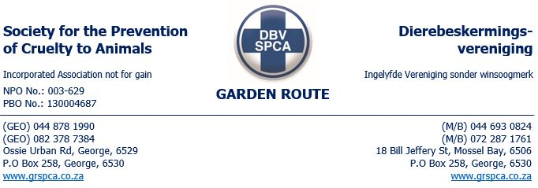
WARNING
Name of Facility: Bokwe security company
Name of Manager: Christo Kammies
Physical Address: 32 Marsh street
Telephone: 044 0070295
In respect of the inspection conducted on the 14 of March 2024 at Bokwe Security site in Marsh street. See below as discussed with the supervisor MR Maduna
You are hereby warned:
Under the Animals Protection Act no 71 of 1962 in conjunction with the Performing Animals Protection ACT 24 of 1935, the following concerns were discussed during the inspection and corrective actions were advised to be taken.
➢ Rest and off duty periods – The animals should have regular and appropriate daily rest periods and not be overworked. Animals should have regular opportunities to engage in species-specific natural behaviour such as grazing, playing, or exploring:

1. Dogs routine records should be recorded and kept safe.
2. The dog is not rested on a resting camp

➢ Equipment – any equipment used on animals should be humane; designed for the intended purpose; free of any harmful features; well fitted and maintained, including allowing the animal to perform comfortably. Equipment shall only be used on animals by staff who are adequately trained and competent to use the equipment humanely:

- The chain used to walk the dog is unacceptable as it chokes the dog and may cause further injuries.
- Equipment used on the animal should be kept neatly and tidy.

➢ Nutrition – should be of a suitable quantity and quality to ensure good health and performance. Frequency of feeding should be appropriate for the age, condition, work output and relevant species;

➢ Health – animals must be provided with the best preventative health and veterinary care to maintain a good physical state. Prompt veterinary care must be provided in the event of injury or illness with suitable post-treatment care and rest;
1. The dog must be seen by a veterinary at least twice a year, if dog was seen by a veterinarian please provide all medical documentation to the SPCA.

All above mentioned concerns are to be rectified within the next 7 days. A follow up will be conducted no later than the 21st of March 2024.

This warning has been issued in terms of the Society for the Prevention of Cruelty to Animals Act no 169of 1993.
Failure to comply with this warning may render you liable for prosecution under the Animals Protection Act no 71 of 1962 and /or Performing Animals Protection Act no 24 of 1935
Any person who; obstruct, hinder or resist an officer authorised in terms of the animals protection act no71 of 1962 or conceals any animal shall be guilty of an offence in terms of section 8(4) of the aforementioned act.

Signed and accepted by: __ Sent by email _____________________________
Place: _____ Mosselbay _______________________________
Inspector: ___ Thembinkosi_Malinga _________________

