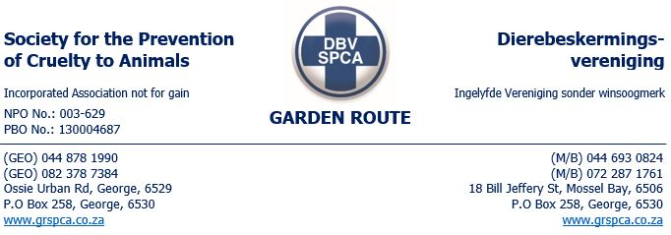
WARNING : 5209

PHYSICAL ADDRESS: Buffelsdrift Dairy Farm, Blands Drift, Mossel Bay, Western Cape
GPS Co-Ordinates: -34.110329984042615, 21.707414101165217 ID No. ___
TEL. No. CELL No. _0814001199_ REG No._________________
Email: danielb@wispernet.co.za

You are hereby warned:

- That the calves in the camps do not have any protection from the elements. This is also a requirement in terms of SANS 1694:2018 The welfare of dairy cattle as well as the Animals Protection Act 71 of 1962. This must be rectified by no later than the close of business on 02 December 2024. Proof of compliance is to be sent to inspector1@grspca.com or 0722871761.
- That it was observed that there was a calve in the one camp that appeared to be sick. Kindly provide proof by 08h00 tomorrow 29 November 2024 that this calve are being treated accordingly. This calve in question was found lying in the sun without adequate shelter and could barely stand up straight.

This warning has been issued in terms of the Society for the Prevention of Cruelty to Animals Act No 169 of 1993.
Failure to comply with this warning may render you liable for prosecution under the Animals Protection Act No 71 of 1962 and/or Performing Animals Protection Act No 24 of 1935.
Any person who:- obstructs, hinders, or resists an officer authorised in terms of the Animals Protection Act No 71 of 1962 or conceals any animal shall be guilty of an offence in terms of Section 8(4) of the aforementioned Act.

SIGNED & ACCEPTED BY: Sent via email
PLACE: Mosselbay, EC TIME: _16h35_____
INSPECTOR: T. Malinga – 0722871761 ______

