8 Faure Street  Malmesbury  022 487 1157 | 42 Main Street  Riebeek-Kasteel  082 089 1234
PO Box 298, Malmesbury, 7299
E-mail: admin@groenkloofdierekliniek.co.za
Website: www.groenkloofdierekliniek.co.za
Emergency no.: 081 855 0301
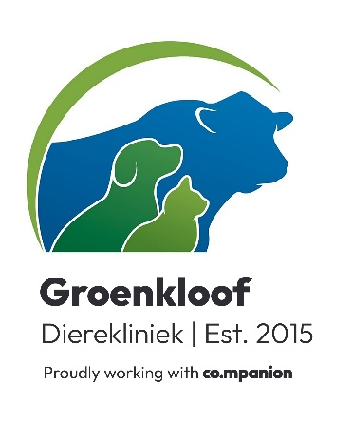
25 September 2024
To whom it may concern,
Your written warning to Dogs and All, Boland Bins, Interpace Road, Wellington refers.
I can report as follow:
- Muis ( ID 900008300510810)
PTS at Groenkloof Dierekliniek on 23/09/24
- Zeus ( ID 933071000052791)

Teeth scaling at Groenkloof Dierekliniek on 23/09/24

If any further information is required, please feel free to contact me.
Vriendelike groete/Kind regards

Dr NJ Heyns
Tel: 022 487 1157
8 Faurestreet, Malmesbury
